**Parkside Lutheran Church**

*Rediscovering the Radical Love of Jesus*

*Gathering All*

*Serving All*

*Caring For All*

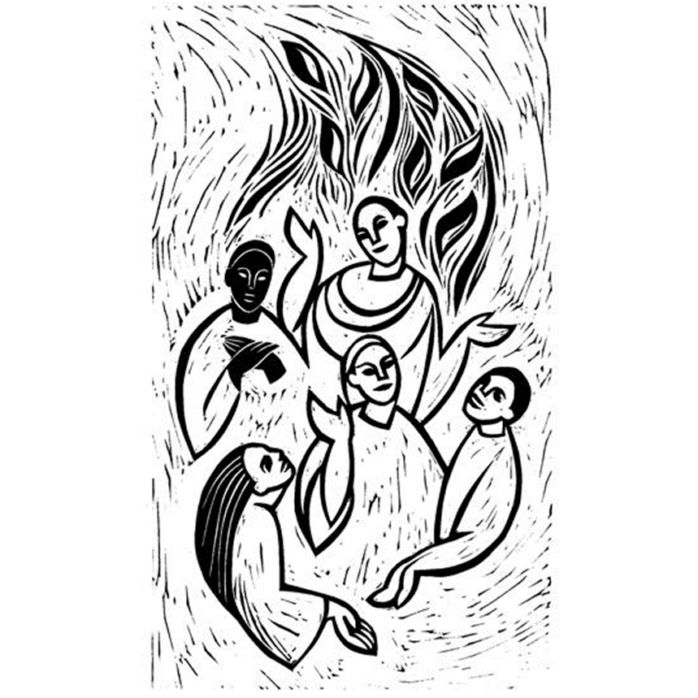

**May 19th, 2024**

**Day of Pentecost**

**Holy Communion 10:00am**

**Preacher: The Rev. Jeremiah Smith**

**Presider: The Rev. Dr. John Scarfia (David’s Grandfather)**

**Welcome to Parkside—** If this is your first time at a church, your first time at Parkside, you’re a regular, or anywhere in between, we are grateful that you havecome for worship today. Thank you for being part of today’s community of faith here at Parkside.  We hope you feel welcomed and that God may touch your life through those around you and through the worship service.

**Welcoming Children in Worship:** “Jesus said, “Let the little children come to me…” Matthew 19:14 Here at Parkside we embrace joyful noise! We know that parents are often worried that their little’s might be disruptive or distracting. However, please know that you worry more than we do! Nothing makes our hearts happier than when a child wanders down the main aisle, drops a snack on the floor, or feels moved to make a joyful noise in the middle of the sermon. We are just delighted that you are in worship. We know how hard it can be just to get them up, dressed, and out the door. All kids are invited to come forward for the children’s message with Pastor. After this message, kids 5 and up are welcome to head to Sunday School. We are currently in the planning stages to add a toddler Sunday School as well! “Busy Packs” are in the back of the church if your child would like crayons during the service. Thanks for being here today!

**\*CHILD CARE – Child Care for children under 5 is available most Sundays.\***

**Check in with Miss Christine in the nursery (Carpenter Room), to the left as you exit the sanctuary.**

**Communion Statement:** Everyone is invited to share in the sacrament of Holy Communion. This invitation comes not from Parkside, or the pastor, but from Jesus Christ. If you seek a connection with Jesus Christ, please come and be fed at this holy meal. All are invited to come forward to receive the host* (wafer) from the Pastor, then dip it in wine or grape juice offered by the Communion Assistant. *You have the option to receive a gluten free wafer upon request. Children are welcome to receive communion as well. Pastor is happy to offer blessings to those who do not wish to receive communion. Simply approach Pastor with hands over heart.

**Supporting the Ministry of Parkside Lutheran:** This community would not be possible without your support. Ways to give: As you entered the Sanctuary there was an offering plate for donations, we also can receive credit card donations online. (Simply click the ‘give’ option on our church website parksidelutheran.org) More than just financial offerings we deeply appreciate gifts of time and prayer. We give thanks to God for you and your generosity.

**For your safety in the event of an emergency:** Please note that in addition to the three exits in the back of the sanctuary, there are also exits on either side of the altar (up the stairs to the altar, past the choir seats)

***Contact us:*** (716) 836-1361

2 Wallace Ave. Buffalo, NY 14214

*parksidelutheran.org |* [*parksidelutheran@gmail.com*](mailto:parksidelutheran@gmail.com)

Visit & *Like* us on Facebook or follow us on Instagram

**GATHER***The Holy Spirit calls us together as the people of God.*

**Preservice Music:** Michael Hooker, *Music Director*

**Introduction to the Day:**  *Fifty days after Easter, we celebrate the outpouring of the Holy Spirit on Pentecost. Crossing all boundaries that would separate us, the Spirit brings the wideness of God’s mercy to places we least expect it—to a crowd of strangers in different lands and tongues, to dry bones, to our weak hearts. Jesus promises his disciples that they will be accompanied by the Holy Spirit, and that this Spirit reveals the truth. We celebrate that we too have been visited with this same Spirit. Guided by the truth, we join together in worship, and then disperse to share the fullness of Christ’s love with the world.*

**Welcome and Announcements**

**+Call to Worship** *Please Stand*

WA: Mighty wind of God,

**C: blow through this place.**

WA: Stir us to praise,

**C: lift us from despair.**

WA: Holy fire of God,

**C: enliven our spirits,**

WA: heat up our compassion,

**C: burn away our fear.**

WA: Mighty wind and holy fire,

**C: revive us again,**

WA: set loose joy

**C: and a chorus of praise.**

WA: We have come to this place

**C: to catch the Spirit and move out!**

**+Gathering Hymn: Spirit, Spirit of Gentleness** **ELW #396**

*(printed next page)*

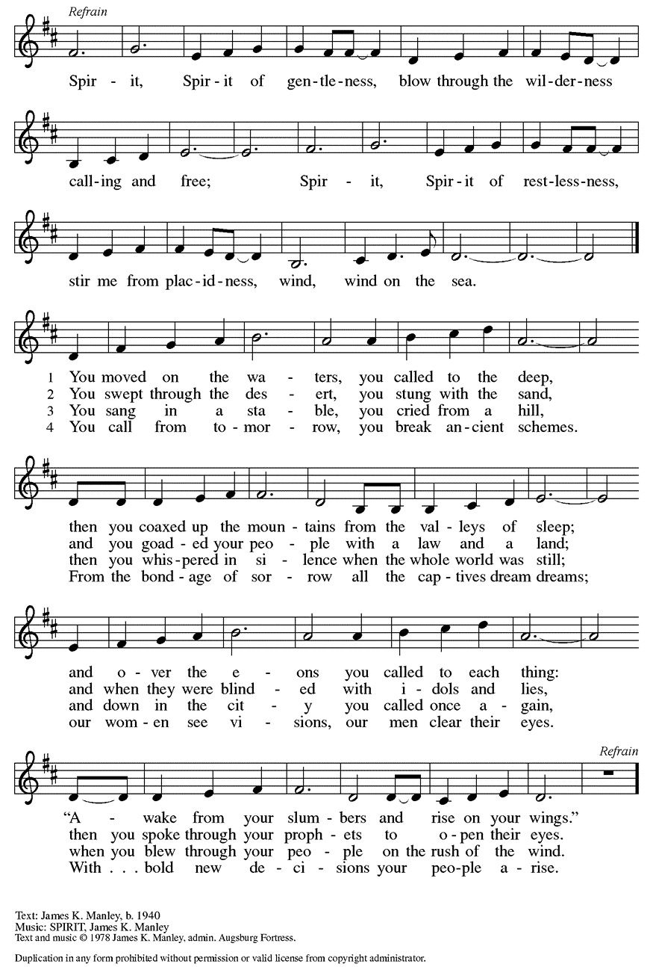

**+Confession and Forgiveness**

P: Blessed be the holy Trinity, **+**one God*,* the God of manna, the God of miracles, the God of mercy.

**C: Amen.**

P: Drawn to Christ and seeking God’s abundance, let us confess our sin.

*Silence is kept for reflection.*

P: God, our provider,   
**C: help us. It is hard to believe there is enough to share. We question your ways when they differ from the ways of the world in which we live. We turn to our own understanding rather than trusting in you. We take offense at your teachings and your ways. Turn us again to you. Where else can we turn? Share with us the words of eternal life and feed us for life in the world. Amen.**

P: Beloved people of God, in Jesus, the manna from heaven, you are fed and nourished. By Jesus, the worker of miracles, there is always more than enough. Through Jesus, **+**the bread of life, you are shown God’s mercy; you are forgiven and loved into abundant life. **C: Amen.**

**Greeting**

WA: The grace of our Lord Jesus Christ, the love of God, and the communion of the Holy Spirit be with you all. **C:** **And also with you.**

**Kyrie** setting 8 *Printed next page*

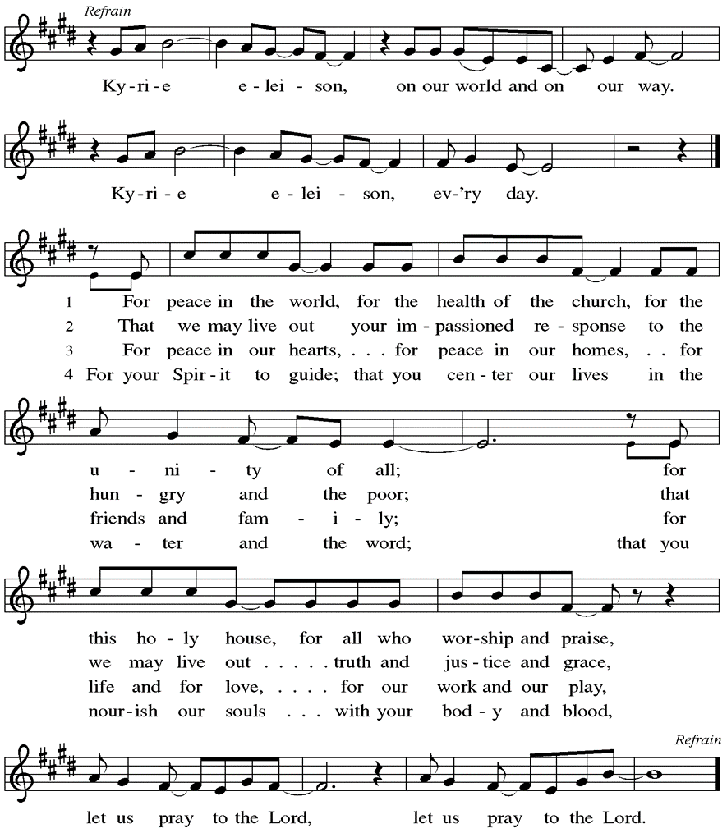

**Prayer of the Day**

WA: Let us pray together.

**C:** **Mighty God, you breathe life into our bones, and your Spirit brings truth to the world. Send us this Spirit, transform us by your truth, and give us language to proclaim your gospel, through Jesus Christ, our Savior and Lord, who lives and reigns with you and the Holy Spirit, one God, now and forever. Amen.**

**Children’s Sermon:** *Jesus said, “Let the little children come to me!”*

*We welcome children in worship.*

**WORD**

*God speaks to us in scripture readings, preaching and song.*

### **First Reading: Acts 21:1-21**

*Originally Pentecost was a Jewish thanksgiving-type festival celebrated seven weeks after Passover. On this particular Pentecost, however, the Holy Spirit is poured out upon the entire community of believers just as Jesus had promised and the scriptures had prophesied. Empowered by the Spirit, the entire community bears witness to God’s activity in multiple languages.*

L: 1When the day of Pentecost had come, [the apostles] were all together in one place. 2And suddenly from heaven there came a sound like the rush of a violent wind, and it filled the entire house where they were sitting. 3Divided tongues, as of fire, appeared among them, and a tongue rested on each of them. 4All of them were filled with the Holy Spirit and began to speak in other languages, as the Spirit gave them ability.  
 5Now there were devout Jews from every nation under heaven living in Jerusalem. 6And at this sound the crowd gathered and was bewildered, because each one heard them speaking in the native language of each. 7Amazed and astonished, they asked, “Are not all these who are speaking Galileans? 8And how is it that we hear, each of us, in our own native language? 9Parthians, Medes, Elamites, and residents of Mesopotamia, Judea and Cappadocia, Pontus and Asia, 10Phrygia and Pamphylia, Egypt and the parts of Libya belonging to Cyrene, and visitors from Rome, both Jews and proselytes, 11Cretans and Arabs—in our own languages we hear them speaking about God’s deeds of power.” 12All were amazed and perplexed, saying to one another, “What does this mean?” 13But others sneered and said, “They are filled with new wine.”  
 14But Peter, standing with the eleven, raised his voice and addressed them, “Men of Judea and all who live in Jerusalem, let this be known to you, and listen to what I say. 15Indeed, these are not drunk, as you suppose, for it is only nine o’clock in the morning. 16No, this is what was spoken through the prophet Joel:  
 17‘In the last days it will be, God declares, that I will pour out my Spirit upon all flesh, and your sons and your daughters shall prophesy, and your young men shall see visions, and your old men shall dream dreams. 18Even upon my slaves, both men and women, in those days I will pour out my Spirit; and they shall prophesy. 19And I will show portents in the heaven above and signs on the earth below, blood, and fire, and smoky mist. 20The sun shall be turned to darkness   and the moon to blood, before the coming of the Lord’s great and glorious day.  21Then everyone who calls on the name of the Lord shall be saved.’ ”

**L:** Word of God, word of life. **C: Thanks be to God.**

**Psalm 104:24-34,35b** *Send forth your Spirit and renew the face of the earth.*

*(Ps. 104:30)*

L: 24How manifold are your works, O Lord!  
  In wisdom you have made them all; the earth is full of your creatures.

**C:** 25**Yonder is the sea, great and wide, with its swarms too many to number,**  
  **living things both small and great.**

L: 26There go the ships to and fro,  
  and Leviathan, which you made for the sport of it.

**C:** 27**All of them look to you to give them their food in due season.**

L: 28You give it to them; they gather it;  
  you open your hand, and they are filled with good things.

**C:** 29**When you hide your face, they are terrified;**  
  **when you take away their breath, they die and return to their dust.**

**L:** 30You send forth your Spirit, and they are created;

and so you renew the face of the earth.

**C:** 31**May the glory of the Lord endure forever;**

**O Lord, rejoice in all your works.**

L: 32You look at the earth and it trembles;  
  you touch the mountains and they smoke.

**C:** 33**I will sing to the Lord as long as I live;**  
  **I will praise my God while I have my being.**

L: 34May these words of mine please God. I will rejoice in the Lord.

**C:** 35b**Bless the Lord, O my soul. Hallelujah!**

L: Word of God, word of life. **C: Thanks be to God.**

**Second Reading**:  **Romans 8:22-27**

*By pouring the Holy Spirit into our hearts, God gives us the promised first fruit of eternal life so that we await God’s future in hope. In the meantime, the Spirit also intercedes for us by carrying the prayers of our weak human hearts to God.*

L: 22We know that the whole creation has been groaning in labor pains until now; 23and not only the creation, but we ourselves, who have the first fruits of the Spirit, groan inwardly while we wait for adoption, the redemption of our bodies. 24For in hope we were saved. Now hope that is seen is not hope. For who hopes for what is seen? 25But if we hope for what we do not see, we wait for it with patience.

26Likewise the Spirit helps us in our weakness; for we do not know how to pray as we ought, but that very Spirit intercedes with sighs too deep for words. 27And God, who searches the heart, knows what is the mind of the Spirit, because the Spirit intercedes for the saints according to the will of God.

L: Word of God, word of life. **C: Thanks be to God.**

*Please stand as you are able*

**+Gospel Acclamation**  setting 8

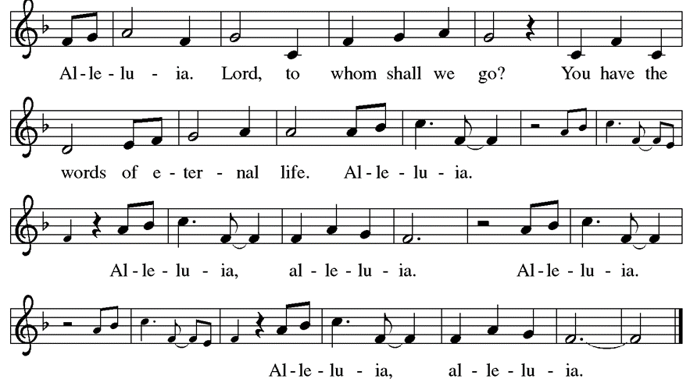

**Gospel Reading: John 15:26-27; 16:4b-15** *While speaking to his disciples before his death, Jesus refers to the Holy Spirit as “the Helper” and describes the difference the Spirit will make in their lives and in the world.*

P: The Holy Gospel According to John. **C: Glory to you, O Lord.**

P: [Jesus said,] 26“When the Advocate comes, whom I will send to you from the Father, the Spirit of truth who comes from the Father, he will testify on my behalf. 27You also are to testify because you have been with me from the beginning.  
 16:4b“I did not say these things to you from the beginning, because I was with you. 5But now I am going to him who sent me; yet none of you asks me, ‘Where are you going?’ 6But because I have said these things to you, sorrow has filled your hearts. 7Nevertheless I tell you the truth: it is to your advantage that I go away, for if I do not go away, the Advocate will not come to you; but if I go, I will send him to you. 8And when he comes, he will prove the world wrong about sin and righteousness and judgment: 9about sin, because they do not believe in me; 10about righteousness, because I am going to the Father and you will see me no longer; 11about judgment, because the ruler of this world has been condemned.  
 12“I still have many things to say to you, but you cannot bear them now. 13When the Spirit of truth comes, he will guide you into all the truth; for he will not speak on his own, but will speak whatever he hears, and he will declare to you the things that are to come. 14He will glorify me, because he will take what is mine and declare it to you. 15All that the Father has is mine. For this reason I said that he will take what is mine and declare it to you.”

P: The Gospel of the Lord. **C: Praise to you, O Christ.**

**Sermon** The Rev. Jeremiah Smith

*Please stand as you are able for Hymn of the Day*

**Hymn of the Day: God of Tempest, God of Whirlwind ELW 400**

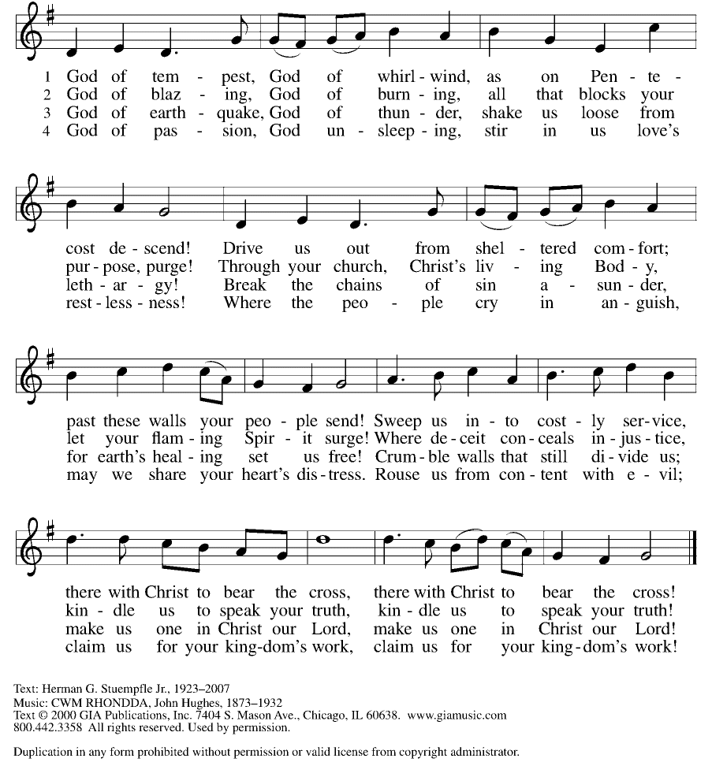

**Prayers of the People**

WA: Rejoicing that Jesus is risen and love has triumphed over fear, let us pray for the church, the world, and all those in need of good news. *(a brief silence)*

WA: We pray for the church universal, for its ministries, and for the spread of the gospel. Shower your Spirit upon Sunday school students, confirmands, especially David L. Macro Jr., and the newly baptized. God of grace, **C: hear our prayer.**

WA: For the nations and those who govern. Give those in authority understanding hearts, that they work together to bring justice and peace on earth. Grant all who vote in elections wisdom and discernment. God of grace,

**C: hear our prayer.**

WA:  For those in need around the world: for victims of crimes, for victims of sexual abuse and exploitation, and for those who are incarcerated. For all who suffer in any way, especially for those whom we name aloud or in the silence of our hearts…. God of grace, **C: hear our prayer**

WA: For this congregation and its ministries; for those who plan and lead worship, for acolytes and communion servers, for readers and tech ministers, for all who prepare and clean our worship space. May our worship be pleasing in your sight. God of grace, **C: hear our prayer.**

WA: We remember the faithful departed. Give us thankful hearts for those who have gone before us in the faith. At the last day, breathe new life into our dry bones, that we might feast forever with all the saints in light. God of grace,

**C: hear our prayer.**

WA: Into your hands, most merciful God, we commend all for whom we pray, trusting in your abiding love; through Jesus Christ, our resurrected and living Lord. **C: Amen.**

**Peace**

P: The peace of Christ be with you always. **C: And also with you.**

**Offering**

We are grateful to those who help sustain our mission. To donate online, please use QR code:



**Offering Music:** *PLC Choir*

***+* Offertory Song“**Praise God From Whom….” *(doxology) ELW 885/3*

*Praise God, from whom all blessings flow; praise God, all creatures here below;*

*praise God above, ye heav’nly host; praise Father, Son, and Holy Ghost. Amen.*

**Offering Prayer**

WA: Let us pray together:

**C: Jesus, Bread of life, you have set this table with your very self, and called us to the feast of plenty. Gather what has been sown among us, and strengthen us in this meal. Make us to be what we receive, your body for the life of the world. Amen.**

**Great Thanksgiving**

P: The Lord be with you. **C: And also with you.**

P: Lift up your hearts. **C: We lift them to the Lord.**

P: Let us give thanks to the Lord our God.

**C: It is right to give our thanks and praise.**

**Preface:**

P: It is indeed right, our duty and our joy, that we should at all times and in all places give thanks and praise to you, almighty and merciful God, through our Savior Jesus Christ. Fulfilling the promise of the resurrection, you pour out the fire of your Spirit, uniting in one body people of every nation and tongue. And so, with Mary Magdalene and Peter and all the witnesses of the resurrection, with earth and sea and all their creatures, and with angels and archangels, cherubim and seraphim, we praise your name and join their unending hymn:

**Holy Holy Holy ELw** setting 8

C:\Users\Admin\Downloads\Holy, holy, holy, ELW Setting Eight (Melody) (1).tif

**Thanksgiving at the Table**

P: In the night in which he was betrayed, our Lord Jesus took bread, and gave thanks; broke it, and gave it to his disciples, saying: Take and eat; this is my body, given for you. Do this for the remembrance of me. Again, after supper, he took the cup, gave thanks, and gave it for all to drink, saying: This cup is the new covenant in my blood, shed for you and for all people for the forgiveness of sin. Do this for the remembrance of me.

**Lord’s Prayer**

P:Lord, remember us in your kingdom and teach us to pray.

**C: Our Father, who art in heaven, hallowed be thy name, thy kingdom come, thy will be done, on earth as it is in heaven. Give us this day our daily bread; and forgive us our trespasses, as we forgive those who trespass against us; and lead us not into temptation, but deliver us from evil. For thine is the kingdom, and the power, and the glory, forever and ever. Amen.**

**Invitation To Communion**

*At Parkside Lutheran Church we have an open table. We believe the invitation to receive comes from Jesus himself and all are welcome at Christ’s table. More than just Bread and Wine these are tangible signs of God’s love for you! If you do not wish to receive communion but would like a blessing, come forward and cross your arms over your chest. The Pastor will give you a blessing before you return to your seat via the side aisle.*

*You’ll receive a communion wafer* in your hands. You may dip it in the cup of wine or juice. When giving the bread and cup, the communion ministers say “*The body of Christ, given for you. The blood of Christ, shed for you.” *and each person may respond :* Amen *Please let Pastor know if you need a gluten-free wafer

P: Christ has set the table with more than enough for all. Come!

**The Communion Distribution**

**Communion Song** ELWsetting 8

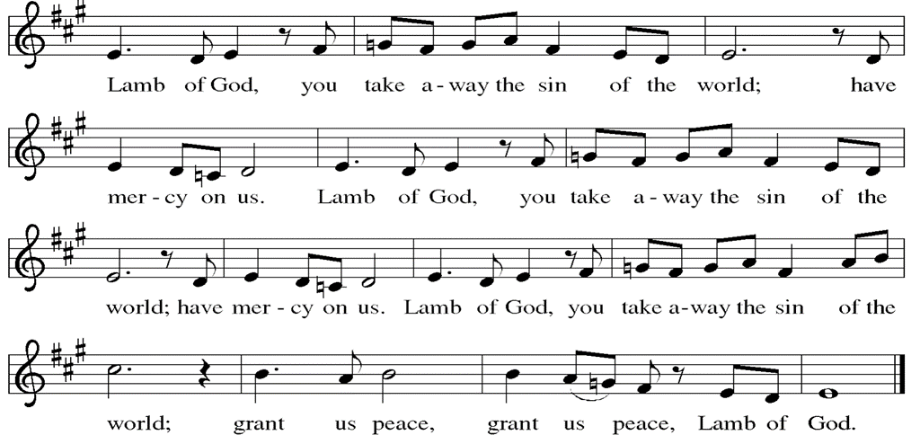

**Communion Song: Sanctuary** *printed next page*

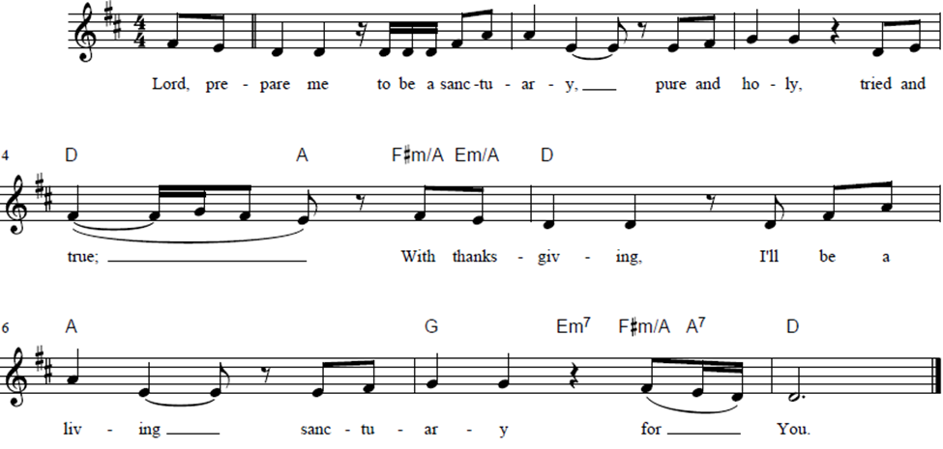

**Post Communion Blessing**

P: The Body and Blood of our Lord and Savior, Jesus Christ, strengthen you and keep you in God's grace. **C: Amen.**

**Prayer After Communion**

WA: Let us pray together.

**C: Jesus, Bread of life, we have received from your table more than we could ever ask. As you have nourished us in this meal, now strengthen us to love the world with your own life. In your name we pray. Amen**

**Confirmation/Affirmation of Baptism:** David L. Macro Jr.

**Presentation**

P: I present David L. Macro Jr. who desires to make public affirmation of his baptism. Let us pray.

Merciful God, we thank you for our sibling David, whom you have made your own by water and the Word in baptism. You have called him to yourself, enlightened him with the gifts of your Spirit, and nourished him in the community of faith. Uphold your servant in the gifts and promises of baptism, and unite the hearts of all whom you have brought to new birth. We ask this in the name of Christ. **Amen.**

**Profession of Faith**

P: I ask you to profess your faith in Christ Jesus,

reject sin, and confess the faith of the church.

P: Do you renounce the devil and all the forces that defy God?

**C: I renounce them.**

P: Do you renounce the powers of this world that rebel against God?

**C: I renounce them.**

P: Do you renounce the ways of sin that draw you from God?

**C: I renounce them.**

P: Do you believe in God the Father?

**C: I believe in God, the Father almighty, creator of heaven and earth.**

P: Do you believe in Jesus Christ, the Son of God?

**C: I believe in Jesus Christ, God’s only Son, our Lord,**

**who was conceived by the Holy Spirit, born of the virgin Mary,**

**suffered under Pontius Pilate, was crucified, died, and was buried;**

**he descended to the dead. On the third day he rose again;**

**he ascended into heaven, he is seated at the right hand of the Father,**

**and he will come to judge the living and the dead.**

P: Do you believe in God the Holy Spirit?

**C: I believe in the Holy Spirit, the holy catholic church, the communion of saints, the forgiveness of sins, the resurrection of the body, and the life everlasting.**

P: You have made public profession of your faith. Do you intend to continue in the covenant God made with you in holy baptism: to live among God’s faithful people, to hear the word of God and share in the Lord’s supper, to proclaim the good news of God in Christ through word and deed, to serve all people, following the example of Jesus, and to strive for justice and peace in all the earth?

***David responds*: I do, and I ask God to help and guide me.**

P: People of God, do you promise to support David and pray for him in his life in Christ? **C: We do, and we ask God to help and guide us.**

P: Let us pray,

We give you thanks, O God, that through water and the Holy Spirit you give us new birth, cleanse us from sin, and raise us to eternal life.

*Pastor may lay both hands on the head of David and say:*

P: Stir up in David the gift of your Holy Spirit: the spirit of wisdom and understanding, the spirit of counsel and might, the spirit of knowledge and the fear of the Lord, the spirit of joy in your presence, both now and forever.

**C: Amen**

*David will stand and face the congregation*

P: Let us rejoice with our new sibling in Christ, David

**C: We rejoice with you in the life of baptism. Together we will give thanks and praise to God and proclaim the good news to all the world.**

**Sending -** *God blesses us and sends us in mission to the world.*

**Blessing**

P: The blessing of God, who provides for us, feeds us, and journeys with us, **+**be upon you now and forever. **C: Amen.**

**Sending Hymn: Joy to the World ELW267**

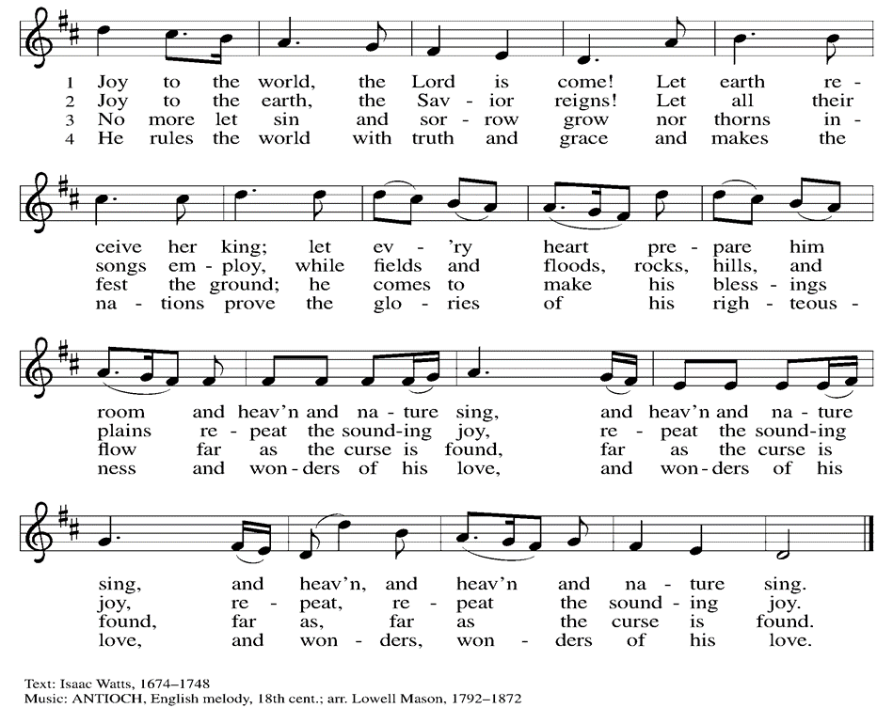

**Dismissal and Postlude**

P: Parkside Lutheran Church is rediscovering the radical love of Jesus.  
**C: Gathering All, Serving All, Caring For All**  
P: Go in peace. You are the body of Christ. **C: Thanks be to God.**

* *Altar Flowers provided by Drew & Lori Hagner.*
* *If you’d like to sponsor Altar flowers or a Soloist, contact the office for more info.*

*ELW Music licensed from Sundays & Seasons, Augsburg Fortress CCLI MUSIC License # 11440069 , CCLI Streaming License#21835523 Do not duplicate any music or Liturgy herein without license and permission*

**PARKSIDE STAFF:**

• The Rev.  Jeremiah Smith: prjeremiahpsmith@gmail.com

• Kris Pope, Office Administrator (Church Office): parksidelutheran@gmail.com

• Mike Hooker, Music Director: [mrhooker@me.com](mailto:mrhooker@me.com)

CHURCH OFFICE HOURS: M/T/R 10:00am-3:00pm   (716)836-1361

**Welcome Visitors!**

Sign up for weekly enewsletter via website parksidelutheran.org.

Find us on Facebook & Instagram

*WIFI: Balcony* password: FreeGrace

**Bathrooms** are on the main level in the office wing (to the right as you exit the Sanctuary, past Stowell lounge) and at the lower level in Atonement Hall. The 2 larger bathrooms on each level have a diaper changing station & supplies. All bathrooms are unisex/gender neutral. Bathroom down the hall from Sanctuary is wheelchair accessible.

**Service is being live-streamed. Find on Facebook or YouTube**

**For your safety in the event of an emergency:** Please note that in addition to the three exits in the back of the sanctuary, there are also exits on either side of the altar (up the stairs to the altar, past the choir seats)

**Coming up:** *(contact office if you need more info – parksidelutheran@gmail.com)*

* **Today** Sun 19th , before Worship -**1st Communion** classes – see Pastor Jeremiah if you’d like your child to participate. Communion celebration Sun, May 26th
* Thursday, May 30th – 7pm – Brewing Theology – new location: Pressure Drop Brewery 1672 Elmwood Ave, Buffalo NY 14207 – All are welcome to join this lively discussion
* Sun June 9th – 100th Anniversary Celebration
* Sun June 30th – Pride Day at Parkside LC

**Prayer Tree:***Congregation*:  For Lina Krolewski, for recovery from surgery; for Susan Bundt and all who mourn the passing of her mother Patricia, For Joan Bauer, who thanks all for their continued prayers; Donna Durkin, and all who mourn the death of her husband; all those who mourn the passing of Jackie Pankow; Shchurowsky family, health; Barbara Herman, health; David Stout; Mo Dolata; Marilynn Horwood; Renee Gaston; Lorri Hagner; Janet Knoell; Fiedler family; Beverly Hirtreiter; Donna Marie *Friends & Family:*Wendelin Family and all who mourn the loss of Philip; For health/healing: Bill Ackley; Jennifer Jaap; Harmony; Tony Nigro; Joe Frank & Patricia Pope; Hannah; Georgianna; Kevin; Jameson; We pray for the church, the world & all in need. *If you would like to add or update a prayer request, please contact the office:*

*email:*[*parksidelutheran@gmail.com,*](mailto:parksidelutheran@gmail.com,)*ph:(716)836-1361, or leave note in collection plate.*

**HELPING OUR NEIGHBORS:**

**North Buffalo Food Pantry** – Open Saturday 9am-1pm – enter on Depew side of building. DASH’s Supermarket receipts are being collected to benefit the Food Pantry. Place them in the small bright green box in the Narthex. *May collection: Canned Veggies*

**Burrito Project:** Every 4th Tuesday of the month, volunteers from Parkside hand out burritos in Downtown Buffalo. Next date 5.28.24. If you’d like to help, contact Alison Smith alisonmsmith07@gmail.com. Thanks for putting love of neighbor into action!

**-------------------------------------------------------------------------------------------------------------**

**From Lutheran Charities of Western NY:**

**Yankees Legends Club Ticket Raffle** Are you a NY Yankees fan or do you know someone who is? Lutheran Charities is offering an opportunity to win four tickets to the Yankees vs the Toronto Blue Jays game at Yankee Stadium on Saturday, Aug. 3, 2024 at 1:05 pm. Your seats will be inside the LEGENDS CLUB at the stadium where you may be joined by Yankees legends such as Alex Rodriguez and Derek Jeter to watch the game. Your tickets will include a private stadium entrance, all-inclusive food and nonalcoholic beverages at the Legends Suite Club, private restrooms in the suite, in-seat wait service and much more. The raffle tickets for this event are $20 each. The drawing will be July 12, 2024 at the Lutheran Charities Golf Classic, and you don’t need to be present to win. See Marilynn Horwood in the narthex after worship to purchase your tickets or go on line to [**www.WNYLutheranCharities.org**](http://www.WNYLutheranCharities.org). GOOD LUCK and thank you for supporting Lutheran Charities and its various community partners!

**Save the Date:** Annual Golf Classic July 12th, Bisons Night at Sahlen Field, August 9th.

-------------------------------------------------------------------------------------------------------------------