**Parkside Lutheran Church**

*Rediscovering the Radical Love of Jesus*

*Gathering All*

*Serving All*

*Caring For All*

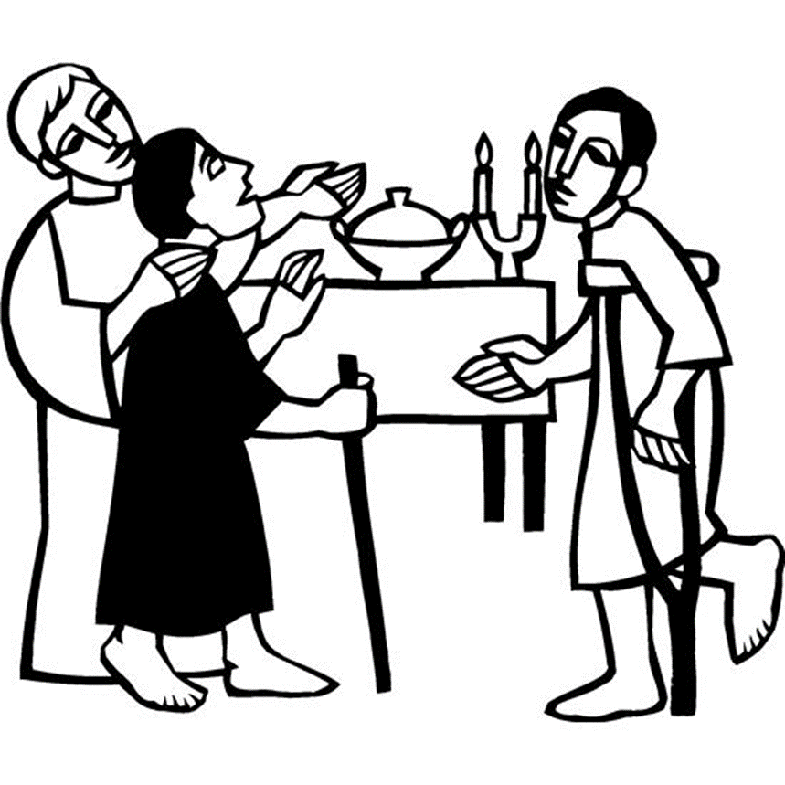

**August 31st, 2025**

**Time after Pentecost**

**Holy Communion 10:00am**

**Rev. Jeremiah Smith**

**Parkside Lutheran Values**

**Proclaiming Grace** - Jesus shared and lived out a message of grace, love, and new life. We believe these promises come from God freely, as a gift for all. We are loved and the Spirit inspires us to share this good news in accessible, relevant, and new ways. *Luke 4:17-19, John 1:16-17, John 3:16-17,* *Ephesians 2:8-9*

**Practicing Hospitality** – Jesus welcomed the little children, broke bread with outcasts, and proclaimed the Good News to all. Whether you are strong in faith, wrestling with doubt, or somewhere in between, we affirm that you are welcome here. Jesus is for everyone. *Leviticus 19:34, Matthew 9:10, Matthew 19:14, Hebrews 13:2*

**Loving Boldly** - Jesus challenged traditions to demonstrate God’s justice and love of neighbor. His compassionate and sacrificial love inspires us to take risks. Striving to follow his command to love neighbor, our ministries serve, transform, and advocate for folks near and far. *Micah 6:8,* *Mark 11:15-17, Luke 10:25-28, John 15:12-13*

**Cultivating Community** - Jesus built communities that transformed lives. We are the body of Christ and we are called to continue this ministry of transformation. Guided by the Holy Spirit, we build connections within and outside of these walls, and with all of God’s creation. *Ecclesiastes 4:9-12, Matthew 28:16-20, 1 Corinthians 12:12-14, Galatians 3:26-29*

**Welcome Visitors!**

**Please use QR code**

**to let us know you were here today or to sign up for our weekly enewsletter**

*or, sign up for weekly enewsletter via website parksidelutheran.org*.

Find us on Facebook & Instagram *WIFI: Balcony* password: FreeGrace

**For your safety in the event of an emergency:** In addition to the three exits in the back of the sanctuary, there are exits on either side of the altar (on left side: floor level near piano *and* up steps past altar. On right side: up steps to the altar, past band area)

***Contact us:*** (716) 836-1361

2 Wallace Ave. Buffalo, NY 14214

*parksidelutheran.org |* [*parksidelutheran@gmail.com*](mailto:parksidelutheran@gmail.com)

**GATHER***The Holy Spirit calls us together as the people of God.*

**Introduction to the Day:** *Invited and inviting—that is the nature of the church. By God’s grace in holy baptism we have a place at Christ’s banquet table. When, by the power of that same Spirit, humility and mutual love continue among us, the church can be more inviting still.*

**Prelude** Michael Hooker, *Music Director*

**Call to Worship** *Please stand as you are able*

WA: Creator God, you call us to hospitality; to give as generously to others as you have given to us.

**C: For there are angels among us.**

WA: Loving God, you call us to give you glory in the compassion we show to one another.

**C: To love without judgment, of ourselves or of others.**

WA: We gather as one Body, seeking to walk in the way you have set for us.

**C: We gather as one Body, to worship the one who is Love.**

**Gathering Hymn: Gather Us In ELW #532**

*(printed next page)*

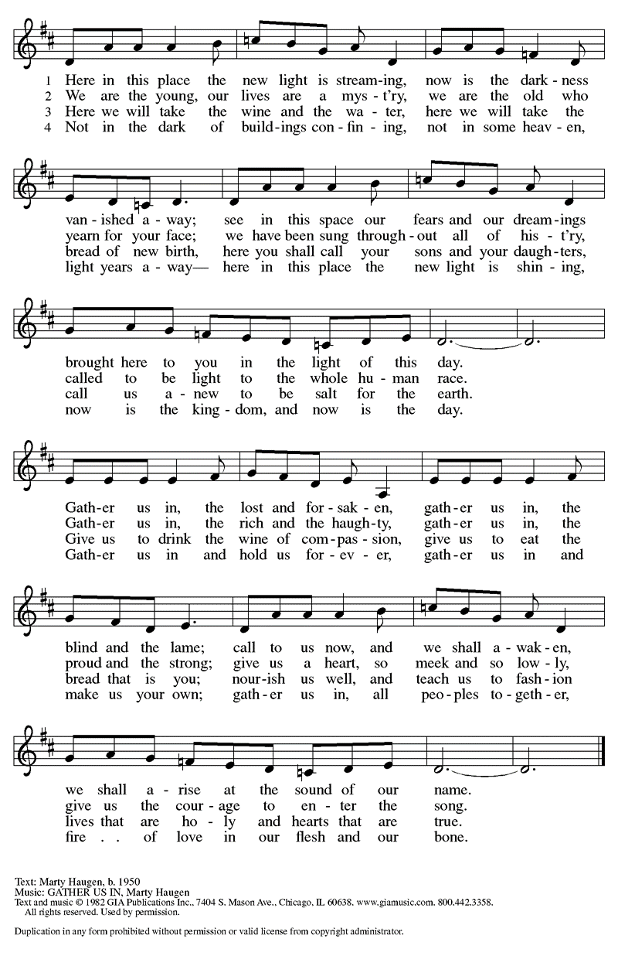

**Welcome and Announcements**

*Please stand as you are able.*

**+Confession and Forgiveness**

P: In the name of the Father, and of the **+**Son, and of the Holy Spirit.

**C: Amen**

P: Baptized into Christ, let us confess our sin. *(a brief silence)*  
P: Merciful God,   
**C: you free us to love others, but we neglect our neighbors and follow our own way. You lead us by the Spirit of joy and peace, but we turn away from the abundant life you offer. You surround us with patience, kindness, and generosity, but we grow weary in doing what is right. In your mercy, forgive us. Do not give up on us. Heal us, break our bonds, and show us the path of life. Amen.**

P: You belong to Christ Jesus and you are God’s children through faith. In the cross of **+**Christ, and through the power of the Holy Spirit, your sins are forgiven. Clothed in Christ, you are a new creation.  **C: Amen**

**Greeting**

WA:The grace of our Lord, Jesus Christ, the love of God, and the communion of the Holy Spirit be with you all. **C:** **And also with you.**

**Hymn of Praise: Lord, I Lift Your Name on High ELW #857***(printed next page)*

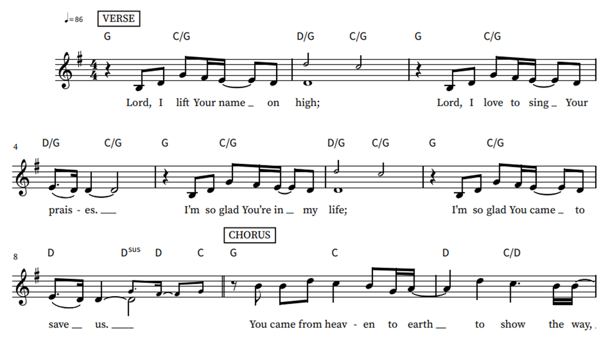

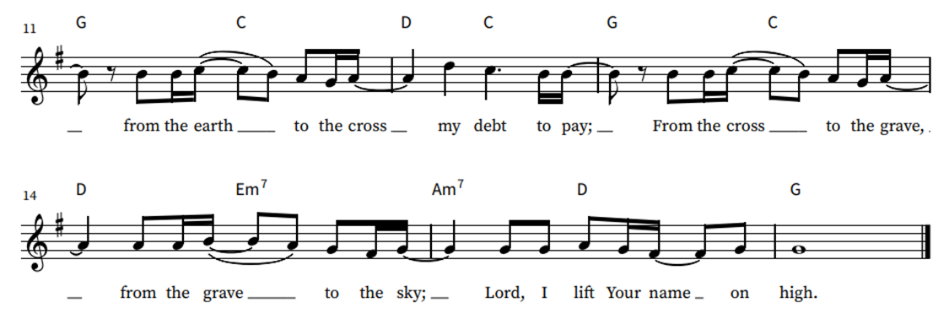



Words & music by Rick Founds, ©1989, Maranatha Praise, Inc., admin. Music Services.

**Prayer of the Day**

WA: Let us pray together.

**C: O God, you resist those who are proud and give grace to those who are humble. Give us the humility of your Son, that we may embody the generosity of Jesus Christ, our Savior and Lord. Amen.**

**Children’s Sermon:** *Jesus said, “Let the little children come to me!”*

*We welcome children in worship.*

**WORD**

*God speaks to us in scripture readings, preaching and song.*

**Psalm: Psalm 112** *The righteous are merciful and full of compassion.  (Ps. 112:4)*

L: 1 Hallelujah! Happy are they who fear the Lord  
  and have great delight in God’s commandments!  
**C:** 2 **Their descendants will be mighty in the land;**  
  **the generation of the upright will be blessed.**  
L: 3 Wealth and riches will be in their house,  
  and their righteousness will last forever.  
**C:** 4 **Light shines in the darkness for the upright;**  
  **the righteous are merciful and full of compassion.**  
L: 5 It is good for them to be generous in lending  
  and to manage their affairs with justice.  
**C:** 6 **For they will never be shaken;**  
  **the righteous will be kept in everlasting remembrance.**   
L: 7 They will not be afraid of any evil rumors;  
  their heart is steadfast, trusting in the Lord.  
**C:** 8 **Their heart is established and will not shrink,**  
  **until they see their desire upon their enemies.**  
L: 9 They have given freely to the poor, and their righteousness stands fast forever;  
   they will hold up their head with honor.  
**C:** 10 **The wicked will see it and be angry; they will gnash their teeth and pine away;**  
   **the desires of the wicked will perish.**

L: Word of God, word of life. **C: Thanks be to God.**

**Reading: Hebrews 13:1-8, 15-16**

The conclusion of the letter to the Hebrews contains suggestions for the conduct of a holy life, all of which are shaped by God’s love toward us in Jesus Christ.

L: 1 Let mutual affection continue. 2 Do not neglect to show hospitality to strangers, for by doing that some have entertained angels without knowing it. 3 Remember those who are in prison, as though you were in prison with them, those who are being tortured, as though you yourselves were being tortured. 4 Let marriage be held in honor by all, and let the marriage bed be kept undefiled, for God will judge the sexually immoral and adulterers. 5 Keep your lives free from the love of money, and be content with what you have, for he himself has said, “I will never leave you or forsake you.” 6 So we can say with confidence,  
 “The Lord is my helper; I will not be afraid. What can anyone do to me?”  
  7 Remember your leaders, those who spoke the word of God to you; consider the outcome of their way of life, and imitate their faith. 8 Jesus Christ is the same yesterday and today and forever. 15 Through him, then, let us continually offer a sacrifice of praise to God, that is, the fruit of lips that confess his name. 16 Do not neglect to do good and to share what you have, for such sacrifices are pleasing to God.

L: Word of God, word of life. **C: Thanks be to God.**

### *Please stand as you are able*

### **+Gospel Acclamation** **ELW** setting 6

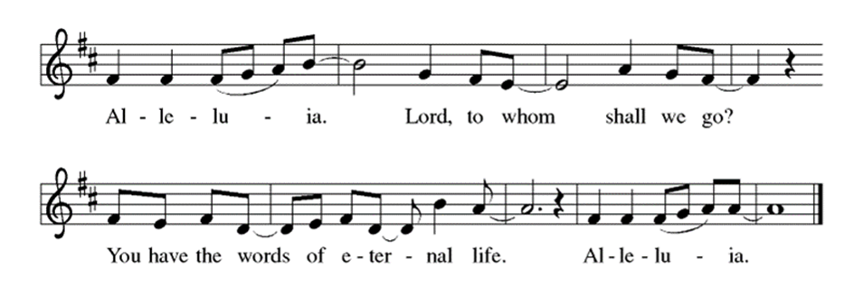

**Gospel Reading: Luke 14:1, 7-14**

Jesus observes guests jockeying for position at the table. He uses the opportunity to teach his hearers to choose humility rather than self-exaltation. Jesus also makes an appeal for hosts to imitate God’s gracious hospitality to those in need.

P: The Holy Gospel According to Luke. **C: Glory to you, O Lord.**

P: 1 On one occasion when Jesus was going to the house of a leader of the Pharisees to eat a meal on the Sabbath, they were watching him closely.  
  7 When he noticed how the guests chose the places of honor, he told them a parable. 8 “When you are invited by someone to a wedding banquet, do not sit down at the place of honor, in case someone more distinguished than you has been invited by your host, 9 and the host who invited both of you may come and say to you, ‘Give this person your place,’ and then in disgrace you would start to take the lowest place. 10 But when you are invited, go and sit down at the lowest place, so that when your host comes, he may say to you, ‘Friend, move up higher’; then you will be honored in the presence of all who sit at the table with you. 11 For all who exalt themselves will be humbled, and those who humble themselves will be exalted.”  
  12 He said also to the one who had invited him, “When you give a luncheon or a dinner, do not invite your friends or your brothers and sisters or your relatives or rich neighbors, in case they may invite you in return, and you would be repaid. 13 But when you give a banquet, invite the poor, the crippled, the lame, and the blind. 14 And you will be blessed because they cannot repay you, for you will be repaid at the resurrection of the righteous.” P: The Gospel of the Lord. **C: Praise to you, O Christ.**

**Sermon** Rev. Jeremiah Smith

*P**lease stand as you are able.*

**Hymn of the Day: O God Beyond All Praising ELW #880**

*(printed next page)*

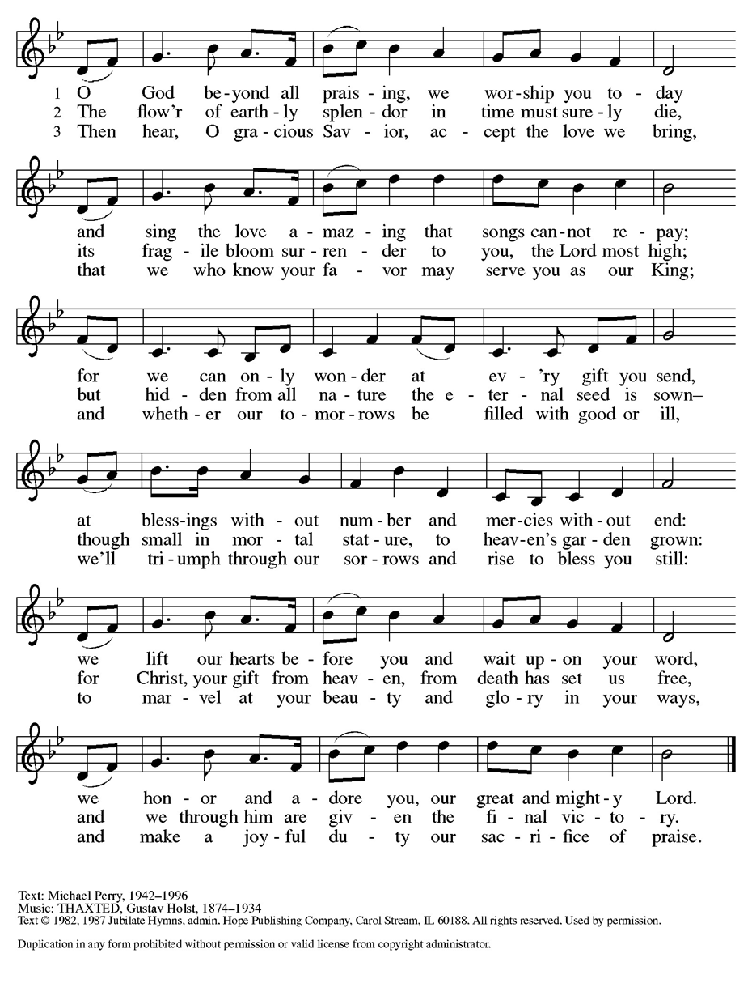

**Apostles Creed**

WA: Let us confess the faith using the words of the Apostles Creed.

**C:  I believe in God, the Father almighty, creator of heaven and earth.**

**I believe in Jesus Christ, God’s only Son, our Lord, who was conceived by the Holy Spirit, born of the virgin Mary, suffered under Pontius Pilate, was crucified, died, and was buried; he descended to the dead. On the third day he rose again; he ascended into heaven, he is seated at the right hand of the Father, and he will come to judge the living and the dead.**

**I believe in the Holy Spirit, the holy catholic church, the communion of saints, the forgiveness of sins, the resurrection of the body, and the life everlasting. Amen.**

**Prayers of the People**  
WA: Let us pray for the church, creation, and the whole people of God, for God is near. *(a brief silence)*

WA: For the leaders of the church, we pray. Inspire deacons, pastors, Sunday school teachers, and Christian education directors with a passion for speaking the word of God. Equip all the baptized to share your word of grace. Hear us, O God.

**C: Your mercy is great.**

WA: For the leaders of towns, cities, provinces, states, and nations, we pray. Guide them to enact equitable laws and policies for all. On this Labor Day weekend, make us mindful of workers whose labor often goes unnoticed. Hear us, O God. **C: Your mercy is great.**

WA: For the lowly and those who are ignored, we pray. Provide for the needs of vulnerable communities, those who are unemployed, burdened by debt or struggle to make ends meet. Accompany all who need reassurance of your loving presence, especially those we name aloud or in the silence of our hearts…. Manifest your healing presence in their midst. Hear us, O God.

**C: Your mercy is great.**

WA: For the hospitality ministries of this congregation, we pray. Give ushes and greeters a spirit of welcome for visitors, and bless the work of those who feed and nourish us. Hear us, O God. **C: Your mercy is great.**

WA: For all the saints who from their labors rest, we give thanks. With them, we offer our sacrifice of praise to you, O God, the same yesterday, today and forever. Hear us, O God. **C: Your mercy is great.**

WA: Confident in God’s presence and promise, we entrust our prayers to the one who always receives them; through Jesus Christ, our wisdom and companion. **C: Amen.**

**Peace**

P: The peace of Christ be with you always. **C: And also with you.**

**Meal**

*God feeds us with the presence of Jesus Christ*

**Offering** *Congregation may be seated*

We are grateful to those who help sustain our mission. To donate online, please use QR code:



**Offering Prayer**

WA: Let us pray together:

**C: Creator God, in your wisdom you bring forth all that is good and the harvest is plentiful. Strengthen us at your table with these gifts of the earth and our labor, that we may work for the good of all; through Jesus Christ, our Savior. Amen.**

*Please stand as you are able*

***+* Offertory Song “**Praise God From Whom….” *(doxology)*

ELW 885 (*music from ELW 883*)

***Praise God, from whom all blessings flow;***

***praise God, all creatures here below;***

***praise God above, ye heav’nly host;***

***praise Father, Son, and Holy Ghost. Amen.***

**GREAT THANKSGIVING**

P: The Lord be with you. **C: And also with you.**

P: Lift up your hearts. **C: We lift them to the Lord.**

P: Let us give thanks to the Lord our God.

**C: It is right to give our thanks and praise.**

**Preface:**

P: It is indeed right, our duty and our joy, that we should at all times and in all places give thanks and praise to you, almighty and merciful God, through our Savior Jesus Christ; who on this day overcame death and the grave, and by his glorious resurrection opened to us the way of everlasting life. And so, with all the choirs of angels, with the church on earth and the host of heaven, we praise your name and join their unending hymn:

**Holy Holy Holy ELw** setting 6

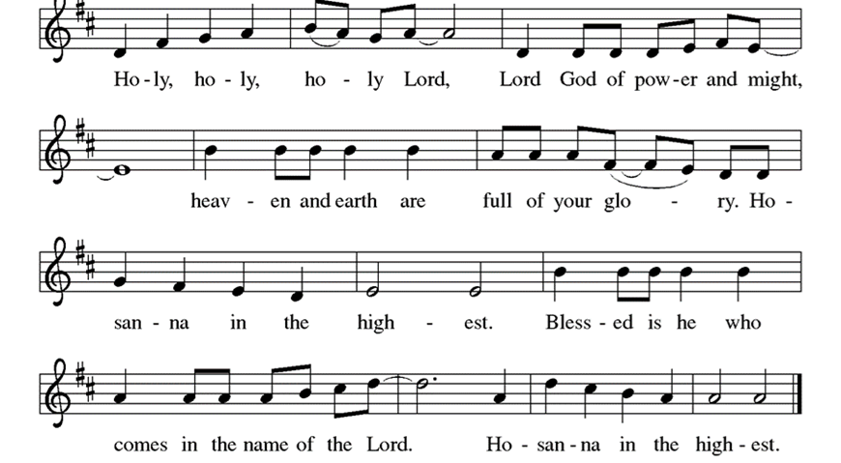

**Thanksgiving at the Table**

P: In the night in which he was betrayed, our Lord Jesus took bread, and gave thanks; broke it, and gave it to his disciples, saying: Take and eat; this is my body, given for you. Do this for the remembrance of me. Again, after supper, he took the cup, gave thanks, and gave it for all to drink, saying: This cup is the new covenant in my blood, shed for you and for all people for the forgiveness of sin. Do this for the remembrance of me.

**Lord’s Prayer**

P:Lord, remember us in your kingdom and teach us to pray.

**C: Our Father, who art in heaven, hallowed be thy name, thy kingdom come, thy will be done, on earth as it is in heaven. Give us this day our daily bread; and forgive us our trespasses, as we forgive those who trespass against us; and lead us not into temptation, but deliver us from evil. For thine is the kingdom, and the power, and the glory, forever and ever. Amen.**

**Invitation to the Table**

*At Parkside Lutheran Church we have an open table. We believe the invitation to receive comes from Jesus himself and all are welcome at Christ’s table. More than just Bread and Wine these are tangible signs of God’s love for you! If you do not wish to receive communion but would like a blessing, come forward and cross your arms over your chest. The Pastor will give you a blessing before you return to your seat via the side aisle. You’ll receive communion bread* in your hands and a small cup containing white wine or grape juice. When giving the bread and cup, the communion ministers say:*

*“*The body of Christ, given for you. The blood of Christ, shed for you.” *and each person may respond :* Amen *Please let Pastor know if you need gluten-free bread

P: The kingdom of God is set before you. Eat and rejoice.

**The Communion Distribution**

**Communion Song** ELWsetting 6

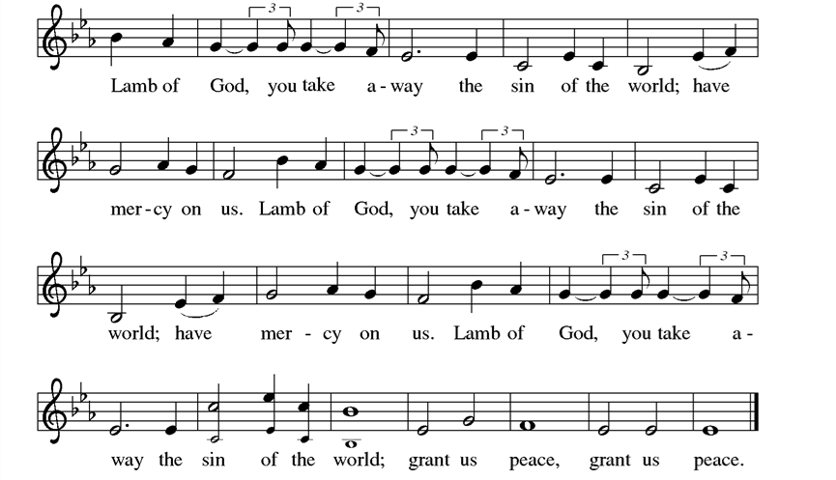

**Communion Song: Thy Word**

***Refrain:* Thy Word is a lamp unto my feet and a light unto my path.**

**Thy Word is a lamp unto my feetand a light unto my path.**

1. **When I feel afraid, and I think I’ve lost my way,**

**still You’re there right beside me.**

**Nothing will I fear as long as You are near.**

**Please be near me to the end. *Refrain***

1. **I will not forget Your love for me, and yet**

**my heart forever is wandering.**

**Jesus, be my guide and hold me to Your side;**

**I will love You to the end *Refrain***

**Communion Song: Sanctuary**

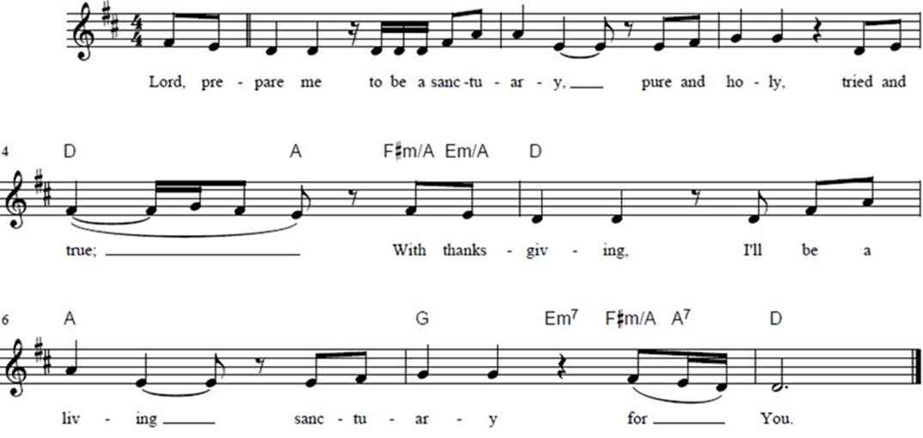

**Post Communion Blessing**

P: The Body and Blood of our Lord and Savior, Jesus Christ, strengthen you and keep you in God's grace. **C: Amen.**

**Prayer After Communion**

WA: Let us pray together.

**C: Mothering God, you gathered us to your table and we drank deeply of your grace. Send us out by your Spirit to love our neighbors as ourselves**

**and proclaim your love in Jesus’ name. Amen.**

**Sending -** *God blesses us and sends us in mission to the world.*

**Blessing**

P: The love of God abound in you; the grace of our Savior Jesus Christ fill your hearts; and the life of the Spirit ☩bless you and give you peace. **C: Amen.**

**Sending Hymn: Hymn Raffle**

**Dismissal and Postlude**

WA: Parkside Lutheran Church is rediscovering the radical love of Jesus.

**C: Gathering All. Serving All. Caring for All.**

WA: Go in peace. Live by the Spirit.

**C: Thanks be to God.**

*ELW Music licensed from Sundays & Seasons, Augsburg Fortress CCLI MUSIC License # 11440069 , CCLI*

*Streaming License#21835523 Do not duplicate any music or Liturgy herein without license and permission*

*To sponsor Altar flowers or a Soloist in honor of a loved one*

*or to mark a special occasion. Contact the office for more info.*

**PARKSIDE STAFF:**

• The Rev.  Jeremiah Smith: prjeremiahpsmith@gmail.com

• Kris Pope & Suzanne Gracie, Admin. Assistants (Church Office): parksidelutheran@gmail.com

• Mike Hooker, Music Director: [mrhooker@me.com](mailto:mrhooker@me.com)

CHURCH OFFICE HOURS: M/T/R 10:00am-3:00pm   (716)836-1361

**SCHEDULES and Events:**

|  |  |  |
| --- | --- | --- |
| Acolytes: |  | Worship Assistants |
| 8/31 – Lucy & Emmet |  | 8/31 - Vince |
| 9/7 – Annalie & Lorenzo |  | 9/7 – Onda |
| Readers: |  | Ushers: |
| 8/31 – Peter |  | 8/31 – Dave C & Sue S |
| 9/7 – John F |  | 9/7 – David H & Bryants |

**Coming up:** *contact office for more info –* [*parksidelutheran@gmail.com*](mailto:parksidelutheran@gmail.com), *(716)836-1361*

* September 7th – Breakfast Church
* September 7th – God’s Work, Our Hands – Distribute Collection Bags for Food Pantry, after Worship
* September 11th – FREE Community Dinner 5 – 6:30pm Atonement Hall
* September 14th – God’s Work, Our Hands – Collect Food Pantry Donations, after Worship
* September 17th – 7pm Brewing Theology at The Garage Bar & Restaurant – RSVP to Marlene by 9/16 - marlene4800@gmail.com
* Harvest House 2025 Baby Shower Collection Drive Begins next week – Needs include Diapers, Wipes, Bottles, Formula, Socks, New or Gently Used Clothing, Towels, Wash Cloths & Baby Wraps. Learn more or donate directly at <https://www.harvesthousebuffalo.org/babyshower2025>
* October 4th – Altar Guild Cleaning Day 9:30am – 12pm
* October 17th – Meat Raffle – VOLUNTEERS NEEDED! Contact Kristen Lenz if you are able to volunteer, donate a raffle item, sponsor a meat round, or buy a table kristenlenz@gmail.com

Detailed announcements and more are found in the e-newsletter. Sign up for e-newsletter on our website parksidelutheran.org or via constant contact with the QR code. You can find the full bulletin in the Worship section of our website www.parksidelutheran.org.