**Parkside Lutheran Church**

*Rediscovering the Radical Love of Jesus*

*Gathering All*

*Serving All*

*Caring For All*

****

***Gratitude > Obedience***

**October 12th, 2025**

**Time after Pentecost**

**Holy Communion 10:00am**

**Rev. Jeremiah Smith**

**Parkside Lutheran Values**

**Proclaiming Grace** - Jesus shared and lived out a message of grace, love, and new life. We believe these promises come from God freely, as a gift for all. We are loved and the Spirit inspires us to share this good news in accessible, relevant, and new ways. *Luke 4:17-19, John 1:16-17, John 3:16-17,* *Ephesians 2:8-9*

**Practicing Hospitality** – Jesus welcomed the little children, broke bread with outcasts, and proclaimed the Good News to all. Whether you are strong in faith, wrestling with doubt, or somewhere in between, we affirm that you are welcome here. Jesus is for everyone. *Leviticus 19:34, Matthew 9:10, Matthew 19:14, Hebrews 13:2*

**Loving Boldly** - Jesus challenged traditions to demonstrate God’s justice and love of neighbor. His compassionate and sacrificial love inspires us to take risks. Striving to follow his command to love neighbor, our ministries serve, transform, and advocate for folks near and far. *Micah 6:8,* *Mark 11:15-17, Luke 10:25-28, John 15:12-13*

**Cultivating Community** - Jesus built communities that transformed lives. We are the body of Christ and we are called to continue this ministry of transformation. Guided by the Holy Spirit, we build connections within and outside of these walls, and with all of God’s creation. *Ecclesiastes 4:9-12, Matthew 28:16-20, 1 Corinthians 12:12-14, Galatians 3:26-29*

**Welcome Visitors!**

**Please use QR code**

**to let us know you were here today or to sign up for our weekly enewsletter**

*or, sign up for weekly enewsletter via website parksidelutheran.org*.

Find us on Facebook & Instagram *WIFI: Balcony* password: FreeGrace

**For your safety in the event of an emergency:** In addition to the three exits in the back of the sanctuary, there are exits on either side of the altar (on left side: floor level near piano *and* up steps past altar. On right side: up steps to the altar, past band area)

***Contact us:*** (716) 836-1361

2 Wallace Ave. Buffalo, NY 14214

*parksidelutheran.org |* [*parksidelutheran@gmail.com*](mailto:parksidelutheran@gmail.com)

**GATHER***The Holy Spirit calls us together as the people of God.*

**Introduction to the Day:** *It’s a miracle! Multiple miracles! The waters of holy baptism have healed us. The body and blood of Jesus in holy communion have made us clean. We have died with Christ and been raised with him. For all this we have returned to offer thanks. From this place we are sent on our way rejoicing to share the good news.*

**Prelude** Michael Hooker, *Music Director*

**Psalm: Psalm 111** *I will give thanks to the Lord with my whole heart.* (Ps. 111:1)

WA: 1 Hallelujah! I will give thanks to the Lord with my whole heart,  
  in the assembly of the upright, in the congregation.  
**C:** 2 **Great are your works, O Lord, pondered by all who delight in them.**   
WA: 3 Majesty and splendor mark your deeds,  
  and your righteousness endures forever.  
**C:** 4 **You cause your wonders to be remembered;**  
  **you are gracious and full of compassion.**  
WA: 5 You give food to those who fear you, remembering forever your covenant.  
**C:** 6 **You have shown your people the power of your works**  
  **in giving them the lands of the nations.**   
WA: 7 The works of your hands are faithfulness and justice;

all of your precepts are sure.  
**C:** 8 **They stand fast forever and ever,**  
  **because they are done in truth and equity.**  
WA: 9 You sent redemption to your people and commanded your covenant forever;  
  holy and awesome is your name.  
**C:** 10 **The fear of the Lord is the beginning of wisdom;**  
  **all who practice this have a good understanding. God’s praise endures forever.** WA: Word of God, word of life. **C: Thanks be to God.**

**Gathering Hymn: 10,000 Reasons ACS # 1097**

*(printed next page)*

**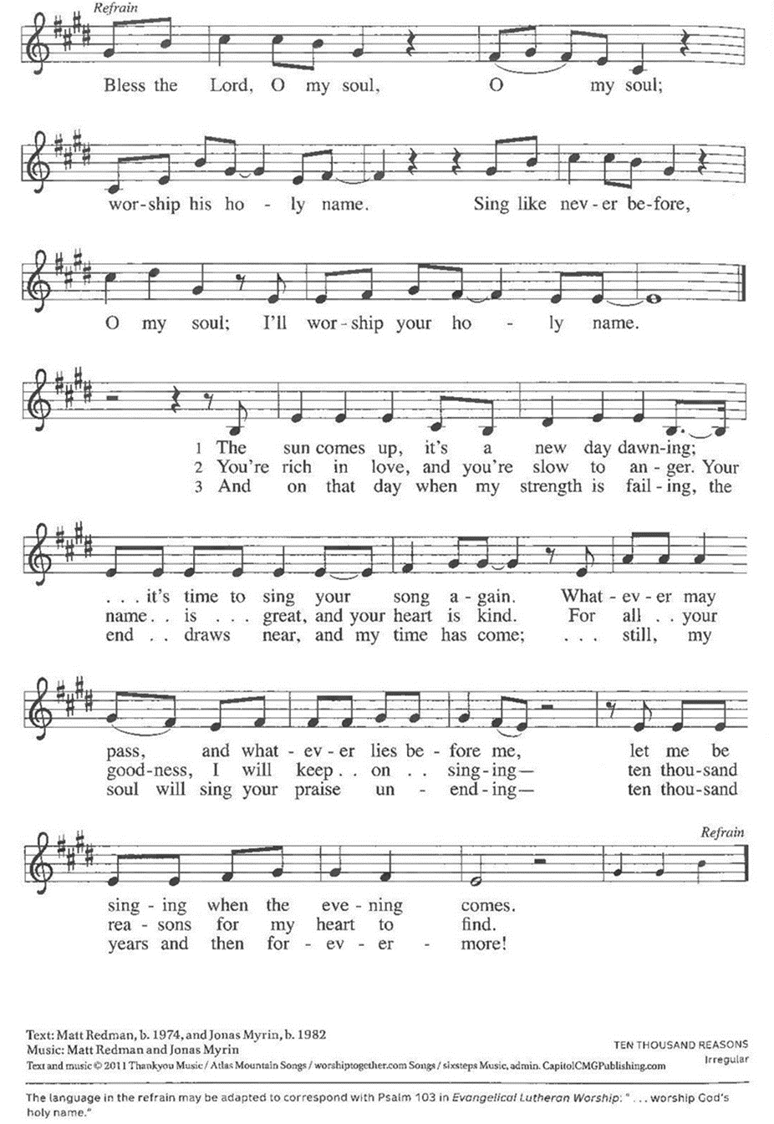**

**Welcome and Announcements**

**+Confession and Forgiveness**

P: Blessed be God the Holy Trinity, **+** the giver of all good, the source of all joy.

**C: Amen.**

P: Let us confess our sin in the presence of God and of one another. *(a brief silence)*  
P: God of all,   
**C: you have given us all that we need and you ask that we share your abundance. We confess that we have not responded to your call to be open channels of your grace. We clench our fists when you ask for open hands; we close our minds when you ask for grace toward our neighbors. Open our hearts to live in the abundance of your creation; loosen our grip and restore our souls, that we may freely give and receive. Amen.**

P: Beloved in Christ, God makes all things new. In the name of Christ, **+** you are forgiven. Your hearts are unfurled; your grasping is unbound. You are free to live as flowing streams of God’s abundant grace. **C: Amen**

**Greeting**

WA:The grace of our Lord, Jesus Christ, the love of God, and the communion of the Holy Spirit be with you all. **C:** **And also with you.**

**Kyrie** setting 8 *(p. 184)*

*(printed next page)*

*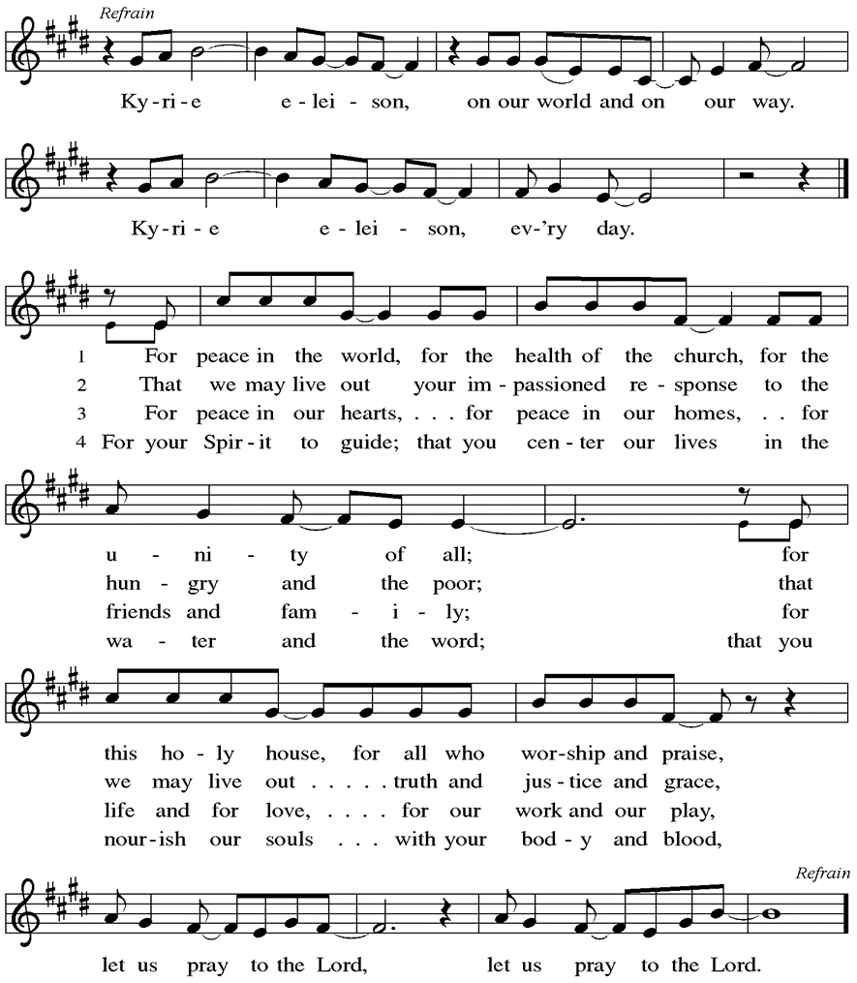*

Words & music by Rick Founds, ©1989, Maranatha Praise, Inc., admin. Music Services.

**Prayer of the Day**

WA: Let us pray together.

**C: God of all, you bless us with the capacity for gratitude and awe. Open to us the wonders of your creation, and make us grateful for every good gift of your hand. Give us glad and generous hearts so that we may be stewards of your mercy and healing in the world. Amen.**

**Children’s Sermon:** *Jesus said, “Let the little children come to me!”*

*We welcome children in worship.*

**WORD**

*God speaks to us in scripture readings, preaching and song.*

**First Reading: Jeremiah 29: 1, 4-7**

1 These are the words of the letter that the prophet Jeremiah sent from Jerusalem to the remaining elders among the exiles and to the priests, the prophets, and all the people whom Nebuchadnezzar had taken into exile from Jerusalem to Babylon. 4 Thus says the Lord of hosts, the God of Israel, to all the exiles whom I have sent into exile from Jerusalem to Babylon: 5 Build houses and live in them; plant gardens and eat what they produce. 6 Take wives and have sons and daughters; take wives for your sons, and give your daughters in marriage, that they may bear sons and daughters; multiply there, and do not decrease. 7 But seek the welfare of the city where I have sent you into exile, and pray to the Lord on its behalf, for in its welfare you will find your welfare.

L: Word of God, word of life. **C: Thanks be to God.**

**Second Reading: 2 Timothy 2:8-15**

*Though Paul is chained as a prisoner, the word of God is never shackled or confined. Timothy is encouraged to proclaim that word of freedom in an honest and upright life as well as in his teaching and preaching.* L: 8 Remember Jesus Christ, raised from the dead, a descendant of David—that is my gospel, 9 for which I suffer hardship, even to the point of being chained like a criminal. But the word of God is not chained. 10 Therefore I endure everything for the sake of the elect, so that they may also obtain the salvation that is in Christ Jesus, with eternal glory. 11 The saying is sure:  
 If we have died with him, we will also live with him;  
 12 if we endure, we will also reign with him;  
 if we deny him, he will also deny us;  
 13 if we are faithless, he remains faithful—  
 he cannot deny himself.  
  14 Remind them of this, and warn them before the Lord that they are to avoid wrangling over words, which does no good but only ruins those who are listening. 15 Do your best to present yourself to God as one approved by him, a worker who has no need to be ashamed, rightly explaining the word of truth. L: Word of God, word of life. **C: Thanks be to God.**

*Please stand as you are able*

**+Gospel Acclamation**  **ELW** setting 8 *(p. 188)*

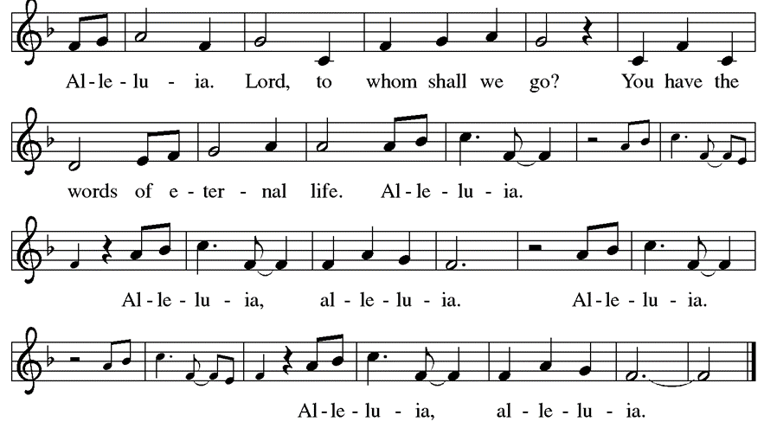

**Gospel Reading: Luke 17:11-19**

Jesus’ mission includes making people clean again. Unexpectedly, a Samaritan healed of leprosy becomes a model for those who would praise and worship God and give thanks for God’s mercy. P: The Holy Gospel according to Luke. **C: Glory to you, O Lord.**

P: 11On the way to Jerusalem Jesus was going through the region between Samaria and Galilee. 12 As he entered a village, ten men with a skin disease approached him. Keeping their distance, 13 they called out, saying, “Jesus, Master, have mercy on us!” 14When he saw them, he said to them, “Go and show yourselves to the priests.” And as they went, they were made clean. 15 Then one of them, when he saw that he was healed, turned back, praising God with a loud voice. 16 He prostrated himself at Jesus’s feet and thanked him. And he was a Samaritan. 17 Then Jesus asked, “Were not ten made clean? So where are the other nine? 18 Did none of them return to give glory to God except this foreigner?”19 Then he said to him, “Get up and go on your way; your faith has made you well.” P: The Gospel of the Lord. **C: Praise to you, O Christ.**

**Sermon** Rev. Jeremiah Smith

*P**lease stand as you are able.*

**Hymn of the Day: Baptized and Set Free ELW #453**

C:\Users\north_000\AppData\Local\Microsoft\Windows\INetCache\Content.Word\Baptized and Set Free (Melody).tif

**Apostles Creed**

WA: Let us confess the faith using the words of the Apostles Creed.

**C:  I believe in God, the Father almighty, creator of heaven and earth.**

**I believe in Jesus Christ, God’s only Son, our Lord, who was conceived by the Holy Spirit, born of the virgin Mary, suffered under Pontius Pilate, was crucified, died, and was buried; he descended to the dead. On the third day he rose again; he ascended into heaven, he is seated at the right hand of the Father, and he will come to judge the living and the dead.**

**I believe in the Holy Spirit, the holy catholic church, the communion of saints, the forgiveness of sins, the resurrection of the body, and the life everlasting. Amen.**

**Prayers of the People**  
WA: Renewed in God’s everlasting grace, let us pray for the church, the world, and all creation. *(a brief silence)*

WA: Gracious God, you lead your people to faith. Remind the church that your word flows into the world. By your Spirit, teach the church to share the word of God for the sake of the world. God of grace, **C: receive our prayer.**

WA: Righteous One, you bring justice and wholeness throughout the world, and your righteousness endures forever. By your spirit, guide leaders of all nations and lands to right relationship with you and with one another.  God of grace,

**C: receive our prayer.**

WA: Merciful God, you know the needs of your people. Show mercy to those suffering in the world. Comfort those in need of your healing, especially those we name aloud or in the silence of our hearts…. God of grace,

**C: receive our prayer.**

WA: Life-giving God, you free us by your word. Help us, by your Spirit, to be transformed to live your word of freedom honestly and uprightly in our teaching, preaching, and serving. God of grace, **C: receive our prayer.**

WA: Holy God, thank you for the witness of those who have died in faith ally). Guide us to trust in the baptismal promise of resurrection in Christ. God of grace, **C: receive our prayer.**

WA: We offer our prayers, O God, trusting in your everlasting grace and mercy, through Jesus Christ our Lord. **C: Amen.**

**Peace**

P: The peace of Christ be with you always. **C: And also with you.**

**Meal**

*God feeds us with the presence of Jesus Christ*

**Offering** *Congregation may be seated*

We are grateful to those who help sustain our mission. To donate online, please use QR code:



**Offering Music:** *“All That We Have” by Gary Ault*

*Faith Journey*

**Offering Prayer**

WA: Let us pray together:

**C: God of life, you have blessed us with every good gift. Open us to share all that we have been given and to love the world in Jesus’ name. Amen.**

*Please stand as you are able*

***+* Offertory Song “We are an Offering”*****ELW 692***

**We lift our voices, we lift our hands, we lift our lives up to you;**

**We are an offering. Lord, use our voices, Lord, use our hands,**

**Lord, use our lives, they are yours; We are an offering.**

**All that we have, all that we are, all that we hope to be-**

**we give to you, we give to you.**

**We lift our voices, we lift our hands, we lift our lives up to you;**

**We are an offering. We are an offering.**

**GREAT THANKSGIVING**

P: The Lord be with you. **C: And also with you.**

P: Lift up your hearts. **C: We lift them to the Lord.**

P: Let us give thanks to the Lord our God.

**C: It is right to give our thanks and praise.**

**Preface:**

P: It is indeed right, our duty and our joy, that we should at all times and in all places give thanks and praise to you, almighty and merciful God, through our Savior Jesus Christ; who on this day overcame death and the grave, and by his glorious resurrection opened to us the way of everlasting life. And so, with all the choirs of angels, with the church on earth and the host of heaven, we praise your name and join their unending hymn:

**Holy Holy Holy ELw** setting 8*(p. 190)*

*(printed next page)*

**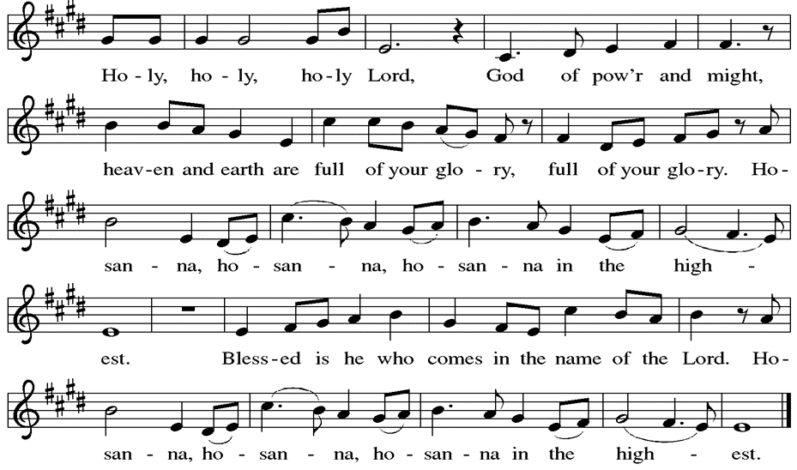**

**Thanksgiving at the Table**

P: Holy God, you alone are holy, you alone are God. The universe declares your praise: beyond the stars; beneath the sea; within each cell; with every breath.

**C: We praise you, O God.**

P: Generations bless your faithfulness: through the water; by night and day; across the wilderness; out of exile; into the future.

**C: We bless you, O God.**

P: We give you thanks for your dear Son: at the heart of human life; near to those who suffer; beside the sinner; among the poor; with us now.

**C: We thank you, O God.**

P: In the night in which he was betrayed, our Lord Jesus took bread, and gave thanks; broke it, and gave it to his disciples, saying: Take and eat; this is my body, given for you. Do this for the remembrance of me. Again, after supper, he took the cup, gave thanks, and gave it for all to drink, saying: This cup is the new covenant in my blood, shed for you and for all people for the forgiveness of sin. Do this for the remembrance of me.

Remembering his love for us on the way, at the table, and to the end, we proclaim the mystery of faith.

**C: Christ has died. Christ is risen. Christ will come again.**

P: We pray for the gift of your Spirit: in our gathering; within this meal; among your people; throughout the world.

Blessing, praise, and thanks to you, holy God, through Christ Jesus, by your Spirit, in your church, without end.

**C: Amen**

**Lord’s Prayer**

P:Lord, remember us in your kingdom and teach us to pray.

**C: Our Father, who art in heaven, hallowed be thy name, thy kingdom come, thy will be done, on earth as it is in heaven. Give us this day our daily bread; and forgive us our trespasses, as we forgive those who trespass against us; and lead us not into temptation, but deliver us from evil. For thine is the kingdom, and the power, and the glory, forever and ever. Amen.**

**Invitation to the Table**

*At Parkside Lutheran Church we have an open table. We believe the invitation to receive comes from Jesus himself and all are welcome at Christ’s table. More than just Bread and Wine these are tangible signs of God’s love for you! If you do not wish to receive communion but would like a blessing, come forward and cross your arms over your chest. The Pastor will give you a blessing before you return to your seat via the side aisle. You’ll receive communion bread\* in your hands and a small cup containing white wine or grape juice. When giving the bread and cup, the communion ministers say:*

*“*The body of Christ, given for you. The blood of Christ, shed for you.” *and each person may respond :* Amen \*Please let Pastor know if you need gluten-free bread

P: Jesus welcomes sinners and eats with them. Come to this meal of mercy.

**The Communion Distribution**

**Communion Song** ELWsetting 8 *(p. 191)*

*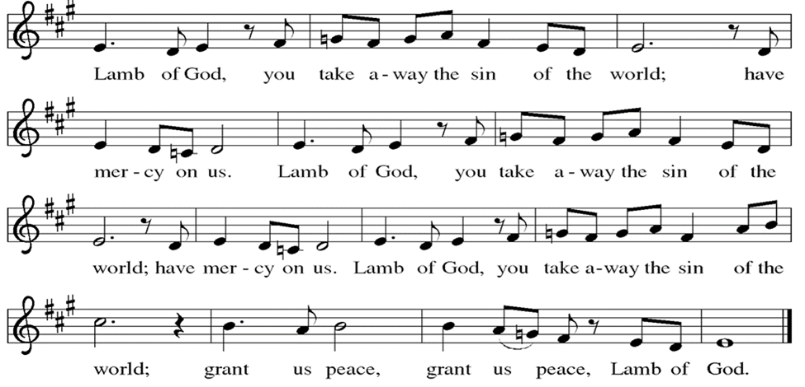*

**Communion Song:** *“Give Thanks” by Henry Smith*

**Communion Song: Sanctuary  
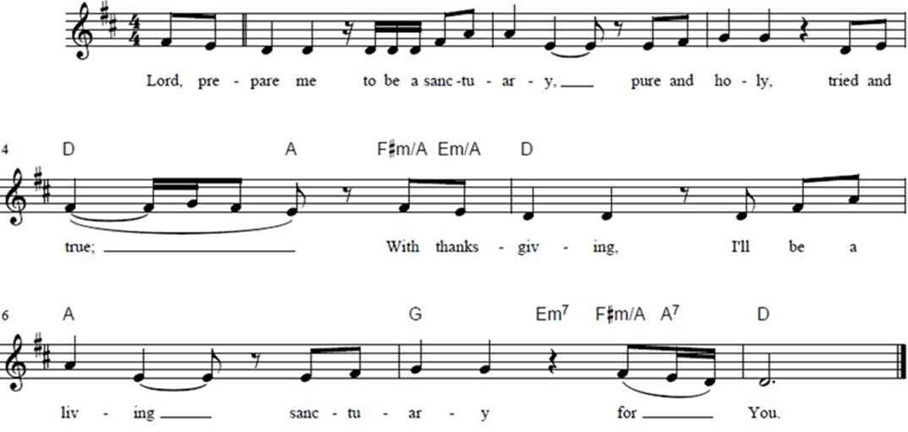**

**Post Communion Blessing**

P: The Body and Blood of our Lord and Savior, Jesus Christ, strengthen you and keep you in God's grace. **C: Amen.**

**Prayer After Communion**

WA: Let us pray together.

**C: Abundant God, you have nourished us with life, love, and grace. Fill us to the brim with your care, that we may go into the world with open arms and open hearts to share your peace with the world. Amen.**

**Sending -** *God blesses us and sends us in mission to the world.*

**Blessing**

P: May God bless you and keep you. May God’s mercy flow freely through you. May you be filled with the abundance of God’s love ☩ and held in God’s peace. **C: Amen.**

**Sending Hymn: Now Thank We All Our God ELW #840***(printed next page)*

C:\Users\north_000\AppData\Local\Microsoft\Windows\INetCache\Content.Word\Now Thank We All Our God (isometric) (Melody).tif

**Dismissal**

WA: Parkside Lutheran Church is rediscovering the radical love of Jesus.

**C: Gathering All. Serving All. Caring for All.**

WA: Go in peace. Do not lose heart.

**C: Thanks be to God.**

**Postlude:** *“Go Out With Joy” by Joe & Leila Huerta*

*ELW Music licensed from Sundays & Seasons, Augsburg Fortress CCLI MUSIC License # 11440069 , CCLI*

*Streaming License#21835523 Do not duplicate any music or Liturgy herein without license and permission*

*To sponsor Altar flowers or a Soloist in honor of a loved one*

*or to mark a special occasion. Contact the office for more info.*

**PARKSIDE STAFF:**

• The Rev.  Jeremiah Smith: prjeremiahpsmith@gmail.com

• Kris Pope & Suzanne Gracie, Admin. Assistants (Church Office): parksidelutheran@gmail.com

• Mike Hooker, Music Director: [mrhooker@me.com](mailto:mrhooker@me.com)

CHURCH OFFICE HOURS: M/T/R 10:00am-3:00pm   (716)836-1361

**SCHEDULES and Events:**

|  |  |  |
| --- | --- | --- |
| Acolytes: |  | Worship Assistants |
| 10/12 – Chris & Katie |  | 10/12 – John |
| 10/19 – Lorenzo & Emmet |  | 10/19 - Susan |
| Readers: |  | Ushers: |
| 10/12 – Josiah |  | 10/12 – David H & Bryants |
| 10/19 – John F |  | 10/19 – Charlie R & Sue S |

**Coming up:** *contact office for more info –* [*parksidelutheran@gmail.com*](mailto:parksidelutheran@gmail.com), *(716)836-1361*

* October 15th – Brewing Theology 7pm – we are back at Steel Leaf Brewing Company
* ***October 17th –*** ***Meat Raffle – Scan the QR Code, or visit the Events Section of our Website to Buy Tickets.***
* October 19th – Intergenerational First Communion Class, after Worship
* October 22nd – Choir Rehearsal at 6pm
* October 25th – Halloween Event 4 – 6pm - ***Donations of Cider, Donut Holes & Hot Cocoa are needed – see sign-up sheet or donate to our “Community & Holiday Events” fund on Tithely ~~>***
* October 26th – Choir Rehearsal at 9:15am
* October 26th – First Communion

**THE 69th Annual CHRISTMAS CANDLELIGHT** **VESPER** will be at First Trinity Lutheran Church on Sunday, December 14th at 5:30 pm (pre-service carol sing at 5 pm).  
**All are welcome to sing in the Vesper Choir!**   
Questions? dwerth@FirstTrinity.com (716) 731-7183  
Rehearsals: Mondays 7:00 – 9:00 pm beginning October 13th   
 Thursdays 1:00 – 3:00 p.m. beginning October 16th.

Detailed announcements and more are found in the e-newsletter. Sign up for e-newsletter on our website parksidelutheran.org or via constant contact with the QR code. You can find the full bulletin in the Worship section of our website www.parksidelutheran.org.