Parkside Lutheran Church
Rediscovering the Radical Love of Jesus
Gathering All
Serving All
Caring For All



November 30th, 2025
First Sunday of Advent
Holy Communion 10:00am
The Rev. Kristen Arends

Parkside Lutheran Values

Proclaiming Grace - Jesus shared and lived out a message of grace, love, and new life. We believe these promises come from God freely, as a gift for all. We are loved and the Spirit inspires us to share this good news in accessible, relevant, and new ways. Luke 4:17-19, John 1:16-17, John 3:16-17, Ephesians 2:8-9

Practicing Hospitality – Jesus welcomed the little children, broke bread with outcasts, and proclaimed the Good News to all. Whether you are strong in faith, wrestling with doubt, or somewhere in between, we affirm that you are welcome here. Jesus is for everyone. Leviticus 19:34, Matthew 9:10, Matthew 19:14, Hebrews 13:2

Loving Boldly - Jesus challenged traditions to demonstrate God’s justice and love of neighbor. His compassionate and sacrificial love inspires us to take risks. Striving to follow his command to love neighbor, our ministries serve, transform, and advocate for folks near and far. Micah 6:8, Mark 11:15-17, Luke 10:25-28, John 15:12-13

Cultivating Community - Jesus built communities that transformed lives. We are the body of Christ and we are called to continue this ministry of transformation. Guided by the Holy Spirit, we build connections within and outside of these walls, and with all of God’s creation. Ecclesiastes 4:9-12, Matthew 28:16-20, 1 Corinthians 12:12-14, Galatians 3:26-29

Welcome Visitors!
Please use QR code
to let us know you were here today or to sign up for our weekly enewsletter
or, sign up for weekly enewsletter via website parksidelutheran.org.
Find us on Facebook & Instagram WIFI: Balcony password: FreeGrace

For your safety in the event of an emergency: In addition to the three exits in the back of the sanctuary, there are exits on either side of the altar (on left side: floor level near piano and up steps past altar. On right side: up steps to the altar, past band area)

Contact us: (716) 836-1361
2 Wallace Ave. Buffalo, NY 14214
parksidelutheran.org | parksidelutheran@gmail.com

GATHER
The Holy Spirit calls us together as the people of God.

In the Time of Herod, We Long for God to Break In

Prelude Michael Hooker, Music Director

Call to Worship
WA: On Sundays and Mondays,
C: on good days and bad days,
WA: early in the morning and very late at night,
C: here in this room, and out in the world, God we long for you to break in.
WA: Meet us in this space.
C: Surprise us with your presence.
WA: Fill this room with your good news.
C: With hope, we sing, we worship, we pray. Amen!

Gathering Hymn: O Come, O Come, Emmanuel verses 1 & 2 ELW 257
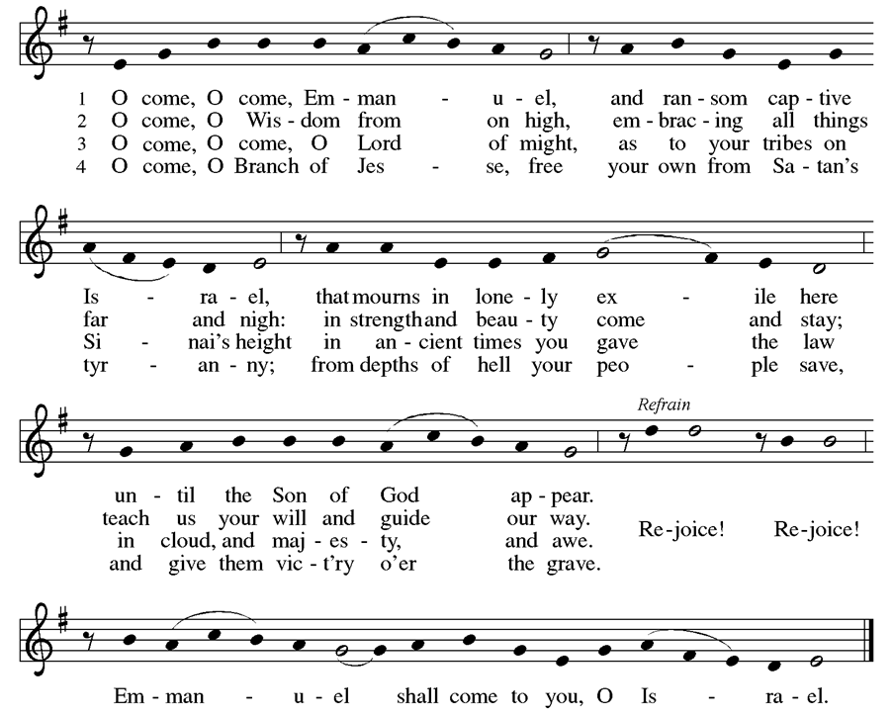
Welcome and Announcements

+Confession and Forgiveness
P: Friends, if you long to feel closer to God, then the prayer of confession is a step in the right direction. For in the prayer of confession, we lay our hearts before God. We pour out the truth of our lives. We do not hide anything from our Creator, and in that simple act, God somehow always feels closer. So, join me in this prayer. Join me as we invite God to draw closer to break in here. (a brief silence)
P: Ever-present God,
C: we long to feel you close. We long to feel your presence in our lives. We long for you to break through the chaos and suffering of this world. However, if we’re honest, we rarely stand still long enough to feel you in our midst. Forgive our rushing and distractions. Forgive our wandering hearts, and center us in this space. Remind us that even in the time of Herod, even on the longest nights, you are always there. Amen. P: Family of faith, even when we doubt God’s presence, even when we fail to notice God’s fingerprints in this world, God is always moving closer to us. Hear and believe the good news this Advent season.
C: Nothing can keep God’s love away. We are seen. We are forgiven. We are not alone. Amen.

Greeting
WA: The grace of our Lord, Jesus Christ, the love of God, and the communion of the Holy Spirit be with you all. C: And also with you.

Prayer of the Day
WA: Let us pray together.
C: With-us God, in the time of Moses, you spoke through water in the desert and a pillar of smoke. In the time of the judges, you spoke through the prophets. In the time of Herod, you spoke through angel choruses and unlikely miracles. In every time you have been speaking. So today, in our time, we ask that you would speak again. Break through the chatter and the distraction of our weary minds and speak to us once more. With hope we pray. Amen.

+Lighting of the Advent Wreath
P: In a world full of fear, where do you see hope?
C: We see hope when we look to the next generation. We feel hopeful when we gather together. We know hope, deep in our bones, when we dream of a better world.
P: You are right. Even in a fearful world, hope is all around us. Today we light the candle of hope as a reminder of this good news. May this flicker of light help us remember that we have reason to hope.
C: Thanks be to God! Amen.

Song: Advent Wreath Hymn (tune: Away in a Manger)
A candle is burning, a flame warm and bright;
A candle of Hope in the winter’s dark night.
While angels sing blessings from heav’n’s starry sky
Our hearts we prepare now, for Jesus is nigh.
Children’s Sermon: Jesus said, “Let the little children come to me!”
We welcome children in worship.
WORD
God speaks to us in scripture readings, preaching and song.

“In the Time of Herod”
L: I didn’t live during Herod’s time—that brutal, murderous king, God save his soul.
But even hundreds of years later, I know the prayers of his people.
I know the prayer of the mothers and children under his rule.
I know the prayer of the young men under his angry arm.
I know their prayers, because anyone who has ever lived in this soft world for more than two days knows how to pray for a miracle.
We rub our hands together.
We fold weary shoulders in,
a cage of bone to protect our bleeding hearts.
We sing, we shall overcome and bind my wandering heart to thee.
We walk across bridges and in front of powerful buildings
We cover our cars in stickers that scream, we will not give up!
We allow a hungry cry to slip from our lips,
giving our lament a life of its own (with room to dance!)
And when all of that is said and done, we whisper to our creator,
God, break through the yelling and the fear. Break through the violence and the oppression.

Get past the Herods of this world, and come be here.
Like every bleeding heart before, we pray for a miracle.

Reading: Lamentations 3:55-57
L: ⁵⁵ I called on your name, O Lord, from the depths of the pit; ⁵⁶ you heard my plea, “Do not close your ear to my cry for help, but give me relief!” ⁵⁷ You came near when I called on you; you said, “Do not fear!”
L: Word of God, word of life. C: Thanks be to God.

Please stand as you are able

+Gospel Acclamation ELW setting 4 (p. 151)

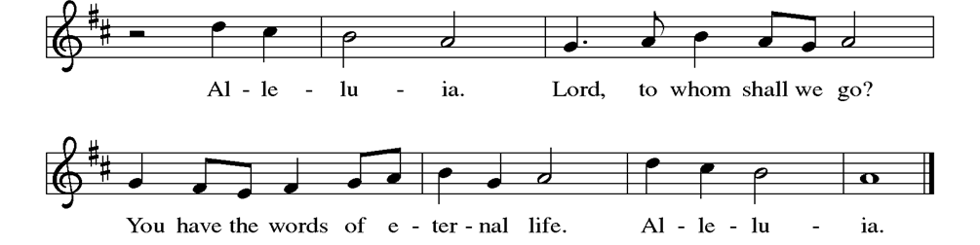

Gospel Reading: Luke 1:5-13
P: The Holy Gospel according to Luke. C: Glory to you, O Lord.
P: ⁵ In the days of King Herod of Judea, there was a priest named Zechariah, who belonged to the priestly order of Abijah. His wife was descended from the daughters of Aaron, and her name was Elizabeth. ⁶ Both of them were righteous before God, living blamelessly according to all the commandments and regulations of the Lord. ⁷ But they had no children because Elizabeth was barren, and both were getting on in years.
⁸ Once when he was serving as priest before God during his section’s turn of duty, ⁹ he was chosen by lot, according to the custom of the priesthood, to enter the sanctuary of the Lord to offer incense. ¹⁰ Now at the time of the incense offering, the whole assembly of the people was praying outside. ¹¹ Then there appeared to him an angel of the Lord, standing at the right side of the altar of incense. ¹² When Zechariah saw him, he was terrified, and fear overwhelmed him. ¹³ But the angel said to him, “Do not be afraid, Zechariah, for your prayer has been heard. Your wife Elizabeth will bear you a son, and you will name him John. P: The Gospel of the Lord. C: Praise to you, O Christ.

Sermon The Rev. Kristen Arends

Please stand as you are able.

Hymn of the Day: Come, Thou Long Expected Jesus ELW # 254

Affirmation of Faith

WA: Let us join together in the Affirmation of Faith.
C: We have seen the valley. We have seen a sky without stars. We have seen the longest night, and still we believe.
We believe in a with-us God. We believe in the hope of tomorrow. We believe that good news is louder than fear. We believe this good news is for all people.
So even when our knees shake, even when our voice trembles, even when fear is all around us, we will hold onto that good news.
We will reach for each other. We will look for God in our midst. We will sing songs of joy. We will proclaim: Unto us, love is born.
We have seen the longest night, and we have seen unimaginable love. So still, we believe. Amen.

Prayers of the People
WA: In our waiting and watching, we come to you in prayer, O God, trusting your promise to renew the church, the nations, and the whole creation. (a brief silence)

WA: In-breaking God, every time we read the story of Zechariah in the temple, we remember that you are a God that draws near. You are a God that breaks into the messy middle of our lies to offer hope, love and good news. You are a God who sees our fears and offers words of comfort. God of grace, C: hear our prayer.
WA: So once more, present God, we bow our heads. Once more we quiet the racing thoughts in our minds. Once more we allow our spirits to lean toward you like trees in the wind. And as we do, we bring you our prayers. God of grace,
C: hear our prayer.

WA: God, today we are grateful for the many amazing things in this world that leave us speechless. Thank you for the beauty of nature as we welcome a new season. Thank you for the contagious joy of children. Thank you for homemade meals and the kindness of strangers. It can be hard to put into words who grateful we truly are. God of grace, C: hear our prayer.

WA: However, in addition to prayers of gratitude, gracious God, we also bring you prayers of grief. We know that Zechariah and Elizabeth were no strangers to grief and longing. We know that for years they prayed for a child that never came. So this morning we also pray for those, who like them, have longed for children and found grief instead. God, we lift up the members of this community who have walked similar journeys of infertility. We pray for those who lie in hospital beds, desperate for good news. We pray for those who cannot put food on the table and wonder how they’ll keep the lights on. We pray for children that feel overlooked, and for adults that feel heartbreakingly alone. We pray especially for those whom we name aloud or in the silence of our hearts…. God of grace, C: hear our prayer.

WA: God, the hurt and longing in this world is enough to leave us speechless. So just as you did for Zechariah, speak to us. Remind us that we are not alone and that our prayers have been heard. God of grace, C: hear our prayer.

WA: Draw near to us, O God, as we commend all for whom we pray, trusting in your mercy through Jesus Christ, Emmanuel. C: Amen.

Peace
P: The peace of Christ be with you always. C: And also with you.

Meal
God feeds us with the presence of Jesus Christ

Offering Congregation may be seated
We are grateful to those who help sustain our mission. To donate online, please use QR code:


Offering Prayer
WA: Let us pray together:
C: Nourishing God, you are water in the wilderness and streams in the desert. Through this meal, satisfy our parched places, that we may rejoice and be for the world signs of your kingdom come. Amen.

Please stand as you are able

+ Offertory Song “We are an Offering” ELW 692
We lift our voices, we lift our hands, we lift our lives up to you;
We are an offering. Lord, use our voices, Lord, use our hands,
Lord, use our lives, they are yours; We are an offering.
All that we have, all that we are, all that we hope to be-
we give to you, we give to you.
We lift our voices, we lift our hands, we lift our lives up to you;
We are an offering. We are an offering.

GREAT THANKSGIVING
P: The Lord be with you. C: And also with you.
P: Lift up your hearts. C: We lift them to the Lord.
P: Let us give thanks to the Lord our God.
C: It is right to give our thanks and praise.

PREFACE:
P: It is indeed right, our duty and our joy, that we should at all times and in all places give thanks and praise to you, almighty and merciful God, through our Savior Jesus Christ. You comforted your people with the promise of a Redeemer, through whom you will also make all things new in the day when he comes to judge the world in righteousness. And so, with all the choirs of angels, with the church on earth and the host of heaven, we praise your name and join their unending hymn:

Holy Holy Holy ELW setting 4 (p. 153)
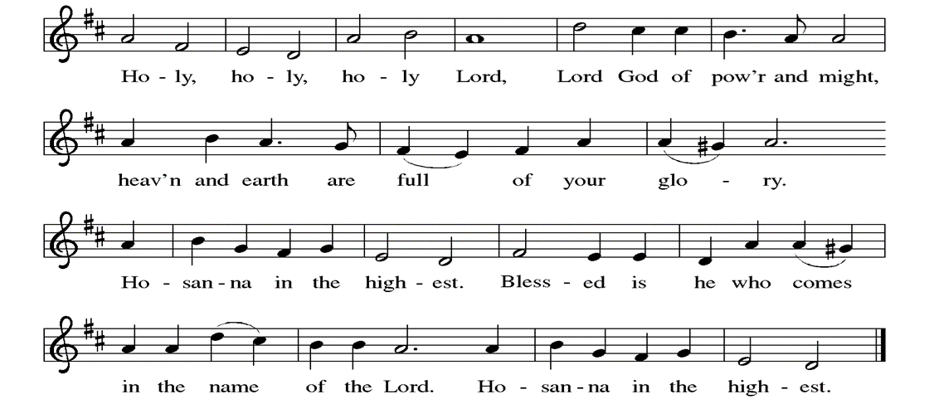

Great Prayer of Thanksgiving
P: With-us God, we live in a fearful world. If we’re honest, we come to this table today with the taste of fear on our tongues. We come to this table carrying our anxiety. We come to this table asking for guidance. We come to this table with all of life’s “what-ifs.”
But you do not disregard our fear. You do not brush it under the rug or call us foolish. You do not ignore the realities in front of us. You do not dish out hurtful platitudes, telling us to “toughen up” or “power through.”
Instead, you meet us here. You listen to our fears. You remind us that we are not alone. You surround us with people who love us. You show us where we are strong. You walk beside us. And you give us a new song to sing.
In the night in which he was betrayed, our Lord Jesus took bread, and gave thanks; broke it, and gave it to his disciples, saying: Take and eat; this is my body, given for you. Do this for the remembrance of me. Again, after supper, he took the cup, gave thanks, and gave it for all to drink, saying: This cup is the new covenant in my blood, shed for you and for all people for the forgiveness of sin. Do this for the remembrance of me.
Today we pray, gracious God: replace the fear on our tongues with words of hope and songs of joy. As we come to this table, remind us that even in a fearful world, you are on the move. Remind us that even in a fearful world, you are here, inviting us to this table, nourishing our spirits, reminding us that we belong, calling us by name.
Instill that good news in us, for this is a joyful feast. Fear is not the loudest voice today. What a gift that is.
Now with hope for a better tomorrow, we pray in your Son’s name. C: Amen

Lord’s Prayer
P: Lord, remember us in your kingdom and teach us to pray.
C: Our Father, who art in heaven, hallowed be thy name, thy kingdom come, thy will be done, on earth as it is in heaven. Give us this day our daily bread; and forgive us our trespasses, as we forgive those who trespass against us; and lead us not into temptation, but deliver us from evil. For thine is the kingdom, and the power, and the glory, forever and ever. Amen.

Invitation to the Table
P: Friends, did you ever have a moment growing up when you walked into the school cafeteria, panned the faces in the crowd, and wondered if you were going to have a place to sit?
Did you ever have a moment, maybe as a new student or at the start of a new school year, when fear nibbled at the back of your mind because you weren’t sure where you belonged?
I image, at some point or another, most of us have experienced that kind of fear. But here at this table, you never have to wonder.
Here at this table, there is enough room, enough food, enough love for everyone. Here at this table, Jesus is standing up on his chair, waving his hands over his head, saying to each of you, “I saved you a seat!” Here at this table, you are wanted and welcomed. You are safe and loved. Here at this table, you belong.
So my friends, there is no need for fear here, for this is a joyful feast. And you are invited. Come. All are welcome.

At Parkside Lutheran Church we have an open table. We believe the invitation to receive comes from Jesus himself and all are welcome at Christ’s table. More than just Bread and Wine these are tangible signs of God’s love for you! If you do not wish to receive communion but would like a blessing, come forward and cross your arms over your chest. The Pastor will give you a blessing before you return to your seat via the side aisle. You’ll receive a communion wafer* in your hands. You may dip it in the cup of wine or juice. When giving the bread and cup, the communion ministers say:
“The body of Christ, given for you. The blood of Christ, shed for you.”
and each person may respond : Amen
*Please let Pastor know if you need gluten-free bread.

The Communion Distribution
Communion Song ELW setting 4 (p. 154)
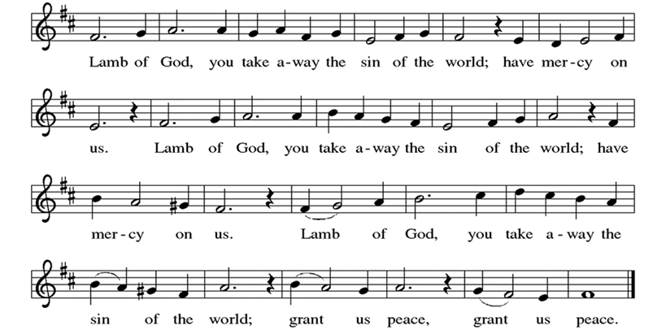

Communion Song: Wait for the Lord ELW #262
Post Communion Blessing
P: The Body and Blood of our Lord and Savior, Jesus Christ, strengthen you and keep you in God's grace. C: Amen.

Prayer After Communion
WA: Let us pray together.
C: Loving God, in a world racked with fear, you gather us together. You set the table. You meet us here. You nourish our bodies as you nourish our spirits. You remind us that this is a joyful feast, and that fear cannot win every time. So with renewed courage, with renewed hope, with renewed conviction, send us out into the world. Help us to feed others as you have fed us. With gratitude we pray. Amen.
Sending - God blesses us and sends us in mission to the world.

Blessing
P: May God who comes among us, Father, ☩ Son, and Holy Spirit, grant you patience in waiting, peace in the darkness, and good news to share today and always. C: Amen.

Sending Hymn: Freedom is Coming
(printed next page)
Dismissal and Postlude
WA: Parkside Lutheran Church is rediscovering the radical love of Jesus.
C: Gathering All. Serving All. Caring for All.
WA: Go in peace. Keep awake.
C: Thanks be to God.

ELW Music licensed from Sundays & Seasons, Augsburg Fortress CCLI MUSIC License # 11440069 , CCLI
Streaming License#21835523 Do not duplicate any music or Liturgy herein without license and permission

PARKSIDE STAFF:
• The Rev. Jeremiah Smith: prjeremiahpsmith@gmail.com
• Kris Pope & Suzanne Gracie, Admin. Assistants (Church Office): parksidelutheran@gmail.com
• Mike Hooker, Music Director: mrhooker@me.com
CHURCH OFFICE HOURS: M/T/R 10:00am-3:00pm (716)836-1361

SCHEDULES and Events:
Acolytes: |  | Worship Assistants
11/30 – Lucy & Emmet |  | 11/30 – Vince
12/7 – Chris & Katie |  | 12/7 - Onda
Readers: |  | Ushers:
11/30 – Josiah |  | 11/30 – Charlie R. & Bryants
12/7 – John F |  | 12/7 – Dave C & Tom S

Coming up: contact office for more info – parksidelutheran@gmail.com, (716)836-1361
- December 5th & 19th – Middle School Game Night 7pm – Stowell Lounge
- December 17th – Brewing Theology at Steel Leaf Brewing 7pm
- December 21st - Christmas Pageant 10am & Longest Night Service 5pm
- December 24th – Christmas Eve Family Service 10am & Candle Light Service 10pm
- December 28th – Lessons & Carols 10am
- January 3rd – Holiday Hayride 4pm – 7pm

Visit our website for more information about these and other Events at Parkside – www.parksidelutheran.org/events



Sponsor Poinsettias for the Sanctuary & Honor your loved ones.
Orders are due by December 7th. Use the attached order form, or fill out the online form which can be found by scanning the QR Code ~~>

