Parkside Lutheran Church
Rediscovering the Radical Love of Jesus
Gathering All
Serving All
Caring For All



The Good News is
Together, the Impossible is Possible

March 8th, 2026
Third Sunday in Lent
Holy Communion 10:00am
The Rev. Kristen Arends
Parkside Lutheran Values

Proclaiming Grace - Jesus shared and lived out a message of grace, love, and new life. We believe these promises come from God freely, as a gift for all. We are loved and the Spirit inspires us to share this good news in accessible, relevant, and new ways. Luke 4:17-19, John 1:16-17, John 3:16-17, Ephesians 2:8-9

Practicing Hospitality – Jesus welcomed the little children, broke bread with outcasts, and proclaimed the Good News to all. Whether you are strong in faith, wrestling with doubt, or somewhere in between, we affirm that you are welcome here. Jesus is for everyone. Leviticus 19:34, Matthew 9:10, Matthew 19:14, Hebrews 13:2

Loving Boldly - Jesus challenged traditions to demonstrate God’s justice and love of neighbor. His compassionate and sacrificial love inspires us to take risks. Striving to follow his command to love neighbor, our ministries serve, transform, and advocate for folks near and far. Micah 6:8, Mark 11:15-17, Luke 10:25-28, John 15:12-13

Cultivating Community - Jesus built communities that transformed lives. We are the body of Christ and we are called to continue this ministry of transformation. Guided by the Holy Spirit, we build connections within and outside of these walls, and with all of God’s creation. Ecclesiastes 4:9-12, Matthew 28:16-20, 1 Corinthians 12:12-14, Galatians 3:26-29

Welcome Visitors!
Please use QR code
to let us know you were here today or to sign up for our weekly enewsletter
or, sign up for weekly enewsletter via website parksidelutheran.org.
Find us on Facebook & Instagram WIFI: Balcony password: FreeGrace

For your safety in the event of an emergency: In addition to the three exits in the back of the sanctuary, there are exits on either side of the altar (on left side: floor level near piano and up steps past altar. On right side: up steps to the altar, past band area)

Contact us: (716) 836-1361
2 Wallace Ave. Buffalo, NY 14214
parksidelutheran.org | parksidelutheran@gmail.com
GATHER
The Holy Spirit calls us together as the people of God.

Prelude Michael Hooker, Music Director

Call to Worship
WA: If you need good news,
C: settle into this space. We have good news to share.
WA: If you need a word of hope,
C: then trust us when we say, there is hope enough to go around.
WA: If you need a glimmer of joy,
C: then you’re in luck! We have resilient joy abounding.
WA: If you need to feel God’s presence in your midst,
C: then know that this is God’s house.
WA: This is the good news of the gospel.
C: God is here. Love is real. Joy is on the move. Let us worship our with-us God!

+Gathering Hymn: Tree of Life and Awesome Mystery ELW #334
v. 1-3 and Lent 3

Lent 3: Living Water of salvation,
be the fountain of each soul;
springing up in new creation,
flow in us and make us whole.
Flow in us and make us whole.

Welcome and Announcements

Holy Baptism: Ezra Jude Smith ELW p. 227

P: God, who is rich in mercy and love, gives us a new birth into a living hope through the sacrament of baptism. By water and the Word God delivers us from sin and death and raises us to new life in Jesus Christ. We are united with all the baptized in the one body of Christ, anointed with the gift of the Holy Spirit, and joined in God's mission for the life of the world.
P: Who do you present to be baptized? Sponsors: We present Ezra for baptism.

P: Called by the Holy Spirit, trusting in the grace and love of God, as his parents, do you desire to have Ezra baptized into Christ? Parents: We do.

P: As you bring him to receive the gift of baptism, you are entrusted with responsibilities: to live with him among God's faithful people, bring him to the word of God and the holy supper, teach him the Lord's Prayer, the Creed, and the Ten Commandments, place in his hands the holy scriptures, and nurture him in faith and prayer, so that he may learn to trust God, proclaim Christ through word and deed, care for others and the world God made, and work for justice and peace.

P: Do you promise to help Ezra grow in the Christian faith and life?
Parents: We do.

P: Sponsors, do you promise to nurture Ezra in the Christian faith as you are empowered by God's Spirit, and to help him live in the covenant of baptism and in communion with the church? Sponsors: We do.

P: People of God, do you promise to support Ezra and pray for him in his new life in Christ? C: We do.

+ Profession of Faith
P: All together as the people of God, I ask you to profess your faith in Christ Jesus, reject sin, and confess the faith of the church.

P: Do you renounce the devil and all the forces that defy God?
C: We renounce them.

P: Do you renounce the powers of this world that rebel against God?
C: We renounce them.

P: Do you renounce the ways of sin that draw you from God?
C: We renounce them.

P: Do you believe in God the Father?
C: I believe in God, the Father almighty, creator of heaven and earth.
P: Do you believe in Jesus Christ, the Son of God?
C: I believe in Jesus Christ, God's only Son, our Lord, who was conceived by the Holy Spirit, born of the virgin Mary, suffered under Pontius Pilate, was crucified, died, and was buried; he descended to the dead.* On the third day he rose again; he ascended into heaven, he is seated at the right hand of the Father, and he will come to judge the living and the dead.

P: Do you believe in God the Holy Spirit?
C: I believe in the Holy Spirit, the holy catholic church, the communion of saints, the forgiveness of sins, the resurrection of the body, and the life everlasting.

Thanksgiving at the Font
P: The Lord be with you. C: And also with you.
P: Let us give thanks to the Lord our God.
C: It is right to give our thanks and praise.

P: We give you thanks, O God, for in the beginning your Spirit moved over the waters and by your Word you created the world, calling forth life in which you took delight. Through the waters of the flood you delivered Noah and his family, and through the sea you led your people Israel from slavery into freedom.
At the river your Son was baptized by John and anointed with the Holy Spirit. By the baptism of Jesus' death and resurrection you set us free from the power of sin and death and raise us up to live in you.
Pour out your Holy Spirit, the power of your living Word, that those who are washed in the waters of baptism may be given new life. To you be given honor and praise through Jesus Christ our Lord, in the unity of the Holy Spirit, now and forever. C: Amen.
The assembly may be seated.
Baptism
P: Ezra Jude, I baptize you in the name of the Father, and of the Son, and of the Holy Spirit. Amen.

Let us pray. We give you thanks, O God, that through water and the Holy Spirit you give your daughters and sons new birth, cleanse them from sin, and raise them to eternal life.
Laying both hands on the head of Ezra the minister prays:

P: Sustain Ezra with the gift of your Holy Spirit: the spirit of wisdom and understanding, the spirit of counsel and might, the spirit of knowledge and the fear of the Lord, the spirit of joy in your presence, both now and forever. Amen.

P: Ezra, child of God, you have been sealed by the Holy Spirit and marked with the cross of Christ forever. Amen.

Welcome
WA: Jesus said, I am the light of the world.
Whoever follows me will have the light of life.

P: Let us welcome Ezra.
C: We welcome you into the body of Christ and into the mission we share: join us in giving thanks and praise to God and bearing God's creative and redeeming word to all the world.

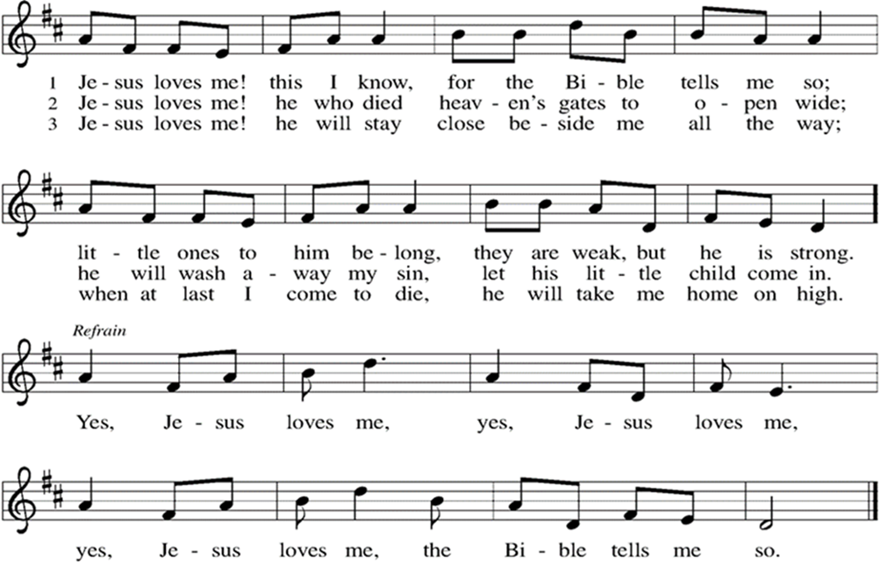

Greeting

WA: The grace of our Lord, Jesus Christ, the love of God, and the communion of the Holy Spirit be with you all. C: And also with you.

Prayer of the Day
WA: Let us pray together.
C: Holy God, we could press our ear to the page, hoping to hear you more clearly. We could silence all the alarms and notifications, hoping to catch a murmur of your voice. We could still our beating hearts, and still we might miss your voice. So today we pray, open up space in our hearts, in our spirits, in our minds, to feel your presence among us. With you, anything is possible. We believe. Help our unbelief. Amen.

WORD
God speaks to us in scripture readings, preaching and song.

“Surely, This Must Be It” L: Everyone has a job. I wash the potatoes, filling the sink with slivers of potato peel. You brine the turkey, hovering by the oven all afternoon. Someone sets the table, taking care to fill a vase with asters and marigolds, springs of holly and shoots of evergreen. We play music while we prepare. “What the World Needs Now is Love” comes on. We can’t get it out of our heads. We whistle along to Dionne all afternoon. And eventually, the doorbell rings.
You’ve invited the neighbors, the grad student who sits on the second row at church, the widower in the choir. We add seats to the table. We go around the room sharing one thing we’re grateful for. Eyes well as we create a laundry list of beauty. The kids get squirmy, but we’re grateful for that too.
And then we eat! We scoop whipped potatoes and crisp green beans with fresh garlic. We pass the bread basket, leaving crumbs all over the table. They are tiny reminders of communion in our midst. And at the end of the night, when we walk our guests to the car and carry sleeping children to their car seats, our neighbors say, What a holy moment it all was. Surely this must be what heaven feels like. Surely we can create it together.
Poem by Rev. Sarah A. Speed

Reading: Ephesians 3:14-21
L: ¹⁴ For this reason I bow my knees before the Father, ¹⁵ from whom every family in heaven and on earth takes its name. ¹⁶ I pray that, according to the riches of his glory, he may grant that you may be strengthened in your inner being with power through his Spirit ¹⁷ and that Christ may dwell in your hearts through faith, as you are being rooted and grounded in love. ¹⁸ I pray that you may have the power to comprehend, with all the saints, what is the breadth and length and height and depth ¹⁹ and to know the love of Christ that surpasses knowledge, so that you may be filled with all the fullness of God.
²⁰ Now to him who by the power at work within us is able to accomplish abundantly far more than all we can ask or imagine, ²¹ to him be glory in the church and in Christ Jesus to all generations, forever and ever. Amen.
L: Word of God, word of life. C: Thanks be to God
Please stand as you are able

Gospel Acclamation ELW #262

Gospel Reading: Mark 6:32-44

P: The Holy Gospel According to Mark. C: Glory to you, O Lord.
P: ³² And they went away in the boat to a deserted place by themselves. ³³ Now many saw them going and recognized them, and they hurried there on foot from all the towns and arrived ahead of them. ³⁴ As he went ashore, he saw a great crowd, and he had compassion for them, because they were like sheep without a shepherd, and he began to teach them many things. ³⁵ When it grew late, his disciples came to him and said, “This is a deserted place, and the hour is now very late; ³⁶ send them away so that they may go into the surrounding country and villages and buy something for themselves to eat.” ³⁷ But he answered them, “You give them something to eat.” They said to him, “Are we to go and buy two hundred denarii worth of bread and give it to them to eat?” ³⁸ And he said to them, “How many loaves have you? Go and see.” When they had found out, they said, “Five, and two fish.” ³⁹ Then he ordered them to get all the people to sit down in groups on the green grass. ⁴⁰ So they sat down in groups of hundreds and of fifties. ⁴¹ Taking the five loaves and the two fish, he looked up to heaven and blessed and broke the loaves and gave them to his disciples to set before the people, and he divided the two fish among them all. ⁴² And all ate and were filled, ⁴³ and they took up twelve baskets full of broken pieces and of the fish. ⁴⁴ Those who had eaten the loaves numbered five thousand men. P: The Gospel of the Lord. C: Praise to you, O Christ.
Sermon Rev. Kristen Arends

Please stand as you are able

+Hymn of the Day: We Shall Overcome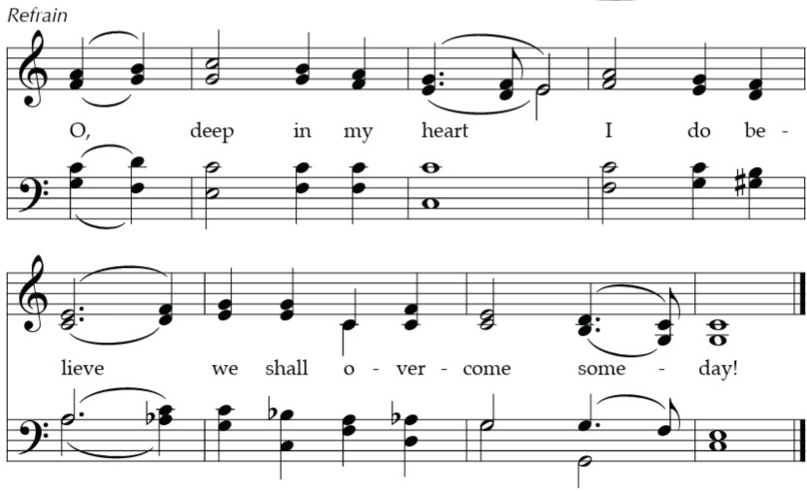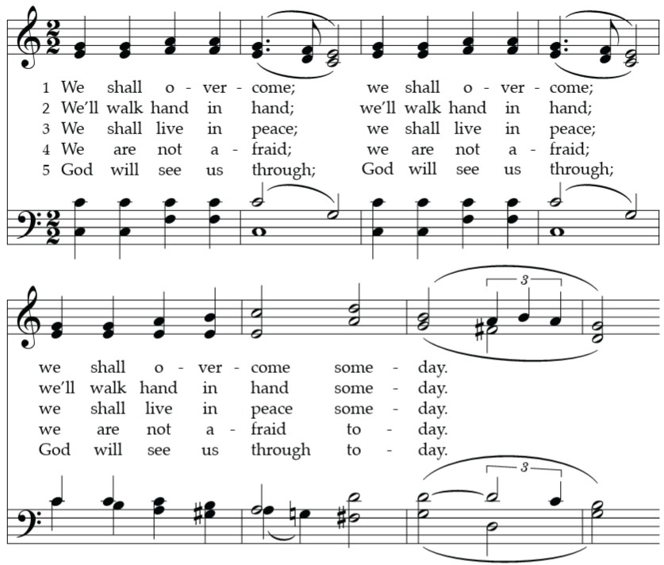
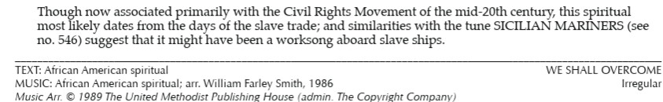

Prayers of the People WA: Reconciled by God’s mercy and sustained by God’s presence, let us pray for the world and its needs. (a brief silence)
WA: Mothering God, we give thanks for the contributions, achievements, leadership, wisdom and gifts of women in the church, and the world, throughout history. This month we remember in prayer; moms, grandmas, Pastors, teachers, friends and neighbors who have told us of your great love. Lord, in your mercy,
C: receive our prayer.
WA: Saving God, when the world is at war and fear grips our hearts, help us to remember that you have declared, “blessed are the peacemakers.” We pray for the people of Iran, Ukraine, Sudan, and all communities experiencing armed conflict. Lord, in your mercy, C: receive our prayer.
WA: Nourishing God, throughout Lent help us to fast from injustice. We lift up to you those who are unemployed or underemployed, those struggling to pay bills, and our neighbors who will go to bed hungry this night. May we hear Christ call, “You give them something to eat.” Lord, in your mercy, C: receive our prayer.
WA: Healing God, be with the sick, the persecuted, and those who have lost hope. Strengthen caregivers with courage, patience, and grace upon grace. We lift up to you this day those on our hearts or the names of those we say aloud…
Lord, in your mercy, C: receive our prayer.

WA: Renewing God, we give thanks for the waters of Baptism that make us new in you! Help us to remember that along with all the Saints we have been set free and forgiven. This day we especially give thanks for the newly Baptized Ezra Jude. Lord, in your mercy, C: receive our prayer.

WA: We offer these prayers, O God, through Jesus Christ, our strength and salvation. C: Amen.

Peace
P: The peace of Christ be with you always. C: And also with you.

Meal - God feeds us with the presence of Jesus Christ

Offering
We are grateful to those who help sustain our mission. To donate online, please use QR code:


Please stand as you are able

Offering Prayer
WA: Let us pray together:
C: O God, maker of heaven and earth, your steadfast love embraces all creation. You send rain and sunshine to nourish the earth and bring forth its bounty. Through these gifts of bread and wine, draw us into the death and life of your Son, who calls us to bear witness to his saving work. We ask this in Jesus’ name. Amen.

+ Offertory Song Create in Me ELW 186
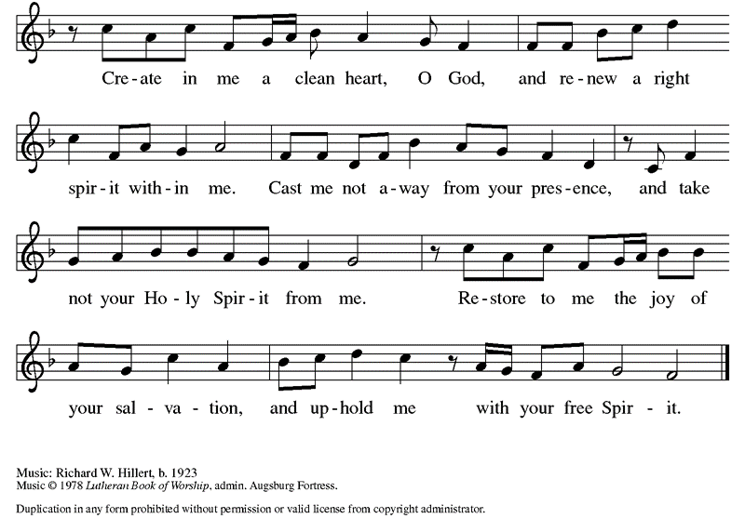

Great Thanksgiving
P: The Lord be with you. C: And also with you.
P: Lift up your hearts. C: We lift them to the Lord.
P: Let us give thanks to the Lord our God.
C: It is right to give our thanks and praise.

Preface
P: It is indeed right, our duty and our joy, that we should at all times and in all places give thanks and praise to you, almighty and merciful God, through our Savior Jesus Christ. You call your people to cleanse their hearts and prepare with joy for the paschal feast, that renewed in the gift of baptism, we may come to the fullness of your grace. And so, with all the choirs of angels, with the church on earth and the hosts of heaven, we praise your name and join their unending hymn:

Holy Holy Holy (spoken)
Holy, holy, holy Lord, God of power and might,
Heaven and earth are full of your glory. Hosanna in the highest.
Blessed is he who comes in the name of the Lord.
Hosanna in the highest, hosanna in the highest.

Thanksgiving at the Table

P: God meets us in the night—
C: before the sun rises, before the wound heals, before there are answers, before there is closure.
P: God meets us in the light—
C: where joy is effervescent, where laughter is contagious, where flowers bloom from cracks in the sidewalk, where people gather around tables.
P: God meets us in between—
C: at the edge of the water, at the beginning of the wilderness, at the start of something new, on the edge of faith.
P: And if God meets us in all those places,
C: then surely God meets us everywhere—at the water’s edge, at the start of something new, after baptism, and before the call.
P: We are not alone. God is all around.
C: Let us meet God in bread and wine.
P: In the night in which he was betrayed, our Lord Jesus took bread, and gave thanks; broke it, and gave it to his disciples, saying: Take and eat; this is my body, given for you. Do this for the remembrance of me. Again, after supper, he took the cup, gave thanks, and gave it for all to drink, saying: This cup is the new covenant in my blood, shed for you and for all people for the forgiveness of sin. Do this for the remembrance of me. C: Amen

Lord’s Prayer
P: Lord, remember us in your kingdom and teach us to pray.
C: Our Father, who art in heaven, hallowed be thy name, thy kingdom come, thy will be done, on earth as it is in heaven. Give us this day our daily bread; and forgive us our trespasses, as we forgive those who trespass against us; and lead us not into temptation, but deliver us from evil. For thine is the kingdom, and the power, and the glory, forever and ever. Amen.

Invitation to the Table
At Parkside Lutheran Church we have an open table. We believe the invitation to receive comes from Jesus himself and all are welcome at Christ’s table. More than just Bread and Wine these are tangible signs of God’s love for you! If you do not wish to receive communion but would like a blessing, come forward and cross your arms over your chest. The Pastor will give you a blessing before you return to your seat via the side aisle. You’ll receive a communion wafer* in your hands. You may dip it in the cup of wine or juice. When giving the bread and cup, the communion ministers say: “The body of Christ, given for you. The blood of Christ, shed for you.”
and each person may respond : Amen
*Please let Pastor know if you need a gluten-free wafer
P: Come to the table. Feast on God’s goodness and mercy.

The Communion Distribution

Communion Song ELW setting 10 (p. 208)
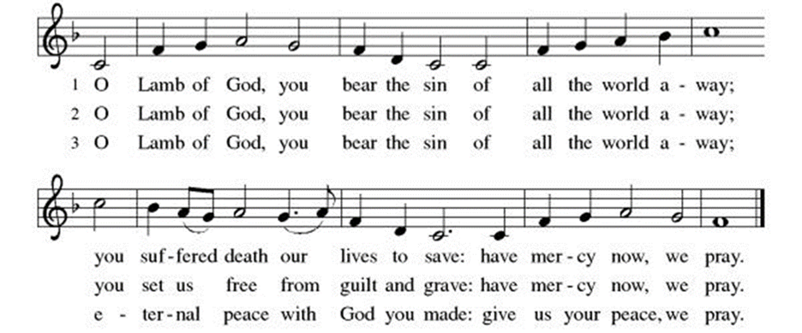

Communion Song: Eat This Bread, Drink This Cup ELW #492
(printed next page)

Post Communion Blessing
P: The Body and Blood of our Lord and Savior, Jesus Christ, strengthen you and keep you in God's grace. C: Amen.

Prayer After Communion
WA: Let us pray together.
C: God of our salvation, we give you thanks for this meal that restores our souls, reconciles us to you, and strengthens us for the journey. Through the body and blood of your Son, may we become Christ’s body in the world, bearing witness to your love for all creation, through Jesus Christ, our Savior and Lord. Amen.

Sending - God blesses us and sends us in mission to the world.

Blessing
P: As you leave this place, when you meet anger, speak with love. When you meet fear, speak with hope. When you meet pain, speak with gentleness. But no matter what, speak the good news. For the good news of the gospel is love and justice for all. It is joy that surprises, and nonviolence that transforms.
The good news of the gospel is alive in the world, so go forth speaking. For if you won’t, then who will? Thanks be to God for this good, good news. May you be blessed in the name of The Creator, Redeemer + and Sustainer. C: Amen

Sending Hymn: We All are One in Mission ELW #576
Dismissal and Postlude
P: Parkside Lutheran Church is rediscovering the radical love of Jesus.
C: Gathering All, Serving All, Caring For All
P: Go in peace. Believe the good news.
C: Thanks be to God.

ELW Music licensed from Sundays & Seasons, Augsburg Fortress CCLI MUSIC License # 11440069 , CCLI Streaming License#21835523 Do not duplicate any music or Liturgy herein without license and permission
scripture readings adapted and written by susan lukey
- Sponsor Easter Lilies or a Soloist in honor of a loved one
or to mark a special occasion. Contact the office for more info.
PARKSIDE STAFF:
• The Rev. Jeremiah Smith: prjeremiahpsmith@gmail.com
• Kris Pope & Suzanne Gracie, Admin. Assistants (Church Office): parksidelutheran@gmail.com
• Mike Hooker, Music Director: mrhooker@me.com

CHURCH OFFICE HOURS: M/T/R 10:00am-3:00pm (716)836-1361
SCHEDULES and Events:
Acolytes: |  |  | Worship Assistants
3/8 – Genevieve & Emmet |  |  | 3/8 - John
3/15 – Franklin & Hudson |  |  | 3/15 - Susan
Readers: |  |  | Ushers:
3/8 – Susan |  |  | 3/8 - Sue S, Joanne N, Charlie R.
3/15 – Josiah |  |  | 3/15 – Dave C, Charlie R, David H
Coming up:
- March 11th - 5:30pm Lenten Dinner & Worship – SIGN UP SHEET IN THE NARTHEX, OR CONTACT THE OFFICE.
- March 20th – Middle School Game Night 7pm in Stowell Lounge

The Buffalo Niagara Praise Orchestra, conducted by Gary Stith and the Houghton University Choir, conducted by Daniel David Black, will present their fifth annual All-WNY Concert & Hymn Sing on Sunday, March 15 at 6:00 PM at the Eastern Hills Church, 8445 Greiner Road in Williamsville. Admission is FREE. Just bring along your vocal cords!!
Visit our website for more information about these and other Events at Parkside – www.parksidelutheran.org/events
Volunteers needed: Want to help with worship but don’t want to stand up front? We are seeking folks to help run the Power Point and/or the live stream during worship. You arrive ten minutes before worship and either click the slides through or click the buttons to change camera angles. Speak to Pastor Jeremiah or Kristen Lenz if you would like to learn more. kristenlenz@gmail.com
Powerpoint Slides Background Image Credit: | A Sanctified Art LLC | sanctifiedart.org

