Palm Sunday Worship

Prelude Michael Hooker, Music Director

Call to Worship
WA: Will you follow? Will you lay down your coat? Will you lay down something important? Will you shout “Hosanna”? Will you join the parade? Will you sing, even if your throat is hoarse? Will you cut down a palm branch? Will you wave it in the air? Will you follow the one riding on a donkey? Will you let this good news inspire you to act?
C: We will. We will sing. We will pay close attention. We will worship. We will follow.
WA: Hosanna in the highest!
C: Hosanna in the highest!

Welcome and Announcements & Children’s Message

Blessing of the Palms
P: The Lord be with you. C: And also with you. P: Let us pray. (brief silence)
We praise you, O God, for entering into Jerusalem, and for entering into Buffalo today. Bless these branches and those who carry them. Grant us grace to follow Jesus throughout this Holy Week, that we, too, might follow the way of the cross and live in newness of life, for us and for all creation. We pray this in the name of the same Jesus Christ, who lives and reigns with you and the Holy Spirit, one God, now and forever. C: Amen.

Processional Gospel: Matthew 21:1-11
Narrator: When they had come near Jerusalem and had reached Bethphage, at the Mount of Olives, Jesus sent two disciples saying to them,

Jesus: Go into the village ahead of you, and immediately you will find a donkey tied and a colt with her; untie them and bring them to me. If anyone says anything to you, just say this, “The Lord needs them.” And he will send them immediately.

Narrator: This took place to fulfill what had been spoken through the prophet:

Pulpit/Right side of Congregation: Tell the daughter of Zion, Look, your king is coming to you, humble and mounted on a donkey, and on a colt, the foal of a donkey.

Narrator: The disciples went and did as Jesus had directed them; they brought the donkey and the colt and put their cloaks on them, and others cut branches from the trees and spread them on the road. The crowds that went ahead of him and that followed were shouting,

Lectern/Left side of Congregation: Hosanna to the Son of David! Blessed is the one who comes in the name of the Lord! Hosanna in the highest heaven!

Narrator: When he entered Jerusalem, the whole city was in turmoil, asking,

Pulpit/Right side of Congregation: Who is this?

Narrator: The crowds were saying,

Lectern/Left side of Congregation: This is the prophet Jesus from Nazareth in Galilee.

Narrator: Word of God, word of life. All: Thanks be to God.

Procession of Palms please stand

+ Processional Hymn “All Glory Laud and Honor” ELW 344

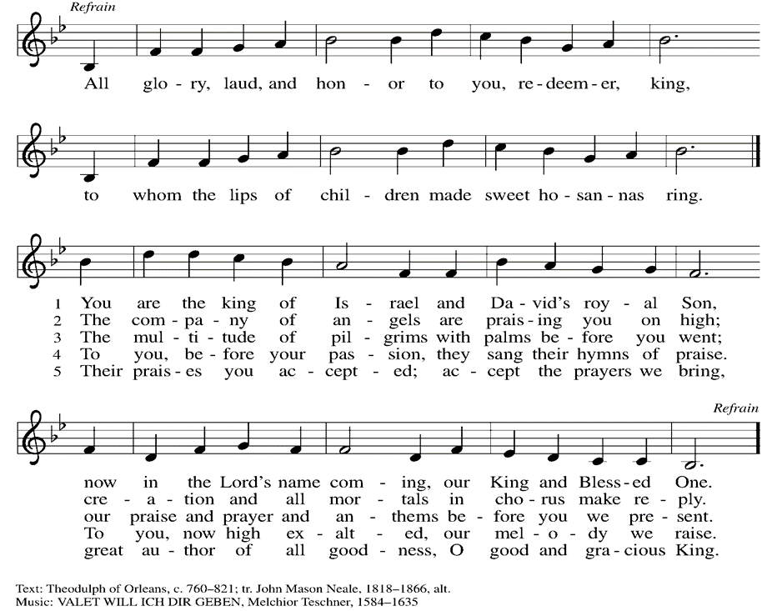
+Confession & Forgiveness
P: The very first Palm Sunday was a day of action. It was a day of movement, of crowded city streets, and cries of “Hosanna!” It was a day of peaceful protest and dreams for a better world. The first Palm Sunday was a day of peaceful, hopeful action.
So friends, on this Palm Sunday, let us join the saints before us in an act of faith. Let us begin with an act of prayer, an act of honesty, an act of transformation. Let us begin by drawing close to God and sharing the truth of our lives. Let us begin with confession. Join me in prayer. (a brief silence)

P: Jesus of Nazareth,
C: we know that you spent your days teaching and healing. You marched through the streets and walked on water. You laid hands on the sick and broke bread at crowded dinner tables. Your good news was not confined to conversation. It was not confined to the Temple. Your good news was an act of love, alive in the world. Holy God, we long for a faith like that. Forgive us for the times when we confine our faith to something we think about, as opposed to something we act upon. Inspire us to love as you loved. Inspire us to act. With hope for tomorrow we pray. Amen.
Root us in mercy, justice and love.

P: Church family, whether or not you wave your palm branches, whether or not you live out your faith, whether or not you allow this good news to inspire your actions, God will never stop loving you. Jesus will never stop marching for you. The Spirit will never stop listening to you.
C: We are claimed, loved, and held in grace. What good, good news. Amen!.

P: Today is a special service because this week is unlike any other week in the Christian calendar. Today we celebrate Palm Sunday, Jesus’ joyous entry into Jerusalem. But now we turn to the events that followed, walking through the moments that led up to Jesus' arrest. Let us begin.

Matthew 26:14-75
Narrator: Then one of the twelve, who was called Judas Iscariot, went to the chief priests and said,

Judas: What will you give me if I betray him to you?

Narrator: They paid him thirty pieces of silver. And from that moment he began to look for an opportunity to betray him. On the first day of Unleavened Bread the disciples came to Jesus, saying,

Congregation: Where do you want us to make the preparations for you to eat the Passover?
Narrator: He said,

Jesus: Go into the city to a certain man and say to him, “The Teacher says, My time is near; I will keep the Passover at your house with my disciples.”

Narrator: So the disciples did as Jesus had directed them, and they prepared the Passover meal.

Offering
We are grateful to those who help sustain our mission. To donate online, please use QR code:


Prayer Over the Gifts
WA: Let us pray together:
C: O God, maker of heaven and earth, your steadfast love embraces all creation. You send rain and sunshine to nourish the earth and bring forth its bounty. Through these gifts of bread and wine, draw us into the death and life of your Son, who calls us to bear witness to his saving work. We ask this in Jesus’ name. Amen.
+ Offertory Song “Create in Me” ELW 186
Create in me a clean heart, O God, and renew a right spirit within me.
Cast me not away from your presence, and take not your Holy Spirit from me.
Restore to me the joy of your salvaion, and uphold me with your free Spirit. Amen.

Narrator: When it was evening, he took his place with the twelve disciples, and while they were eating he said,

Jesus: Truly I tell you, one of you will betray me.

Narrator: And they became greatly distressed and began to say to him one after another,

Congregation: “Surely not I, Lord?”

Narrator: He answered,

Jesus: The one who has dipped his hand into the bowl with me will betray me. ²⁴ The Son of Man goes as it is written of him, but woe to that one by whom the Son of Man is betrayed! It would have been better for that one not to have been born.”

Narrator: Judas, who betrayed him, said,

Judas: Surely not I, Rabbi?
Narrator: He replied,

Jesus: You have said so.

Narrator: While they were eating, Jesus took a loaf of bread, and after blessing it he broke it, gave it to the disciples, and said,

Jesus: Take, eat; this is my body.”

Narrator: Then he took a cup, and after giving thanks he gave it to them, saying,

Jesus: Drink from it, all of you, for this is my blood of the covenant, which is poured out for many for the forgiveness of sins. I tell you, I will never again drink of this fruit of the vine until that day when I drink it new with you in my Father’s kingdom.

P: Lord, remember us in your kingdom and teach us to pray:
Congregation: Our Father, who art in heaven, hallowed be thy name, thy kingdom come, thy will be done, on earth as it is in heaven. Give us this day our daily bread; and forgive us our trespasses, as we forgive those who trespass against us; and lead us not into temptation, but deliver us from evil. For thine is the kingdom, and the power, and the glory, forever and ever. Amen.

Invitation to the Table
At Parkside Lutheran Church we have an open table. We believe the invitation to receive comes from Jesus himself and all are welcome at Christ’s table. More than just Bread and Wine these are tangible signs of God’s love for you! If you do not wish to receive communion but would like a blessing, come forward and cross your arms over your chest. The Pastor will give you a blessing before you return to your seat via the side aisle. You’ll receive a communion wafer* in your hands. You may dip it in the cup of wine or juice. When giving the bread and cup, the communion ministers say:
“The body of Christ, given for you. The blood of Christ, shed for you.” and each person may respond : Amen *Please let Pastor know if you need a gluten-free wafer

P: All who are hungry, come! The feast of grace is spread.

The Communion Distribution

Communion Song: ELW setting 10 (p. 208)
(printed next page)
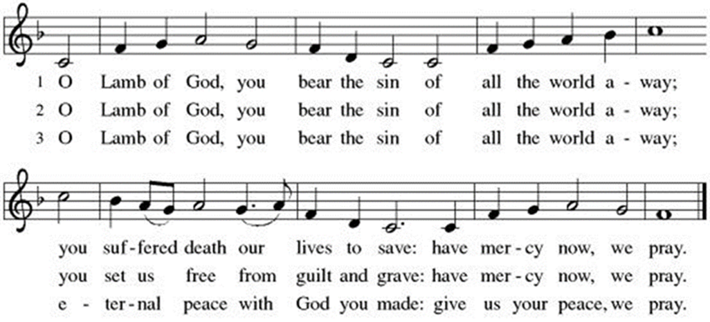

Communion Song: Eat This Bread, Drink This Cup ELW #492
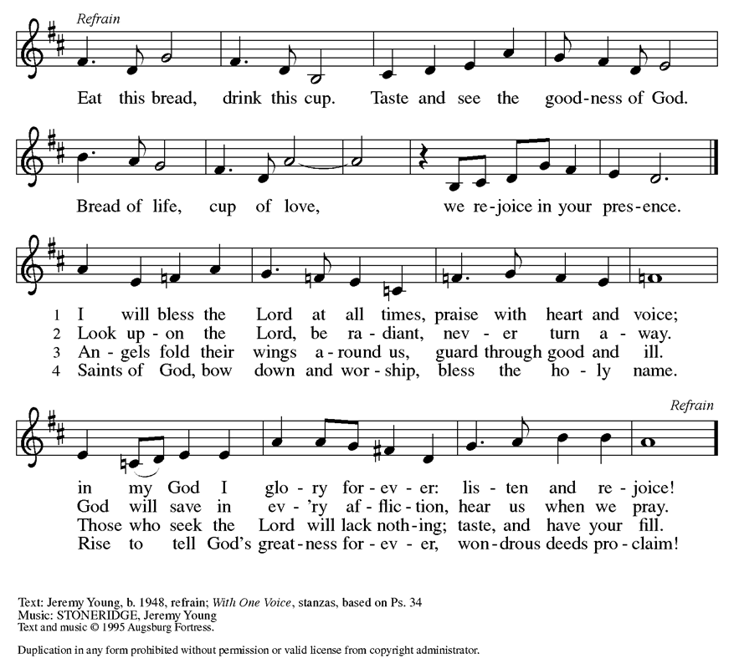

Narrator: When they had sung the hymn, they went out to the Mount of Olives. Then Jesus said to them,

Jesus: You will all fall away because of me this night, for it is written, “I will strike the shepherd, and the sheep of the flock will be scattered.” But after I am raised up, I will go ahead of you to Galilee.

Narrator: Peter said to him,

Peter: Even if all fall away because of you, I will never fall away.

Narrator: Jesus said to him,

Jesus: Truly I tell you, this very night, before the cock crows, you will deny me three times.

Narrator: Peter said to him,

Peter: Even though I must die with you, I will not deny you.

Narrator: And so said all the disciples. Then Jesus went with them to a place called Gethsemane, and he said to his disciples,

Jesus: Sit here while I go over there and pray.

PRAYER OF THE DAY
P: As we now enter into the contemplation of the passion of our Lord Jesus Christ and meditate on the salvation of the world through his sufferings, death, burial, and resurrection, let us pray. (a brief silence)
C: O God of mercy and might, in the mystery of the passion of your Son you offer your infinite life to the world. Gather us around the cross of Christ, and preserve us until the resurrection, through Jesus Christ, our Savior and Lord,
who lives and reign with you and the Holy Spirit One God, now and forever. Amen.

Narrator: He took with him Peter and the two sons of Zebedee and began to be grieved and agitated. Then he said to them,

Jesus: My soul is deeply grieved, even to death; remain here, and stay awake with me.

Narrator: And going a little farther, he threw himself on the ground and prayed,

Jesus: My Father, if it is possible, let this cup pass from me, yet not what I want but what you want.

Narrator: Then he came to the disciples and found them sleeping, and he said to Peter,

Jesus: So, could you not stay awake with me one hour? Stay awake and pray that you may not come into the time of trial; the spirit indeed is willing, but the flesh is weak.
Narrator: Again he went away for the second time and prayed,

Jesus: My Father, if this cannot pass unless I drink it, your will be done.

Narrator: Again he came and found them sleeping, for their eyes were heavy. So leaving them again, he went away and prayed for the third time, saying the same words. Then he came to the disciples and said to them,

Jesus: Are you still sleeping and taking your rest? Now the hour is at hand, and the Son of Man is betrayed into the hands of sinners. Get up, let us be going. Look, my betrayer is at hand.
Narrator: While he was still speaking, Judas, one of the twelve, arrived; with him was a large crowd with swords and clubs, from the chief priests and the elders of the people. Now the betrayer had given them a sign, saying,

Judas: The one I will kiss is the man; arrest him.

Narrator: At once he came up to Jesus and said,

Judas: Greetings, Rabbi!

Narrator: and kissed him. Jesus said to him,

Jesus: Friend, do what you are here to do.

Narrator: Then they came and laid hands on Jesus and arrested him. Suddenly one of those with Jesus put his hand on his sword, drew it, and struck the slave of the high priest, cutting off his ear. Then Jesus said to him,

Jesus: Put your sword back into its place, for all who take the sword will die by the sword. Do you think that I cannot appeal to my Father, and he will at once send me more than twelve legions of angels? But how then would the scriptures be fulfilled, which say it must happen in this way?

Narrator: At that hour Jesus said to the crowds,

Jesus: Have you come out with swords and clubs to arrest me as though I were a rebel? Day after day I sat in the temple teaching, and you did not arrest me. But all this has taken place, so that the scriptures of the prophets may be fulfilled.

Narrator: Then all the disciples deserted him and fled. Those who had arrested Jesus took him to Caiaphas the high priest, where the scribes and the elders had gathered. But Peter was following him at a distance, as far as the courtyard of the high priest, and going inside he sat with the guards in order to see how this would end. Now the chief priests and the whole council were looking for false testimony against Jesus so that they might put him to death, but they found none, though many false witnesses came forward. At last two came forward and said,
Congregation: This fellow said, “I am able to destroy the temple of God and to build it in three days.”

Narrator: The high priest stood up and said,

Men of the Congregation: Have you no answer? What is it that they testify against you?

Narrator: But Jesus was silent. Then the high priest said to him,

Men of the Congregation: I put you under oath before the living God, tell us if you are the Messiah, the Son of God.”

Narrator: Jesus said to him,

Jesus: You have said so. But I tell you, from now on you will see the Son of Man
seated at the right hand of Power and coming on the clouds of heaven.

Narrator: Then the high priest tore his clothes and said,

Men of the Congregation: He has blasphemed! Why do we still need witnesses? You have now heard his blasphemy. What do you think?

Narrator: They answered,

Congregation: He deserves death.

Narrator: Then they spat in his face and struck him, and some slapped him, saying,

Congregation: Prophesy to us, you Messiah! Who is it that struck you?
Narrator: Now Peter was sitting outside in the courtyard. A female servant came to him and said,

Women of the Congregation: You also were with Jesus the Galilean.

Narrator: But he denied it before all of them, saying,

Peter: I do not know what you are talking about.

Narrator: When he went out to the porch, another female servant saw him, and she said to the bystanders,

Women of the Congregation: This man was with Jesus the Nazarene.

Narrator: Again he denied it with an oath,

Peter: I do not know the man.

Narrator: After a little while the bystanders came up and said to Peter,

Congregation: Certainly you are also one of them, for your accent betrays you.

Narrator: Then he began to curse, and he swore an oath,

Peter: I do not know the man!

Narrator: At that moment the cock crowed. Then Peter remembered what Jesus had said: “Before the cock crows, you will deny me three times.” And he went out and wept bitterly.

Hymn of the Day: Abide with Me ELW #629

Matthew 27
Narrator: When morning came, all the chief priests and the elders of the people conferred together against Jesus in order to bring about his death. They bound him, led him away, and handed him over to Pilate the governor.
When Judas, his betrayer, saw that Jesus was condemned, he repented and brought back the thirty pieces of silver to the chief priests and the elders. He said,

Judas: I have sinned by betraying innocent blood.

Narrator: But they said,

Congregation: What is that to us? See to it yourself.

Narrator: Throwing down the pieces of silver in the temple, he departed, and he went and hanged himself. But the chief priests, taking the pieces of silver, said,

Congregation: It is not lawful to put them into the treasury, since they are blood money.

Narrator: After conferring together, they used them to buy the potter’s field as a place to bury foreigners. For this reason that field has been called the Field of Blood to this day. Then was fulfilled what had been spoken through the prophet Jeremiah, “And they took the thirty pieces of silver, the price of the one on whom a price had been set, on whom some of the people of Israel had set a price, and they gave them for the potter’s field, as the Lord commanded me.” Now Jesus stood before the governor, and the governor asked him,

Pilate: Are you the king of the Jews?

Narrator: Jesus said,

Jesus: You say so.

Narrator: But when he was accused by the chief priests and elders, he did not answer. Then Pilate said to him,

Pilate: Do you not hear how many accusations they make against you?

Narrator: But he gave him no answer, not even to a single charge, so that the governor was greatly amazed. Now at the festival the governor was accustomed to release a prisoner for the crowd, anyone whom they wanted. At that time they had a notorious prisoner called Jesus Barabbas. So after they had gathered, Pilate said to them,

Pilate: Whom do you want me to release for you, Jesus Barabbas or Jesus who is called the Messiah?

Narrator: For he realized that it was out of jealousy that they had handed him over. While he was sitting on the judgment seat, his wife sent word to him,

Pilate’s wife: Have nothing to do with that innocent man, for today I have suffered a great deal because of a dream about him.

Narrator: Now the chief priests and the elders persuaded the crowds to ask for Barabbas and to have Jesus killed. The governor again said to them,

Pilate: Which of the two do you want me to release for you?

Narrator: And they said,

Congregation: Barabbas.

Narrator: Pilate said to them,

Pilate: Then what should I do with Jesus who is called the Messiah?

Narrator: All of them said,

Congregation: Let him be crucified!

Narrator: Then he asked,

Pilate: Why, what evil has he done?

Narrator: But they shouted all the more,

Congregation: Let him be crucified!
Narrator: So when Pilate saw that he could do nothing but rather that a riot was beginning, he took some water and washed his hands before the crowd, saying,

Pilate: I am innocent of this man’s blood; see to it yourselves.

Narrator: Then the people as a whole answered,

Congregation: His blood be on us and on our children!

Narrator: So he released Barabbas for them, and after flogging Jesus he handed him over to be crucified. Then the soldiers of the governor took Jesus into the governor’s headquarters, and they gathered the whole cohort around him. They stripped him and put a scarlet robe on him, and after twisting some thorns into a crown they put it on his head. They put a reed in his right hand and knelt before him and mocked him, saying,

Congregation: Hail, King of the Jews!

Narrator: They spat on him and took the reed and struck him on the head. After mocking him, they stripped him of the robe and put his own clothes on him. Then they led him away to crucify him. As they went out, they came upon a man from Cyrene named Simon; they compelled this man to carry his cross. And when they came to a place called Golgotha (which means Place of a Skull), they offered him wine to drink, mixed with gall, but when he tasted it, he would not drink it. And when they had crucified him, they divided his clothes among themselves by casting lots; then they sat down there and kept watch over him.
Over his head they put the charge against him, which read, “This is Jesus, the King of the Jews.” Then two rebels were crucified with him, one on his right and one on his left. Those who passed by derided him, shaking their heads and saying,

Congregation: You who would destroy the temple and build it in three days, save yourself! If you are the Son of God, come down from the cross.

Narrator: In the same way the chief priests also, along with the scribes and elders, were mocking him, saying,

Congregation: He saved others; he cannot save himself. He is the King of Israel; let him come down from the cross now, and we will believe in him. He trusts in God; let God deliver him now, if he wants to, for he said, “I am God’s Son.”

Narrator: The rebels who were crucified with him also taunted him in the same way. From noon on, darkness came over the whole land until three in the afternoon. And about three o’clock Jesus cried with a loud voice,

Jesus: Eli, Eli, lema sabachthani?

Narrator: that is, “My God, my God, why have you forsaken me?” When some of the bystanders heard it, they said,

Congregation: This man is calling for Elijah.

Narrator: At once one of them ran and got a sponge, filled it with sour wine, put it on a stick, and gave it to him to drink. But the others said,

Congregation: Wait, let us see whether Elijah will come to save him.

Narrator: Then Jesus cried again with a loud voice and breathed his last.

The lights are turned off in the church.

Narrator: At that moment the curtain of the temple was torn in two, from top to bottom. The earth shook, and the rocks were split. The tombs also were opened, and many bodies of the saints who had fallen asleep were raised. After his resurrection they came out of the tombs and entered the holy city and appeared to many. Now when the centurion and those with him, who were keeping watch over Jesus, saw the earthquake and what took place, they were terrified and said,

Centurion: Truly this man was God’s Son!

Narrator: Many women were also there, looking on from a distance; they had followed Jesus from Galilee, ministering to him. Among them were Mary Magdalene, and Mary the mother of James and Joseph, and the mother of the sons of Zebedee. When it was evening, there came a rich man from Arimathea named Joseph, who also was himself a disciple of Jesus.
He went to Pilate and asked for the body of Jesus; then Pilate ordered it to be given to him. So Joseph took the body and wrapped it in a clean linen cloth and laid it in his new tomb, which he had hewn in the rock. He then rolled a great stone to the door of the tomb and went away. Mary Magdalene and the other Mary were there, sitting opposite the tomb.
The next day, that is, after the day of Preparation, the chief priests and the Pharisees gathered before Pilate and said, “

Congregation: Sir, we remember what that impostor said while he was still alive, “After three days I will rise again.” Therefore command the tomb to be made secure until the third day; otherwise, his disciples may go and steal him away and tell the people, “He has been raised from the dead,” and the last deception would be worse than the first.”

Narrator: Pilate said to them,

Pilate: You have a guard of soldiers; go, make it as secure as you can.

Narrator: So they went with the guard and made the tomb secure by sealing the stone.
This is the Gospel of the Lord.
Congregation: Thanks be to God.

Stripping of the Altar - Reading of Psalm 22
This action symbolizes the abandonment of Jesus by his disciples and the stripping of Jesus by the
soldiers before his crucifixion. It represents the humiliation of Jesus and the consequences of
sin as a preparation for the celebration of new life.

¹My God, my God, why have you forsaken me?
Why so far from saving me, so far from the words of my groaning?
²My God, I cry out by day, but you do not answer; by night, but I | find no rest.
³Yet you are the Holy One, enthroned on the praises of Israel.
⁴Our ancestors put their trust in you, they trusted, and you | rescued them.
⁵They cried out to you and were delivered;
they trusted in you and were not put to shame.
⁶But as for me, I am a worm and not human,
scorned by all and despised by the people.
⁷All who see me laugh me to scorn; they curl their lips; they shake their heads.
⁸“Trust in the Lord; let the Lord deliver;
let God rescue him if God so delights in him.”
⁹Yet you are the one who drew me forth from the womb,
and kept me safe on my mother’s breast.
¹⁰I have been entrusted to you ever since I was born;
you were my God when I was still in my mother’s womb.
¹¹Be not far from me, for trouble is near, and there is no one to help.
¹²Many young bulls encircle me; strong bulls of Bashan surround me.
¹³They open wide their jaws at me, like a slashing and roaring lion.
¹⁴I am poured out like water; all my bones are out of joint;
my heart within my breast is melting wax.
¹⁵My strength is dried up like a potsherd; my tongue sticks to the roof of my mouth; and you have laid me in the dust of death.
¹⁶Packs of dogs close me in, a band of evildoers circles round me;
they pierce my hands and my feet.
¹⁷I can count all my bones while they stare at me and gloat.
¹⁸They divide my garments among them; for my clothing, they cast lots.
¹⁹But you, O Lord, be not far away; O my help, hasten to my aid.
²⁰Deliver me from the sword, my life from the power of the dog.
²¹Save me from the lion’s mouth!
From the horns of wild bulls you have rescued me.
²²I will declare your name to my people;
in the midst of the assembly I will praise you.
²³You who fear the Lord, give praise! All you of Jacob’s line, give glory.
Stand in awe of the Lord, all you offspring of Israel.
²⁴For the Lord does not despise nor abhor the poor in their poverty; neither is the Lord’s face hidden from them; but when they cry out, the Lord hears them.
²⁵From you comes my praise in the great assembly;
I will perform my vows in the sight of those who fear the Lord.
²⁶The poor shall eat and be satisfied.
Let those who seek the Lord give praise! May your hearts live forever!
²⁷All the ends of the earth shall remember and turn to the Lord;
all the families of nations shall bow before God.
²⁸For dominion belongs to the Lord, who rules over the nations.
²⁹Indeed, all who sleep in the earth shall bow down in worship;
all who go down to the dust, though they be dead, shall kneel before the Lord.
³⁰Their descendants shall serve the Lord,
whom they shall proclaim to generations to come.
³¹They shall proclaim God’s deliverance to a people yet unborn,
saying to them, “The Lord has acted!”

Special Music: Were You There #ELW 353
VERSE 1 – All sing; VERSE 2 - Left/Lectern Side; VERSE 3 Right/Pulpit Side
VERSE 4 All, Acapella; VERSE 5 – Soloist

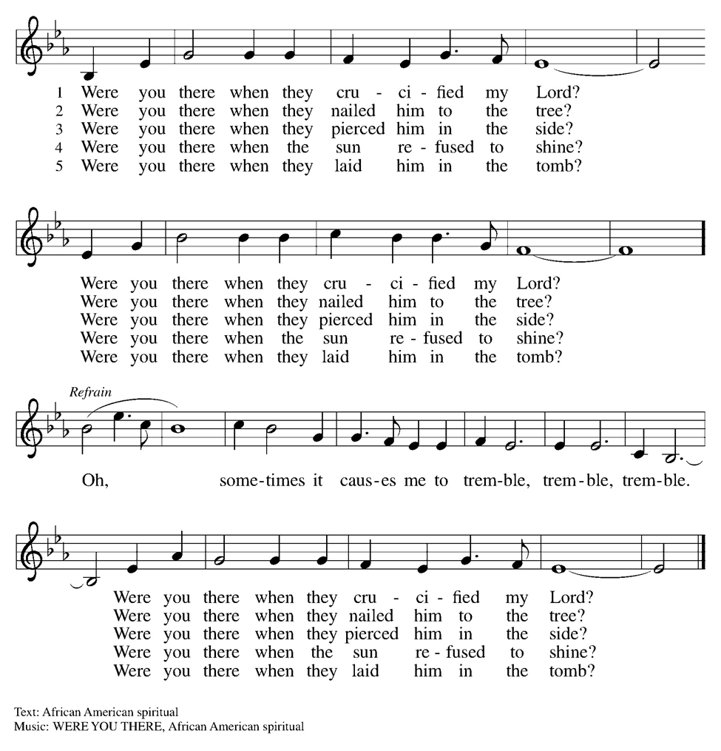

You are invited to sit in silent contemplation for as long as you wish.
When you are ready to leave, please do so in silence and go with peace.

ELW Music licensed from Sundays & Seasons, Augsburg Fortress CCLI MUSIC License # 11440069 , CCLI Streaming License#21835523 Do not duplicate any music or Liturgy herein without license and permission
scripture readings adapted and written by susan lukey

