Parkside Lutheran Church
Rediscovering the Radical Love of Jesus
Gathering All
Serving All
Caring For All



The Good News is
Alive in the World

April 5th, 2026
Easter Day
Holy Communion 10:00am
Rev. Jeremiah Smith
Parkside Lutheran Values

Proclaiming Grace - Jesus shared and lived out a message of grace, love, and new life. We believe these promises come from God freely, as a gift for all. We are loved and the Spirit inspires us to share this good news in accessible, relevant, and new ways. Luke 4:17-19, John 1:16-17, John 3:16-17, Ephesians 2:8-9

Practicing Hospitality – Jesus welcomed the little children, broke bread with outcasts, and proclaimed the Good News to all. Whether you are strong in faith, wrestling with doubt, or somewhere in between, we affirm that you are welcome here. Jesus is for everyone. Leviticus 19:34, Matthew 9:10, Matthew 19:14, Hebrews 13:2

Loving Boldly - Jesus challenged traditions to demonstrate God’s justice and love of neighbor. His compassionate and sacrificial love inspires us to take risks. Striving to follow his command to love neighbor, our ministries serve, transform, and advocate for folks near and far. Micah 6:8, Mark 11:15-17, Luke 10:25-28, John 15:12-13

Cultivating Community - Jesus built communities that transformed lives. We are the body of Christ and we are called to continue this ministry of transformation. Guided by the Holy Spirit, we build connections within and outside of these walls, and with all of God’s creation. Ecclesiastes 4:9-12, Matthew 28:16-20, 1 Corinthians 12:12-14, Galatians 3:26-29

Welcome Visitors!
Please use QR code to let us know you were here today or to sign up for our weekly enewsletter. Find us on Facebook & Instagram
WIFI: Balcony password: FreeGrace

For your safety in the event of an emergency: In addition to the three exits in the back of the sanctuary, there are exits on either side of the altar (on left side: floor level near piano and up steps past altar. On right side: up steps to the altar, past band area)

Contact us: (716) 836-1361
2 Wallace Ave. Buffalo, NY 14214
parksidelutheran.org | parksidelutheran@gmail.com

GATHER
The Holy Spirit calls us together as the people of God.

Preservice Music: Michael Hooker, Music Director
Russell Owens, Trumpet

The congregation is invited to please stand and face the processional cross.

Call to Worship
WA: On Friday, we thought the good news had been silenced.
C: On Friday, we thought the good news had taken its last breath.
WA: On Friday, we thought the good news had been buried.
C: But today, we know the good news is alive and well.
WA: The good news is dancing!
C: The good news is on the loose!
WA: The good news is out in the world, calling your name!
C: Alleluia! Even death has lost its sting.
WA: Let us worship our good-news God.

Lighting of the Paschal Candle
P: Alleluia! Christ is risen!

C: Christ is risen indeed! Alleluia!

P: This Easter morning we celebrate the power of the light of Christ to transform our lives and the world. Christ Jesus, the light of the world, cannot be extinguished. Throughout the season of Easter, at every celebration of Holy Baptism, and at every funeral, where we celebrate the power of life over death, we light this paschal candle. This candle represents the light of Christ that dispels the darkness around and within us.

P: Christ, yesterday and today,
C: the beginning and the ending.
P: To Christ belongs all time and all ages;
C: to Christ belongs glory and dominion now and forever. Amen.

+Gathering Hymn: Jesus Christ Is Risen Today ELW #365

(printed next page)

Welcome and Announcements

+Confession and Forgiveness
P: Friends, on Easter Sunday we remember that the world did its worst to God. The world battered and bruised, betrayed and abandoned, crucified and buried our living God. And despite it all, Jesus still chose to return. Jesus rose again and immediately went to work spreading God’s love to the very people who had hurt him. So hear me when I say, there is nothing you can do that could keep God’s love at bay.
With that good news in mind, let us go to God in prayer, trusting that Jesus Christ loves, claims, and seeks us. Friends, let us pray.
Gracious God,
C: we want to be Easter people. We want to shout your good news from the rooftop. We want to follow the disciples, who ran to look for you. We want to follow the angels, who said, “Be not afraid,” but we are afraid. And we don’t know where to look. And we are worried we’ll say the wrong thing. So forgive us, for we are imperfect Easter people. We are best intentions and best laid plans. We are an out-of-tune chorus of “alleluias.” We are on our way, but we are not there yet.
Show us how to embody your good news in this world. Show us how to be your Easter people. With hope for tomorrow, we pray. Amen.
P: God, who is rich in mercy, loved us even when we were dead to sin, and made us alive together with Christ. By grace you have been saved. In the name of Jesus Christ + your sins are forgiven. So join me in this good news declaration:
C: Through Jesus Christ we are seen, saved, loved, and claimed. This is the good news of the gospel! Thanks be to God! Amen.

Greeting

WA: The grace of our Lord, Jesus Christ, the love of God, and the communion of the Holy Spirit be with you all. C: And also with you.

Kyrie
(printed next page)

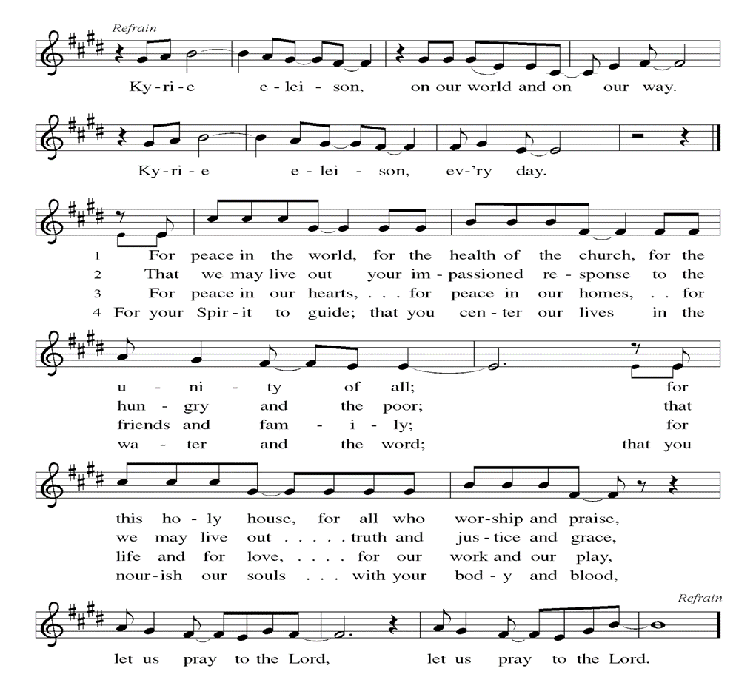

Canticle of Praise (printed next page)
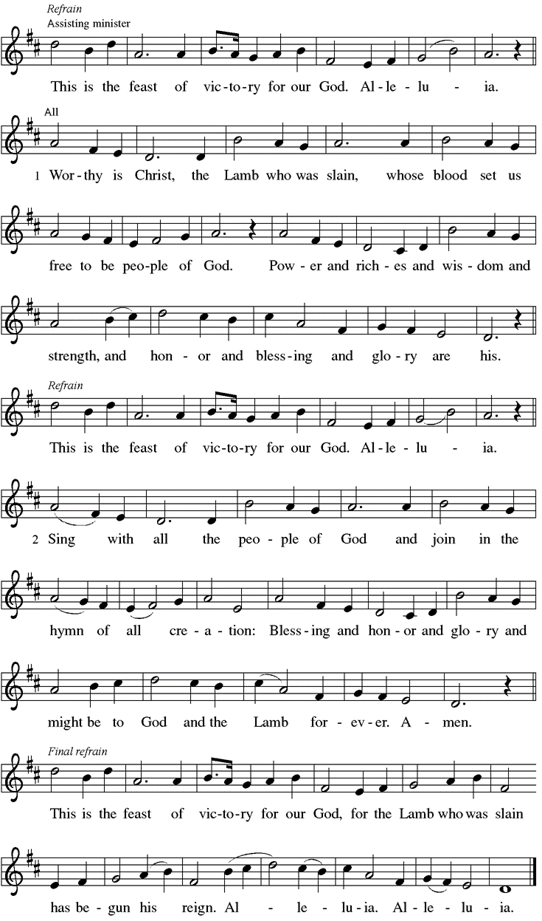
Prayer of the Day
WA: Let us pray together.
C: Holy One, all over the world, people are gathering to hear the same story. All over the world, people are gathering to hear how death lost its sting. All over the world, people are gathering together, praying for a glimpse of you. So like our neighbors all over the world, we pray, be here. Speak to us today. Soften the calloused parts of our hearts until we can sense your Holy Spirit in our midst once more. With eagerness and hope we run to the tomb. We sing alleluia. We bow our heads. We listen for you. Amen.

Children’s Sermon: Jesus said, “Let the little children come to me!”
We welcome children in worship.

WORD
God speaks to us in scripture readings, preaching and song.

“Birdsong” L: Every morning the sun rises,
majestic and steady.
She is greeted
in all her strength
With the joyous cacophony of birdsong.
I like to believe
that this holy chorus
is the birds telling each other—
I’m here.
We made it through the night.
You’re not alone.
What good, good news.
I think the resurrection is a bit like that.
God is here.
We made it through the night.
We are not alone.
What good, good news. Poem by Rev. Sarah A. Speed

Reading: Acts 10:34-43
L: ³⁴ Then Peter began to speak to them: “I truly understand that God shows no partiality, ³⁵ but in every people anyone who fears him and practices righteousness is acceptable to him. ³⁶ You know the message he sent to the people of Israel, preaching peace by Jesus Christ—he is Lord of all. ³⁷ That message spread throughout Judea, beginning in Galilee after the baptism that John announced: ³⁸ how God anointed Jesus of Nazareth with the Holy Spirit and with power; how he went about doing good and healing all who were oppressed by the devil, for God was with him. ³⁹ We are witnesses to all that he did both in Judea and in Jerusalem. They put him to death by hanging him on a tree, ⁴⁰ but God raised him on the third day and allowed him to appear, ⁴¹ not to all the people but to us who were chosen by God as witnesses and who ate and drank with him after he rose from the dead. ⁴² He commanded us to preach to the people and to testify that he is the one ordained by God as judge of the living and the dead. ⁴³ All the prophets testify about him that everyone who believes in him receives forgiveness of sins through his name.” L: Word of God, word of life. C: Thanks be to God

Please stand as you are able

Gospel Acclamation ELW Setting 4 (p. 151)
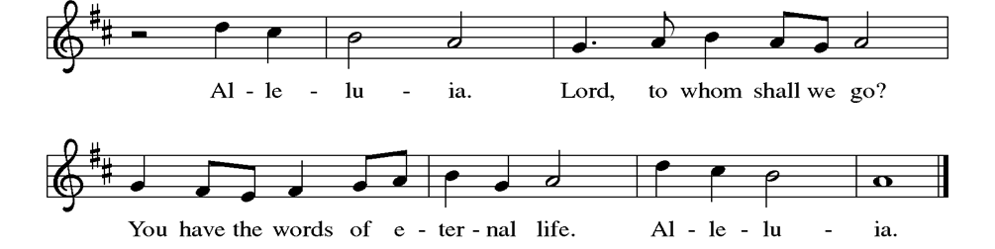

Gospel Reading: Matthew 28:1-10

P: The Holy Gospel According to Matthew. C: Glory to you, O Lord.
P: ¹ After the Sabbath, as the first day of the week was dawning, Mary Magdalene and the other Mary went to see the tomb. ² And suddenly there was a great earthquake, for an angel of the Lord, descending from heaven, came and rolled back the stone and sat on it. ³ His appearance was like lightning and his clothing white as snow. ⁴ For fear of him the guards shook and became like dead men. ⁵ But the angel said to the women, “Do not be afraid, for I know that you are looking for Jesus who was crucified. ⁶ He is not here, for he has been raised, as he said. Come, see the place where he lay. ⁷ Then go quickly and tell his disciples, ‘He has been raised from the dead, and indeed he is going ahead of you to Galilee; there you will see him.’ This is my message for you.” ⁸ So they left the tomb quickly with fear and great joy and ran to tell his disciples. ⁹ Suddenly Jesus met them and said, “Greetings!” And they came to him, took hold of his feet, and worshiped him. ¹⁰ Then Jesus said to them, “Do not be afraid; go and tell my brothers and sisters to go to Galilee; there they will see me.” P: The Gospel of the Lord. C: Praise to you, O Christ.

Sermon Rev. Jeremiah Smith

Please stand as you are able

+Hymn of the Day: In Christ Alone

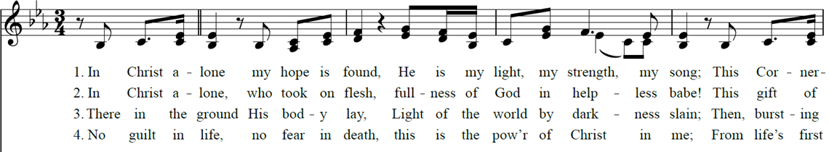
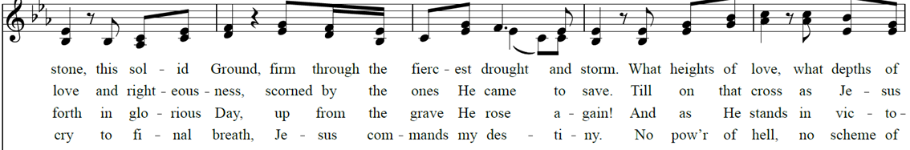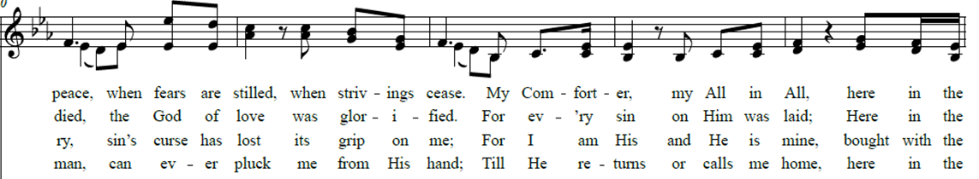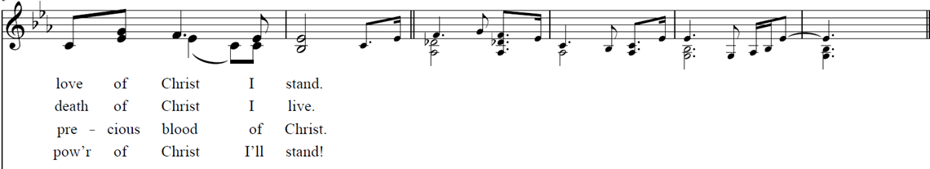

Nicene Creed WA: Let us confess the faith using the words of the Nicene Creed.
C: We believe in one God, the Father, the Almighty, maker of heaven and earth, of all that is, seen and unseen.
We believe in one Lord, Jesus Christ, the only Son of God, eternally begotten of the Father, God from God, Light from Light,
true God from true God, begotten, not made, of one Being with the Father; through him all things were made. For us and for our salvation he came down from heaven, was incarnate of the Holy Spirit and the virgin Mary and became truly human. For our sake he was crucified under Pontius Pilate; he suffered death and was buried. On the third day he rose again in accordance with the scriptures; he ascended into heaven and is seated at the right hand of the Father. He will come again in glory to judge the living and the dead, and his kingdom will have no end.
We believe in the Holy Spirit, the Lord, the giver of life, who proceeds from the Father and the Son, who with the Father and the Son is worshiped and glorified, who has spoken through the prophets. We believe in one holy catholic and apostolic church. We acknowledge one baptism for the forgiveness of sins. We look for the resurrection of the dead, and the life of the world to come. Amen.

Prayers of the People WA: Trusting in the power of Christ’s resurrection to heal and redeem our broken world, let us pray for the needs of all creation. (a brief silence)
WA: Risen Lord, this Easter we give thanks that now the green blade rises from the buried grain. We thank you for the gift of creation, the waters of Lake Erie, the orchards in Niagara County, and the land beneath our feet. Bless our efforts to build a community garden and inspire us all to care for this world.
Merciful God, C: receive our prayer.
WA: Saving God, deliver us from leaders whose only motivation is selfish ambition. Grant your church servant hearts emboldened by the promise of new life. May we speak your Gospel truth even when our voices shake, knowing nothing in all of creation can separate us from your love.
Merciful God, C: receive our prayer.
WA: Healing Savior, we feel surrounded by brokenness. We see fractured relationships, countries at war, bills that are too high, neighbors afraid to leave homes, loved ones that are sick, friends losing hope. We pray especially for those we name aloud or in the silence of our hearts… Help us remember no one is beyond the power of resurrection. Merciful God, C: receive our prayer.
WA: Life giving Spirit, this Easter morning we humbly pray for ourselves and this community. Stir in our hearts so that we live in such a way that the world is able to ‘spot the difference.’ Let that difference by your radical love. Give us ears to listen, eyes to see, hands to serve, and mouths to speak of your Good, Good News. Merciful God, C: receive our prayer.

WA: God of the Empty Tomb, Bless all those who prepare for Baptism. Renew each of us daily in your living waters to be an Easter People; who are not afraid, who go and tell, and are confident we will see Jesus. We remember and give thanks for all the Saints who have gone before and now rest in you.
Merciful God, C: receive our prayer.

WA: God of resurrection power, use us and these prayers to proclaim the good news of new life to all the world, through Jesus Christ, our risen Savior. C: Amen.

Peace
P: The peace of Christ be with you always. C: And also with you.

Meal - God feeds us with the presence of Jesus Christ

Offering
We are grateful to those who help sustain our mission. To donate online, please use QR code:


Offering Music – PLC Choir

“O Come to the Altar” - Elevation Worship
“Great Are You Lord” - All Sons & Daughters.

Please stand as you are able

Offering Prayer
WA: Let us pray together:
C: Merciful God, accept the fruits of our labor, gathered to give you glory. You have set a table before us, a glimpse of that great day when we will hunger and thirst no more. Nourish us with the body and blood of Jesus, that goodness and mercy may follow us, and bless the world you love. In the name of Jesus. Amen.

+ Offertory Song “Praise God From Whom….” (doxology)
ELW 885 (music from ELW 883)
Praise God, from whom all blessings flow;
praise God, all creatures here below;
praise God above, ye heav’nly host;
praise Father, Son, and Holy Ghost. Amen.

Great Thanksgiving
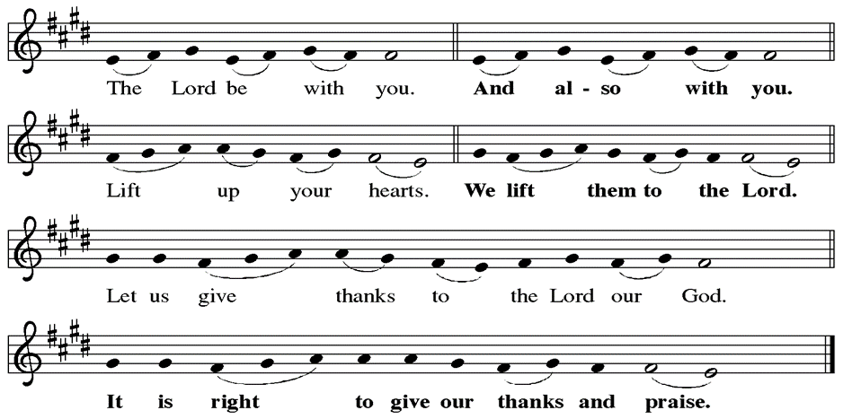

Preface
P: It is indeed right, our duty and our joy, that we should at all times and in all places give thanks and praise to you, almighty and merciful God for the glorious resurrection of our Savior Jesus Christ, the true Paschal Lamb who gave himself to take way our sin, who in dying has destroyed death, and in rising has brought us to eternal life. And so, with Mary Magdalene and Peter and all the witnesses of the resurrection, with earth and sea and all their creatures, and with angels and archangels, cherubim and seraphim, we praise your name and join their unending hymn:
Holy Holy Holy ELw setting 4 (p. 153)
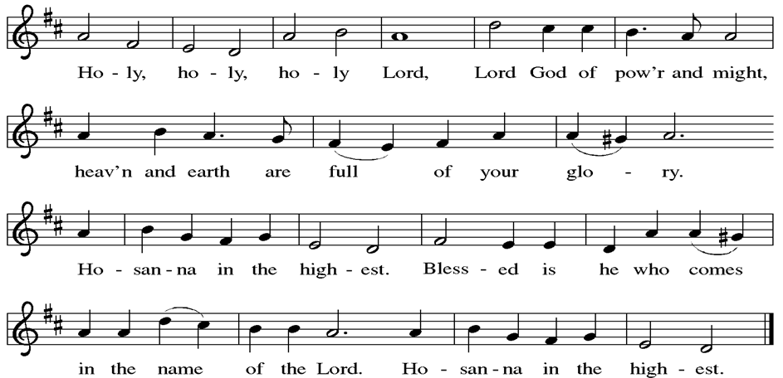

Thanksgiving at the Table

P: Blessed are you, O God of the universe. Your mercy is everlasting and your faithfulness endures from age to age.
Praise to you for creating the heavens and the earth. Praise to you for saving the earth from the waters of the flood. Praise to you for bringing the Israelites safely through the sea. Praise to you for leading your people through the wilderness to the land of milk and honey. Praise to you for the words and deeds of Jesus, your anointed one. Praise to you for the death and resurrection of Christ. Praise to you for your Spirit poured out on all nations.
In the night in which he was betrayed, our Lord Jesus took bread, and gave thanks; broke it, and gave it to his disciples, saying: Take and eat; this is my body, given for you. Do this for the remembrance of me. Again, after supper, he took the cup, gave thanks, and gave it for all to drink, saying: This cup is the new covenant in my blood, shed for you and for all people for the forgiveness of sin.
Do this for the remembrance of me.
With this bread and cup we remember our Lord’s passover from death to life
as we proclaim the mystery of faith:
C: Christ has died. Christ is risen. Christ will come again.
P: O God of resurrection and new life: Pour out your Holy Spirit on us
and on these gifts of bread and wine. Bless this feast. Grace our table with your presence.
C: Come, Holy Spirit.

P: Reveal yourself to us in the breaking of the bread. Raise us up as the body of Christ for the world. Breathe new life into us. Send us forth, burning with justice, peace, and love.
C: Come, Holy Spirit.
P: With your holy ones of all times and places, with the earth and all its creatures, with sun and moon and stars, we praise you, O God, blessed and holy Trinity, now and forever. C: Amen.

Lord’s Prayer
P: Lord, remember us in your kingdom and teach us to pray.
C: Our Father, who art in heaven, hallowed be thy name, thy kingdom come, thy will be done, on earth as it is in heaven. Give us this day our daily bread; and forgive us our trespasses, as we forgive those who trespass against us; and lead us not into temptation, but deliver us from evil. For thine is the kingdom, and the power, and the glory, forever and ever. Amen.

Invitation to the Table
At Parkside Lutheran Church we have an open table. We believe the invitation to receive comes from Jesus himself and all are welcome at Christ’s table. More than just Bread and Wine these are tangible signs of God’s love for you! If you do not wish to receive communion but would like a blessing, come forward and cross your arms over your chest. The Pastor will give you a blessing before you return to your seat via the side aisle. You’ll receive a communion wafer* in your hands. You may dip it in the cup of wine or juice. When giving the bread and cup, the communion ministers say: “The body of Christ, given for you. The blood of Christ, shed for you.”
and each person may respond : Amen
*Please let Pastor know if you need a gluten-free wafer
P: Come to the table of new life. Receive the risen Lord.

The Communion Distribution

Communion Song ELW setting 4 (p. 154)
(printed next page)
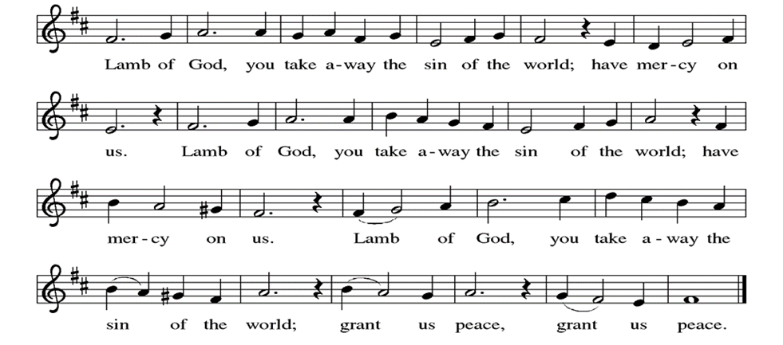

Communion Song: 10,000 Reasons
(printed next page)
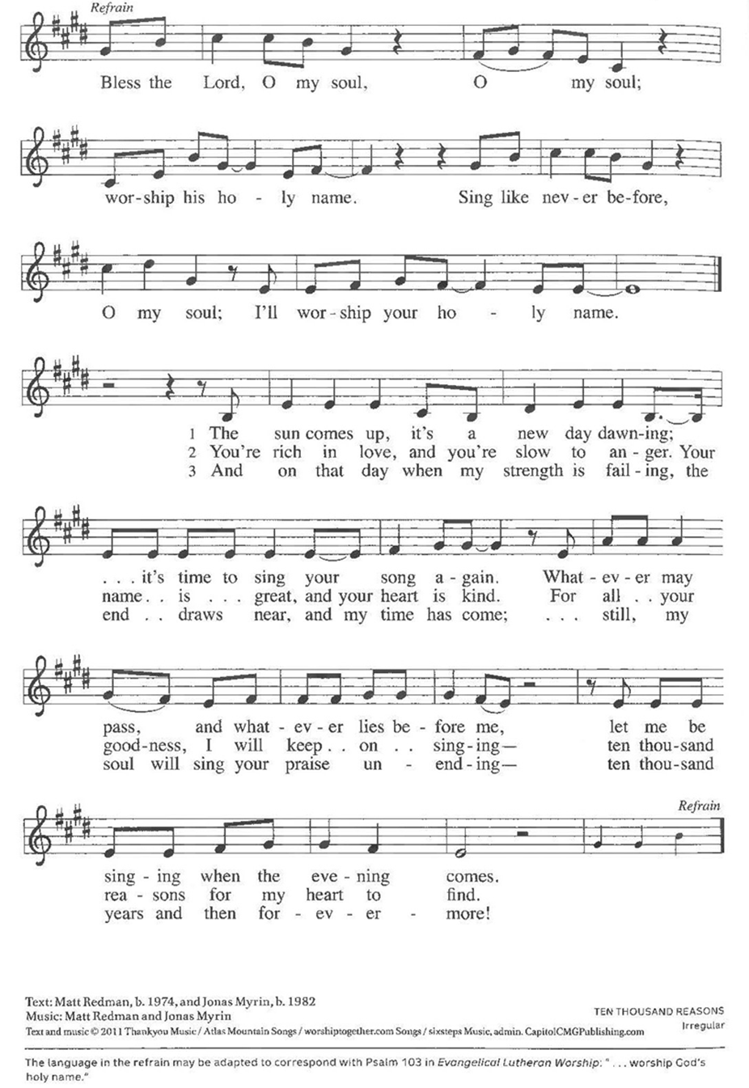
Communion Song: How Great Thou Art ELW #856
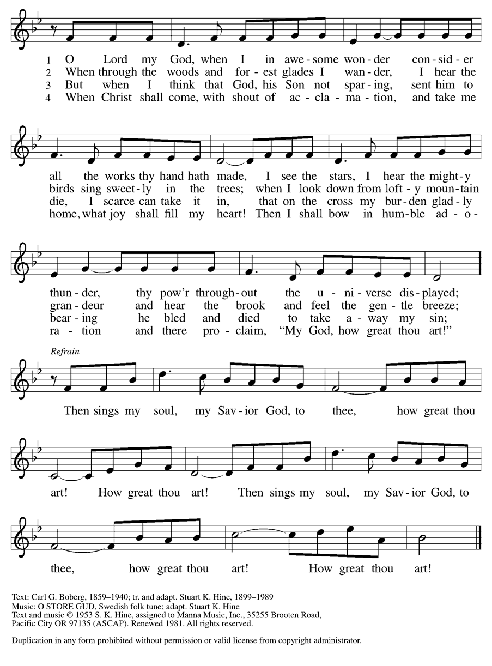

Communion Song: Sanctuary
(printed next page)
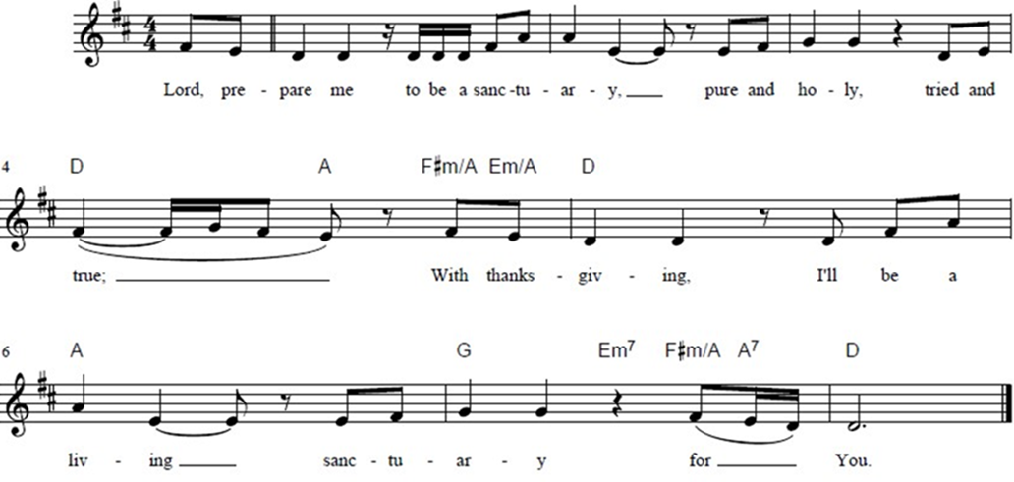

Post Communion Blessing
P: The Body and Blood of our Lord and Savior, Jesus Christ, strengthen you and keep you in God's grace. C: Amen.

Prayer After Communion
WA: Let us pray together.
C: Loving Christ, thank you for the bread that nourishes our bodies. Thank you for the cup that quenches our thirst. Thank you for this community, which reminds us who we are. Thank you for this Table that brings us together. Thank you for the music that lifts our spirits. Thank you for the promise that at this Table, and every table, you will be there. May this holy meal nourish us to out into the world speaking of your good, good news. With joy and hope we pray. Amen.

Sending - God blesses us and sends us in mission to the world.

Blessing
P: As you leave this place, when you meet anger, speak with love. When you meet fear, speak with hope. When you meet pain, speak with gentleness. But no matter what, speak the good news. For the good news of the gospel is love and justice for all. It is joy that surprises, and nonviolence that transforms. The good news of the gospel is alive in the world, so go forth speaking. For if you won’t, then who will? Thanks be to God for this good, good news. May you be blessed in the name of The Creator, Redeemer + and Sustainer. C: Amen
Sending Hymn: Christ is Risen, Alleluia! ELW #382
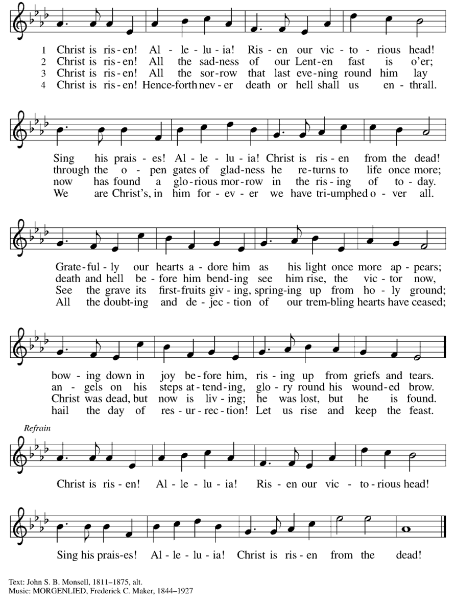
Dismissal and Postlude
P: Parkside Lutheran Church is rediscovering the radical love of Jesus.
C: Gathering All, Serving All, Caring for All
P: Go in peace. Praise the Lord. Alleluia!
C: Thanks be to God. Alleluia! Alleluia!

ELW Music licensed from Sundays & Seasons, Augsburg Fortress CCLI MUSIC License # 11440069 , CCLI Streaming License#21835523 Do not duplicate any music or Liturgy herein without license and permission
scripture readings adapted and written by susan lukey
Acolytes: |  | Worship Assistants
4/5 – David & Grace |  | 4/5 – Susan
4/12 – Franklin & Hudson |  | 4/12 – John
Readers: |  | Ushers:
4/5 - Kathie |  | 4/5 – Joanne, Dave, Sue
4/12 – Dave P |  | 4/12 – Elaine, Tom, Dave
Coming up:
- TODAY! –Easter Egg Hunt and Coffee after Worship
- April 15th – Brewing Theology 7pm at Chandler Street Breweries
Visit our website for more information about these and other Events at Parkside – www.parksidelutheran.org/events
Easter Lilies given by:
Alison & Tom Smith | In Memory of Jim Killeen; Beth Lynch;  Peggy & Jerry Murnane; Barbara & Ray Smith
Susan & Gary Kenline | In Honor of Our Family and Friends
The Griffa & Harden Families | In Memory of Arthur Griffa, June Dennis &  Jac Harston
Paul & Linda Witmer | In Honor of Loved Ones
Pastor Jeremiah Smith & Katie Smith | In Memory of Robert & Beverly Evans; Sherilyn Smith
Marilynn Horwood | In Honor of Grandchildren Sarina, Garrett, Ian & Jake
Gail Petschke | In Memory of Thomas Petschke &  Thomas Petschke Jr.
Pam & Jim Budny | In Honor of Grandchildren
The Walek | In Memory of Florence E. Lennert &  Eleanor Seirs
The Alt Family | In Memory of Our Grandparents & Terri
Jo & Judi | In Memory of Doris & Dick Carpenter;  Pat & Sue
Susan Bundt | In Memory of Patricia & Richard Bundt
Kathy & Gary Szakmary | In Memory of All the Departed
The Then Family | In Honor of Friends & Family
David Halm | In Memory of Bob & Jean Halm
Stephanie Rogers | In Honor of Friends and Family

Thank you for sponsoring lilies! If you would like to bring your lilies home,
you are welcome to take them with you today.
We will deliver remaining lilies to those who would appreciate them.

Upcoming Service Opportunities
Community Garden Build – Join us after worship on May 3rd as we build and prepare the Community Garden beds. Volunteers are also needed for planting, watering, and general upkeep of the gardens. Contact Tom Smith - tsmith189@gmail.com
Adopt a Garden – Volunteer to maintain and upkeep a garden space at Parkside.

Activity Packages – Donate Art & Craft Supplies & Assemble packages for Migrant Children – see the supply list and drop box in the Narthex.
Childcare for Migrant Children – Volunteers are needed at Justice for Migrant Families Meetings & Events. Scan the QR Code or contact the office if you would like to volunteer.
Kenmore-North Buffalo Food Pantry - Volunteers are needed to unload deliveries, pickup retail partner donations, stock shelves, and assist clients with “shopping”. Contact Kristen Konkel Lenz to sign up kristenlenz@gmail.com.
Buffalo Burrito Project – Volunteers are needed to pick-up supplies, assemble burritos, and distribute burritos, coffee, snacks, and other supplies to the unhoused population in downtown Buffalo, on the fourth Tuesday of every month. Contact Alison Smith to sign up alisonmsmith07@gmail.com.
Worship Committee – Volunteers are needed for Worship Assistants, Readers, Acolytes, and Communion Assistants. Contact Susan Bundt susanbundt@gmail.com
Ushers – Volunteers are needed to welcome attendees, distribute bulletins, assist guests, and maintain order and flow during Offering and Communion. Contact David Canose davecpsyd@gmail.com
Screens & Live Stream – Volunteer to help run the PowerPoint Presentation and Live Stream during Worship. Contact Kristen Konkel kristenlenz@gmail.com.
Care Committee – Volunteer to and help sending cards to members and staff. Contact Sandra Rice sandrarice98@gmail.com
Vacation Bible School – Cook a meal, plan an activity, or volunteer.

Special Events at Parkside – Volunteer to Chair or Assist with one of our Special Events, including Community Meals, The Pride Parade, Meat Raffle Fundraiser, Refugee Thanksgiving, Halloween Party, Holiday Hayride, and more. Contact the Church Office parksidelutheran@gmail.com
Parkside Apparel Sale - Support our mission by purchasing a Parkside t-shirt or hoodie! Scan the QR Code, or visit our website to place your order.
Visit our website at parksidelutheran.org, or contact the office for more information at parksidelutheran@gmail.com or 716-836-1361.

