Parkside Lutheran Church
Rediscovering the Radical Love of Jesus
Gathering All
Serving All
Caring For All



October 25th, 2026
Reformation Sunday
Holy Communion 10:00am
The Rev. Jeremiah Smith
Parkside Lutheran Values

Proclaiming Grace - Jesus shared and lived out a message of grace, love, and new life. We believe these promises come from God freely, as a gift for all. We are loved and the Spirit inspires us to share this good news in accessible, relevant, and new ways. Luke 4:17-19, John 1:16-17, John 3:16-17, Ephesians 2:8-9

Practicing Hospitality – Jesus welcomed the little children, broke bread with outcasts, and proclaimed the Good News to all. Whether you are strong in faith, wrestling with doubt, or somewhere in between, we affirm that you are welcome here. Jesus is for everyone. Leviticus 19:34, Matthew 9:10, Matthew 19:14, Hebrews 13:2

Loving Boldly - Jesus challenged traditions to demonstrate God’s justice and love of neighbor. His compassionate and sacrificial love inspires us to take risks. Striving to follow his command to love neighbor, our ministries serve, transform, and advocate for folks near and far. Micah 6:8, Mark 11:15-17, Luke 10:25-28, John 15:12-13

Cultivating Community - Jesus built communities that transformed lives. We are the body of Christ and we are called to continue this ministry of transformation. Guided by the Holy Spirit, we build connections within and outside of these walls, and with all of God’s creation. Ecclesiastes 4:9-12, Matthew 28:16-20, 1 Corinthians 12:12-14, Galatians 3:26-29

Welcome Visitors!
Please use QR code to let us know you were here today or to sign up for our weekly enewsletter. Find us on Facebook & Instagram
WIFI: Balcony password: FreeGrace

For your safety in the event of an emergency: In addition to the three exits in the back of the sanctuary, there are exits on either side of the altar (on left side: floor level near piano and up steps past altar. On right side: up steps to the altar, past band area)

Contact us: (716) 836-1361
2 Wallace Ave. Buffalo, NY 14214
parksidelutheran.org | parksidelutheran@gmail.com

GATHER
The Holy Spirit calls us together as the people of God.
Introduction to the Day: Rooted in the past and growing into the future, the church must always be reformed in order to live out the love of Christ in an ever-changing world. We celebrate the good news of God’s grace, that Jesus Christ sets us free every day to do this life-transforming work. Trusting in the freedom given to us in baptism, we pray for the church, that Christians will unite more fully in worship and mission.

Prelude Michael Hooker, Music Director

Please stand as you are able

Call to Worship
WA: Be still! C: We come to quiet ourselves in this haven of holiness.
WA: Be still and know…
C: we come to discern the Word which can set us free.
WA: Be still and know that God is
C: our Hope, our Help, our Refuge, and our Redeemer.

+Gathering Hymn: Christ is Made the Sure Foundation ELW #645
(printed next page)

Welcome and Announcements

Holy Baptism: Mary Louisa King ELW p. 227

P: God, who is rich in mercy and love, gives us a new birth into a living hope through the sacrament of baptism. By water and the Word God delivers us from sin and death and raises us to new life in Jesus Christ. We are united with all the baptized in the one body of Christ, anointed with the gift of the Holy Spirit, and joined in God's mission for the life of the world.
P: Who do you present to be baptized? Sponsors: We present Mary for baptism.

P: Called by the Holy Spirit, trusting in the grace and love of God, as their parents, do you desire to have Mary baptized into Christ? Parents: We do.
P: As you bring her to receive the gift of baptism, you are entrusted with responsibilities: to live with her among God's faithful people, bring her to the word of God and the holy supper, teach her the Lord's Prayer, the Creed, and the Ten Commandments, place in her hands the holy scriptures, and nurture her in faith and prayer, so that she may learn to trust God, proclaim Christ through word and deed, care for others and the world God made, and work for justice and peace.

P: Do you promise to help Mary grow in the Christian faith and life?
Parents: We do.

P: Sponsors, do you promise to nurture Mary in the Christian faith as you are empowered by God's Spirit, and to help her live in the covenant of baptism and in communion with the church? Sponsors: We do.

P: People of God, do you promise to support Mary and pray for her in her new life in Christ? C: We do.

+ Profession of Faith
P: All together as the people of God, I ask you to profess your faith in Christ Jesus, reject sin, and confess the faith of the church.

P: Do you renounce the devil and all the forces that defy God?
C: We renounce them.

P: Do you renounce the powers of this world that rebel against God?
C: We renounce them.

P: Do you renounce the ways of sin that draw you from God?
C: We renounce them.

P: Do you believe in God the Father?
C: I believe in God, the Father almighty, creator of heaven and earth.
P: Do you believe in Jesus Christ, the Son of God?
C: I believe in Jesus Christ, God's only Son, our Lord, who was conceived by the Holy Spirit, born of the virgin Mary, suffered under Pontius Pilate, was crucified, died, and was buried; he descended to the dead.* On the third day he rose again; he ascended into heaven, he is seated at the right hand of the Father, and he will come to judge the living and the dead.
P: Do you believe in God the Holy Spirit?
C: I believe in the Holy Spirit, the holy catholic church, the communion of saints, the forgiveness of sins, the resurrection of the body, and the life everlasting.

Thanksgiving at the Font
P: The Lord be with you. C: And also with you.
P: Let us give thanks to the Lord our God.
C: It is right to give our thanks and praise.

P: We give you thanks, O God, for in the beginning your Spirit moved over the waters and by your Word you created the world, calling forth life in which you took delight. Through the waters of the flood you delivered Noah and his family, and through the sea you led your people Israel from slavery into freedom.
At the river your Son was baptized by John and anointed with the Holy Spirit. By the baptism of Jesus' death and resurrection you set us free from the power of sin and death and raise us up to live in you.
Pour out your Holy Spirit, the power of your living Word, that those who are washed in the waters of baptism may be given new life. To you be given honor and praise through Jesus Christ our Lord, in the unity of the Holy Spirit, now and forever. C: Amen.

Baptism
P: Mary Louisa, I baptize you in the name of the Father, and of the Son, and of the Holy Spirit. Amen.

P: Let us pray. We give you thanks, O God, that through water and the Holy Spirit you give your daughters and sons new birth, cleanse them from sin, and raise them to eternal life.

Laying hands on the head of Mary, the minister prays:
P: Sustain Mary with the gift of your Holy Spirit: the spirit of wisdom and understanding, the spirit of counsel and might, the spirit of knowledge and the fear of the Lord, the spirit of joy in your presence, both now and forever. Amen.

P: Mary, child of God, you have been sealed by the Holy Spirit and marked with the cross of Christ forever. Amen.

Welcome
WA: Jesus said, I am the light of the world.
Whoever follows me will have the light of life.

P: Let us welcome Mary.
C: We welcome you into the body of Christ and into the mission we share; join us in giving thanks and praise to God and bearing God's creative and redeeming word to all the world.
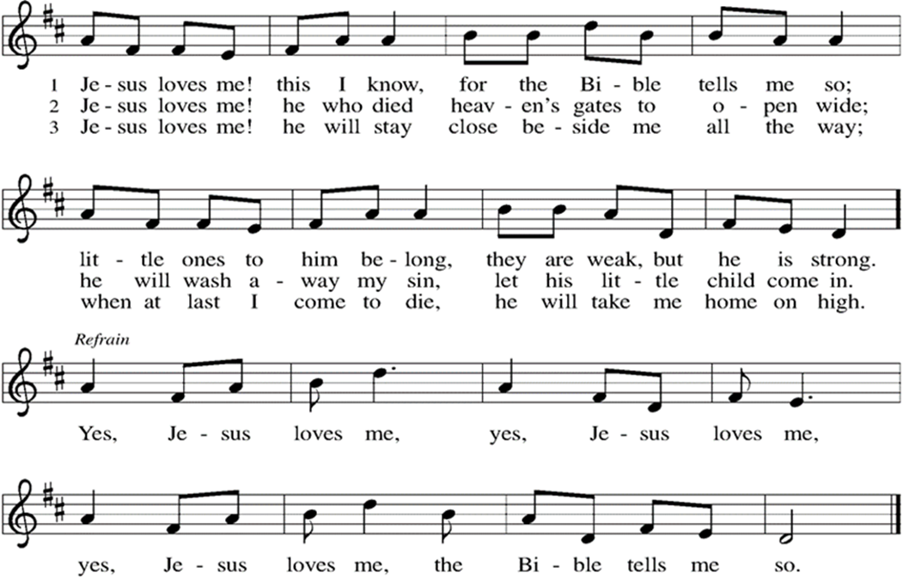

Greeting

WA: The grace of our Lord, Jesus Christ, the love of God, and the communion of the Holy Spirit be with you all. C: And also with you.

Prayer of the Day
WA: Let us pray together.
C: Almighty God, gracious Lord, we thank you that your Holy Spirit renews the church in every age. Pour out your Holy Spirit on your faithful people.
Keep them steadfast in your word, protect and comfort them in times of trial, defend them against all enemies of the gospel, and bestow on the church your saving peace, through Jesus Christ, our Savior and Lord, who lives and reigns with you and the Holy Spirit, one God, now and forever. Amen.

Children’s Sermon: Jesus said, “Let the little children come to me!”
We welcome children in worship.

WORD
God speaks to us in scripture readings, preaching and song.
First Reading: Jeremiah 31:31-34
The renewed covenant will not be breakable, but like the old covenant it will expect the people to live upright lives. To know the Lord means that one will defend the cause of the poor and needy (Jer. 22:16). The renewed covenant is possible only because the Lord will forgive iniquity and not remember sin. Our hope lies in a God who forgets.
L: ³¹The days are surely coming, says the Lord, when I will make a new covenant with the house of Israel and the house of Judah. ³²It will not be like the covenant that I made with their ancestors when I took them by the hand to bring them out of the land of Egypt—a covenant that they broke, though I was their husband, says the Lord. ³³But this is the covenant that I will make with the house of Israel after those days, says the Lord: I will put my law within them, and I will write it on their hearts; and I will be their God, and they shall be my people. ³⁴No longer shall they teach one another, or say to each other, “Know the Lord,” for they shall all know me, from the least of them to the greatest, says the Lord; for I will forgive their iniquity, and remember their sin no more.
L: Word of God, word of life. C: Thanks be to God.

Psalm: Psalm 46 The Lord of hosts is with us; the God of Jacob is our stronghold. (Ps. 46:7)
L: ¹God is our refuge and strength, a very present help in trouble.
C: ²Therefore we will not fear, though the earth be moved,
and though the mountains shake in the depths of the sea;
L: ³though its waters rage and foam,
and though the mountains tremble with its tumult.
C: ⁴There is a river whose streams make glad the city of God,
the holy habitation of the Most High.
L: ⁵God is in the midst of the city; it shall not be shaken;
God shall help it at the break of day.
C: ⁶The nations rage, and the kingdoms shake;
God speaks, and the earth melts away.
L: ⁷The Lord of hosts is with us; the God of Jacob is our stronghold.
C: ⁸Come now, regard the works of the Lord,
what desolations God has brought upon the earth;
L: ⁹behold the one who makes war to cease in all the world;
who breaks the bow, and shatters the spear, and burns the shields with fire.
C: ¹⁰“Be still, then, and know that I am God;
I will be exalted among the nations; I will be exalted in the earth.”
L: ¹¹The Lord of hosts is with us; the God of Jacob is our stronghold.
L: Word of God, word of life. C: Thanks be to God.
Second Reading: Romans 3:19-28
Paul’s words stand at the heart of the preaching of Martin Luther and other Reformation leaders. No human beings make themselves right with God through works of the law. We are brought into a right relationship with God through the divine activity centered in Christ’s death. This act is a gift of grace that liberates us from sin and empowers our faith in Jesus Christ.
L: ¹⁹Now we know that whatever the law says, it speaks to those who are under the law, so that every mouth may be silenced, and the whole world may be held accountable to God. ²⁰For “no human being will be justified in his sight” by deeds prescribed by the law, for through the law comes the knowledge of sin.
²¹But now, apart from law, the righteousness of God has been disclosed, and is attested by the law and the prophets, ²²the righteousness of God through faith in Jesus Christ for all who believe. For there is no distinction, ²³since all have sinned and fall short of the glory of God; ²⁴they are now justified by his grace as a gift, through the redemption that is in Christ Jesus, ²⁵whom God put forward as a sacrifice of atonement by his blood, effective through faith. He did this to show his righteousness, because in his divine forbearance he had passed over the sins previously committed; ²⁶it was to prove at the present time that he himself is righteous and that he justifies the one who has faith in Jesus.
²⁷Then what becomes of boasting? It is excluded. By what law? By that of works? No, but by the law of faith. ²⁸For we hold that a person is justified by faith apart from works prescribed by the law.
L: Word of God, word of life. C: Thanks be to God.
Please stand as you are able

Gospel Acclamation Setting 8 (p. 188)
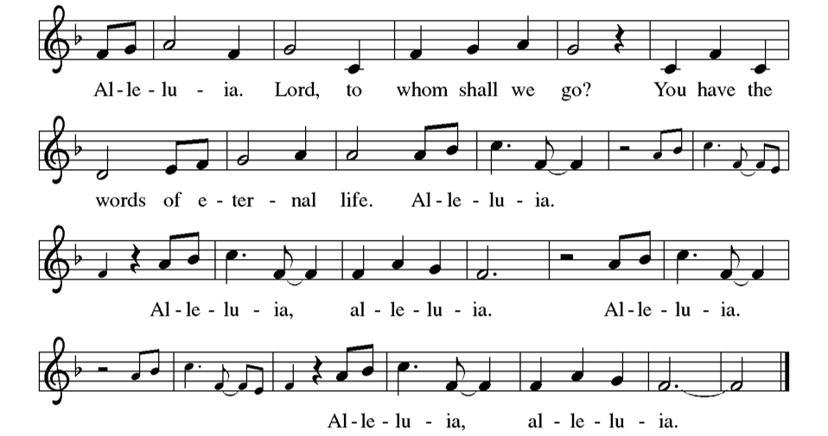
Gospel Reading: Matthew 22:34-46
³⁴ When the Pharisees heard that he had silenced the Sadducees, they gathered together, ³⁵ and one of them, an expert in the law, asked him a question to test him. ³⁶ “Teacher, which commandment in the law is the greatest?” ³⁷ He said to him, “ ‘You shall love the Lord your God with all your heart and with all your soul and with all your mind.’ ³⁸ This is the greatest and first commandment. ³⁹ And a second is like it: ‘You shall love your neighbor as yourself.’ ⁴⁰ On these two commandments hang all the Law and the Prophets.”
⁴¹ Now while the Pharisees were gathered together, Jesus asked them this question: ⁴² “What do you think of the Messiah? Whose son is he?” They said to him, “The son of David.” ⁴³ He said to them, “How is it then that David by the Spirit calls him Lord, saying,
⁴⁴ ‘The Lord said to my Lord,
“Sit at my right hand,
until I put your enemies under your feet” ’?
⁴⁵ “If David thus calls him Lord, how can he be his son?” ⁴⁶ No one was able to give him an answer, nor from that day did anyone dare to ask him any more questions.
P: The Gospel of the Lord. C: Praise to you, O Christ.

Sermon The Rev. Jeremiah Smith

Please stand as you are able

+Hymn of the Day : A Mighty Fortress is Our God ELW #504 (printed next page)

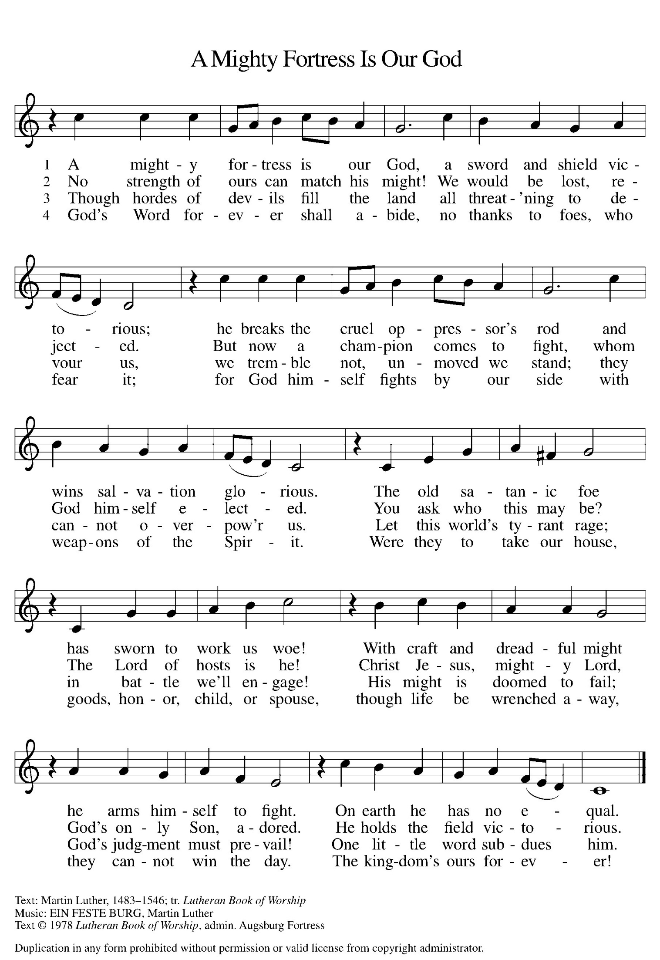

Prayers of the People WA: Seeking the Spirit of God who makes all things new, we pray for the church and the world. (a brief silence)
WA: As we celebrate Reformation Sunday, we remember the witness of Martin Luther and the reformers of the church in every generation. Empower us to continue the work of reform and renewal in our own day. Hear us, O God.
C: Your mercy is great.

WA: We pray for our criminal justice systems and all those whose lives are affected by them. Give wisdom and discernment to police, probation officers, judges, and attorneys; give courage and peace to prisoners and the formerly incarcerated. Hear us, O God. C: Your mercy is great.

WA: We ask your blessing upon all people who have been harmed by the church and its leaders, that the truth may make them free. We pray for the relief of all those who are sick or suffering, especially those we name aloud or in the silence of our hearts…. Hear us, O God, C: Your mercy is great.

WA: We give thanks for those exploring or returning to a life of faith. Encourage and guide them, that they may find their hope in you. Hear us, O God,
C: Your mercy is great.

WA: With gratitude, we remember those disciples who paved the way for us and all of our beloved dead. Hear us, O God. C: Your mercy is great.

WA: Trusting in your boundless grace, O God, we lift up these spoken prayers and those in our hearts; through Jesus Christ our Lord. C: Amen.

Peace
P: The peace of Christ be with you always. C: And also with you.

Meal - God feeds us with the presence of Jesus Christ

Offering
We are grateful to those who help sustain our mission. To donate online, please use QR code:


Offering Music: “O Lord, Your Word has Come to Us” by Joseph M. Martin
PLC Choir

+ Offertory Song: “We are an Offering” ELW 692
We lift our voices, we lift our hands, we lift our lives up to you;
We are an offering. Lord, use our voices, Lord, use our hands,
Lord, use our lives, they are yours; We are an offering.
All that we have, all that we are, all that we hope to be-
we give to you, we give to you.
We lift our voices, we lift our hands, we lift our lives up to you;
We are an offering. We are an offering.

+ Offering Prayer
WA: Let us pray together:
C: Generous and loving God, we come to you in thanksgiving, knowing that all we are and all that we have is a gift from you. In faith and love, help us to do your will. We are listening. Speak your words into the depth of our souls, that we may hear you clearly.
We offer to you this day not only our pledges but all the facets of our lives, whether it be at home, at work, or at school. We seek to be patient, to be merciful, to be generous, to be holy. Give us the wisdom and insight to understand your will for us and the fervor to carry out our good intentions.
We offer our gifts of time, talent and possessions to you as an act of faith, to reflect our love for you and our neighbors. Help us to reach out to others as you have reached out to us. Amen.

Great Thanksgiving
P: The Lord be with you. C: And also with you.
P: Lift up your hearts. C: We lift them to the Lord.
P: Let us give thanks to the Lord our God.
C: It is right to give our thanks and praise.

Preface
P: It is indeed right, our duty and our joy, that we should at all times and in all places give thanks and praise to you, almighty and merciful God, through our Savior Jesus Christ; who on this day overcame death and the grave, and by his glorious resurrection opened to us the way of everlasting life. And so, with all the choirs of angels, with the church on earth and the host of heaven, we praise your name and join their unending hymn:
Holy Holy Holy ELW setting 8 (p. 190)
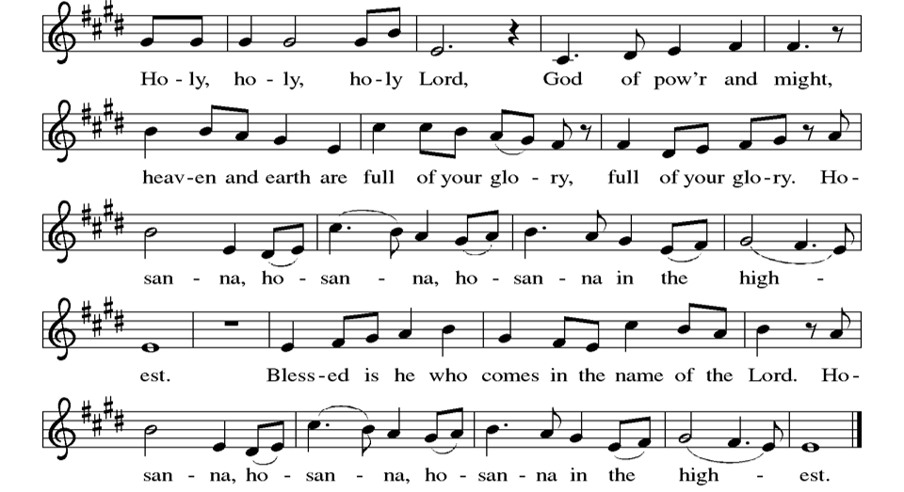

Thanksgiving at the Table
P: In the night in which he was betrayed, our Lord Jesus took bread, and gave thanks; broke it, and gave it to his disciples, saying: Take and eat; this is my body, given for you. Do this for the remembrance of me.
Again, after supper, he took the cup, gave thanks, and gave it for all to drink, saying: This cup is the new covenant in my blood, shed for you and for all people for the forgiveness of sin. Do this for the remembrance of me.

Lord’s Prayer
P: Lord, remember us in your kingdom and teach us to pray.
C: Our Father, who art in heaven, hallowed be thy name, thy kingdom come, thy will be done, on earth as it is in heaven. Give us this day our daily bread; and forgive us our trespasses, as we forgive those who trespass against us; and lead us not into temptation, but deliver us from evil. For thine is the kingdom, and the power, and the glory, forever and ever. Amen.

Invitation to the Table
At Parkside Lutheran Church we have an open table. We believe the invitation to receive comes from Jesus himself and all are welcome at Christ’s table. More than just Bread and Wine these are tangible signs of God’s love for you! If you do not wish to receive communion but would like a blessing, come forward and cross your arms over your chest. The Pastor will give you a blessing before you return to your seat via the side aisle.
You’ll receive a communion wafer* in your hands. You may dip it in the cup of wine or juice. When giving the bread and cup, the communion ministers say: “The body of Christ, given for you. The blood of Christ, shed for you.”
and each person may respond: Amen
*Please let Pastor know if you need a gluten-free wafer
P: Christ invites you to this table. All who are hungry, all who are thirsty, come!

The Communion Distribution

Communion Song ELW setting 10 (p. 191)
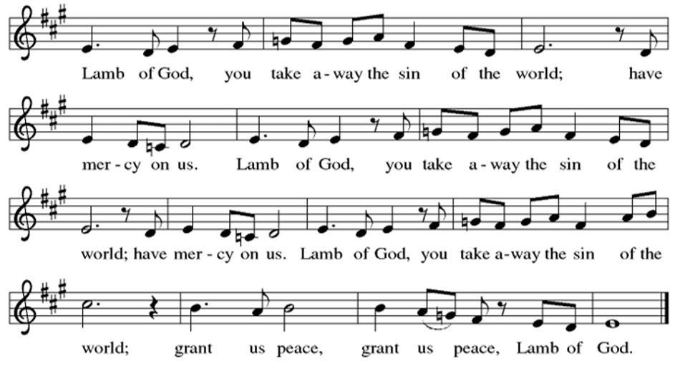

Communion Song: Thy Word
Refrain: Thy Word is a lamp unto my feet and a light unto my path.
Thy Word is a lamp unto my feetand a light unto my path.

- When I feel afraid, and I think I’ve lost my way,
still You’re there right beside me.
Nothing will I fear as long as You are near.
Please be near me to the end. Refrain

- I will not forget Your love for me, and yet
my heart forever is wandering.
Jesus, be my guide and hold me to Your side;
I will love You to the end Refrain

Communion Song: Sanctuary
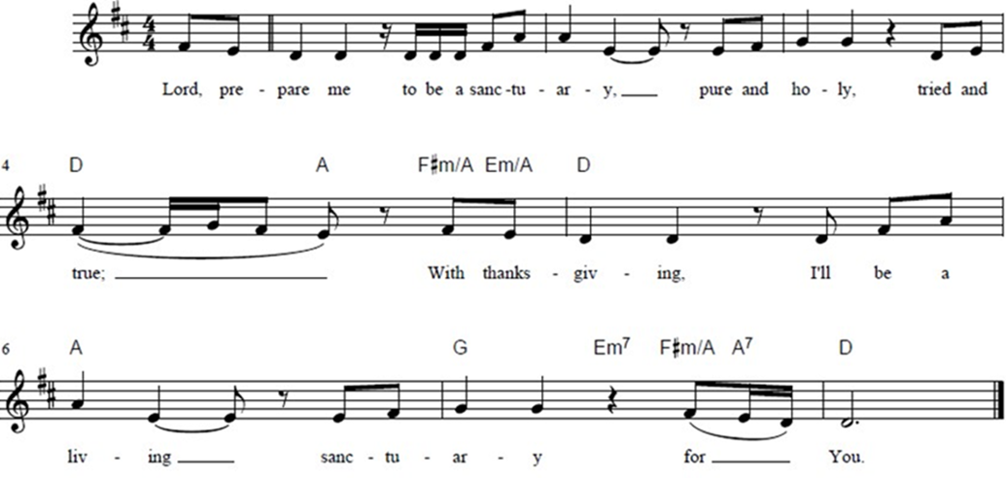

Post Communion Blessing
P: The Body and Blood of our Lord and Savior, Jesus Christ, strengthen you and keep you in God's grace. C: Amen.

Prayer After Communion
WA: Let us pray together.
C: Sustaining God, with this bread and cup, you nourish us with mercy and abundant life. By your Spirit, send us from this table to serve a needy world. Make us living signs of your liberation, healing, and love,
following the way of Jesus, in whose name we pray. Amen.

Sending - God blesses us and sends us in mission to the world.

Blessing
P: The God of love draw you into full accord and one mind, in the body of Christ Jesus. C: Amen.
P: The God of hope grant you strength and joy in all circumstances through the interceding of the Spirit. C: Amen.
P: The God of grace ☩ bless you now and forever. C: Amen.

Sending Hymn: Rise, Shine, You People ELW #665
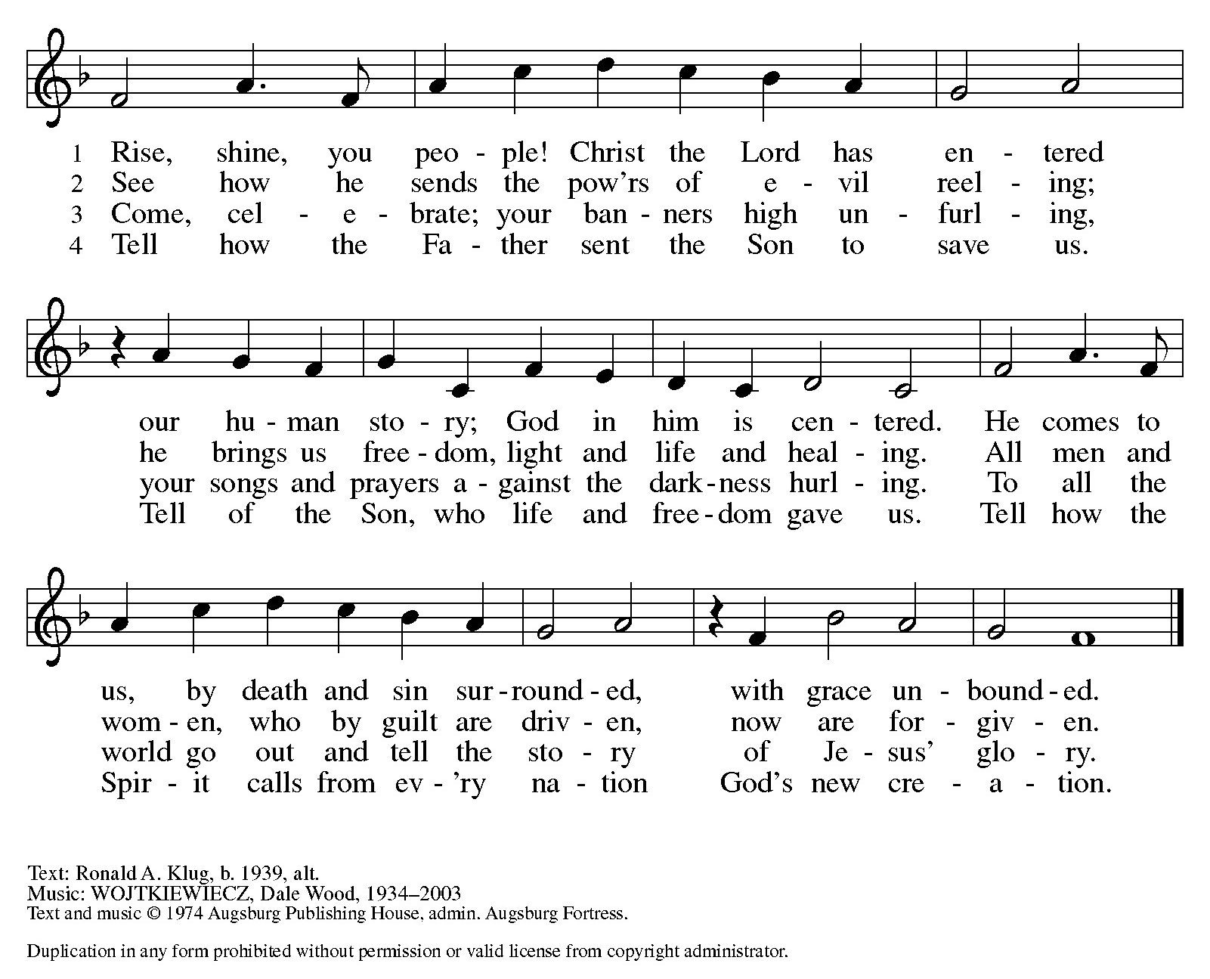

Dismissal and Postlude
WA: Parkside Lutheran Church is rediscovering the radical love of Jesus.
C: Gathering All, Serving All, Caring for All
WA: Go out in joy. Be led forth in peace.
C: Thanks be to God.

ELW Music licensed from Sundays & Seasons, Augsburg Fortress CCLI MUSIC License # 11440069 , CCLI Streaming License#21835523 Do not duplicate any music or Liturgy herein without license and permission
scripture readings adapted and written by susan lukey

PARKSIDE STAFF:
• The Rev. Jeremiah Smith: prjeremiahpsmith@gmail.com
• Kris Pope & Suzanne Gracie, Admin. Assistants (Church Office): parksidelutheran@gmail.com
• Mike Hooker, Music Director: mrhooker@me.com
CHURCH OFFICE HOURS: M/T/R 10:00am-3:00pm (716)836-1361
SCHEDULES and Events:
Acolytes: |  | Worship Assistants:
10/25 – Max & Lucy |  | 10/25 - Susan
11/1 – Max B & Solomon |  | 11/1 - Vince
Readers: |  | Ushers:
10/25 – John F |  | 10/25 – Ricky, Shannon, David
11/1 - Anne |  | 11/1 – Sue, Zack, Elaine
Coming up:
TODAY - Sunday School Parent Meeting – after Worship
October 30th – Halloween Boo Bash 6:30pm in Fellowship Hall

November 18th – International Thanksgiving Dinner 5:30pm in Fellowship Hall
All Saints Sunday - If you would like to have a friend or loved one remembered during the worship services on All Saints Sunday, fill out a form (found in the Narthex) or use the QR code ~~>

International Thanksgiving Dinner - We are collecting the following items to distribute at the dinner. Donations can be left in the bin, located in the Narthex. If you would like to volunteer, or bring a dish to the event, you can sign-up using the link on our website, or the QR Code below.
- Rice
- Pasta
- Bread
- Pita bread
- Flour
- Sugar
- Cornmeal
- Vegetable or corn oil
- Tea
- Dried or canned beans (black, red, kidney, garbanzo, etc.)
- Dried lentils
- Canned fruits and vegetables
- Tomato paste

